3.X Reliability of Study Instruments (this part goes in your methodology)
Scale refinement followed both statistical and theoretical criteria (DeVellis, 2017; Clark and Watson, 2019). For Procurement Compliance, three items were removed before the reliability analysis was run. Each item measured something adjacent to compliance rather than compliance itself: one asked about legal understanding, another about rights awareness, and a third about the perceived consequences of non-compliance. These are conditions that may precede or accompany compliance, but they are not the behaviour. The four items retained in the final scale address procedural awareness, the distribution of procurement information within schools, and the direct connection between knowing the rules and acting on them qualities that correspond more closely to how procurement compliance was defined for this study.
For Ethics, one item was removed because it asked respondents to report the absence of unethical behaviour rather than the presence of ethical conduct. The distinction matters. Churchill (1979) notes that these are not empirically the same: avoiding unethical acts may reflect fear, social pressure, or habit rather than genuine ethical commitment, and an item framed around absence captures something different from one framed around presence. The six items retained for the Ethics scale all describe positive ethical conduct and principled action within the IPDC, which gives the scale greater internal coherence and reduces the likelihood that negatively worded items skew the alpha estimate.
Cronbach's alpha was then calculated for each refined scale. Table 0 presents the results. Top management support produced the strongest alpha of the four constructs (0.84), which falls within the range George and Mallery (2021) classify as good. Ethics (alpha = 0.77) and staff training (alpha = 0.74) both met the 0.70 threshold the same authors set as the minimum for acceptable reliability. Procurement compliance returned an alpha of 0.68, marginally below that threshold. This is low enough to warrant a note of caution: the four compliance items showed somewhat less agreement with one another than those of the other three scales, and any findings related to compliance should be read with that limitation in mind. Taken as a whole, however, the four scales provide an adequate basis for the regression analyses that follow.
Table 0: Reliability Statistics (Cronbach's Alpha) for Study Constructs
Construct | Items | α | Interpretation
Procurement Compliance | 4 | 0.68 | Near acceptable
Staff Training | 7 | 0.74 | Acceptable
Ethics | 6 | 0.77 | Acceptable
Top Management Support | 6 | 0.84 | Good
Note. α = .70 was the threshold for acceptable internal consistency (George & Mallery, 2021).
PCA Factor loadings will be provided when the supervisor says so, but I feel like its not very important now; maybe later.

CHAPTER FOUR: RESULTS

4.0 Introduction
This chapter presents the empirical findings of the study on factors influencing public procurement compliance in public secondary schools in Rumphi District. The chapter begins with the response rate and the demographic profile of respondents, followed by descriptive statistics for the study constructs. Bivariate relationships between the variables are then examined through correlation analysis, before the individual effects of each predictor on procurement compliance are presented through simple linear regression. Assumption checking for the multiple regression model is discussed with reference to a Q-Q plot, and the chapter concludes with the multiple regression results showing the combined effect of all predictors on procurement compliance.

4.1 Response Rate
Of the 68 IPDC members targeted by the study, 62 returned completed questionnaires, yielding a response rate of 91.2%. This exceeds the 70% threshold considered adequate for survey-based studies (Saunders et al., 2019), and the high rate substantially reduces the risk of non-response bias. The findings can therefore be regarded as representative of IPDC membership across public secondary schools in Rumphi District.

4.2 Demographic Profile of Respondents
Table 1 summarises the socio-demographic characteristics of the 62 respondents. The sharpest feature of the sample is the near-universal absence of professional procurement body membership: only one of the 62 respondents held any affiliation with the Malawi Institute of Procurement and Supply (MIPS), registered as a student member. Sixty-one (98.4%) had none at all. Given that the study examines compliance in a procurement function, this finding warrants particular attention and is revisited in the discussion. The majority of respondents were male (61.3%, n = 38), and over two-thirds held a bachelor's degree (67.7%, n = 42). Nearly half had served between one and five years on an IPDC (46.8%, n = 29), pointing to a relatively recently constituted workforce. CDSS schools provided the largest share of respondents (46.8%, n = 29), which reflects their numerical prevalence among public secondary schools in Rumphi District. Full breakdowns by category are presented in Table 1.
Table 1: Demographic Profile of Respondents
Characteristic | Frequency (n) | Percentage (%)
Gender
Female | 18 | 29.0
Male | 38 | 61.3
Prefer not to say | 6 | 9.7
Highest Level of Education
Bachelor's degree | 42 | 67.7
Diploma | 8 | 12.9
Master's degree | 11 | 17.7
MSCE | 1 | 1.6
Years Worked in IPDC
Less than a year | 8 | 12.9
1–5 years | 29 | 46.8
6–10 years | 18 | 29.0
Over 10 years | 7 | 11.3
Position in IPDC
Chair | 7 | 11.3
Committee member | 16 | 25.8
Controlling officer | 19 | 30.6
Secretary | 20 | 32.3
School Category
CDSS | 29 | 46.8
Conventional | 5 | 8.1
Day | 10 | 16.1
District | 17 | 27.4
National | 1 | 1.6
MIPS Membership
None | 61 | 98.4
Student member | 1 | 1.6
Note. N = 62.

4.3 Descriptive Statistics
Table 2 tells a story that the inferential results must then explain. Ethics scored highest of the four constructs (M = 4.47, SD = 0.45), followed by top management support (M = 4.13, SD = 0.30), both sitting well above the scale midpoint of 3.0. Procurement compliance, by contrast, returned the lowest mean (M = 2.74, SD = 0.29), below the midpoint, suggesting that IPDC members generally rated compliance in their schools as poor. Staff training was similarly low (M = 2.99, SD = 0.41), barely clearing the midpoint. The distribution shapes add nuance. Ethics responses clustered heavily toward the top of the scale (skewness = -3.46), reflecting a ceiling effect in which most IPDC members regarded ethical conduct within their committees as strong. Staff training showed the reverse: a positively skewed distribution (skewness = 1.59) in which most respondents rated training as inadequate, with fewer reporting higher levels. Taken together, Table 2 raises a question that simple assertion cannot answer: why do schools where members report strong ethics and management support still return weak compliance scores? The correlation and regression analyses presented below examine this.
Table 2: Descriptive Statistics for Construct Composite Scores
Construct | N | M | SD | Median | Min | Max | Skewness | Kurtosis
Procurement Compliance | 62 | 2.74 | 0.29 | 2.75 | 2.25 | 3.50 | -0.10 | -0.19
Staff Training | 62 | 2.99 | 0.41 | 2.86 | 2.29 | 4.43 | 1.59 | 3.44
Ethics | 62 | 4.47 | 0.45 | 4.50 | 1.83 | 5.00 | -3.46 | 17.15
Top Management Support | 62 | 4.13 | 0.30 | 4.33 | 3.00 | 4.33 | -1.63 | 2.26
Note. Scores are based on a 5-point Likert scale (1 = strongly disagree, 5 = strongly agree).

4.4 Correlation Analysis
Pearson correlation coefficients were computed to examine bivariate relationships among the study constructs prior to regression analysis. The full correlation matrix is presented in Table 3. Awareness was the only predictor variable to show a statistically significant positive correlation with procurement compliance (r = 0.56, p < 0.001), indicating a moderate-to-strong positive relationship: schools where IPDC members reported higher awareness of procurement regulations also tended to report higher compliance levels. The remaining three predictors (ethics, top management support, and staff training) showed no significant bivariate association with compliance at the conventional threshold (all p > 0.05).
Among the predictors themselves, ethics and top management support correlated strongly and positively (r = 0.65, p < 0.001), suggesting that schools with more committed management also tended to score higher on ethical conduct within the IPDC, and the reverse. Staff training returned significant negative correlations with both ethics (r = -0.42, p < 0.01) and top management support (r = -0.47, p < 0.01). These inverse relationships may reflect a sampling dynamic: IPDC members who received formal training became more critical in their appraisal of ethical and managerial conditions at their schools, or alternatively, schools with weaker institutional cultures may have sought external training more actively. Awareness showed no significant correlation with any of the other predictor variables, confirming that it captures a dimension of procurement capacity distinct from training, ethics, and management support.
The high correlation between ethics and management support (r = 0.65) raises the question of multicollinearity in the multiple regression model; this is addressed through the model diagnostics presented i. The correlation matrix also appears as a heatmap (Figure 1) in the results outputs, where statistically significant cells are marked with asterisks (* p < 0.05, ** p < 0.01, *** p < 0.001), consistent with conventions in quantitative social research.
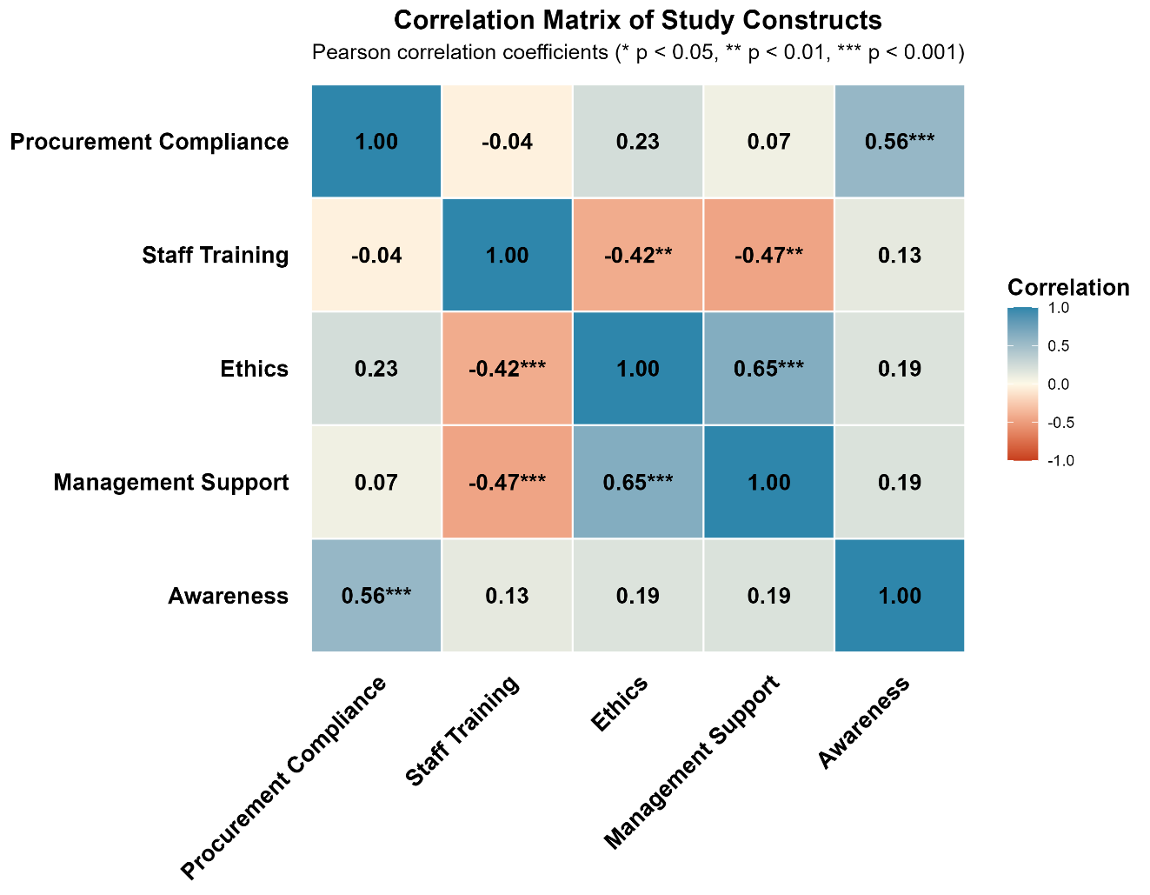
Note: ** p < 0.01; *** p < 0.001. Awareness data captured as part of the extended variable set.
Figure 1: Correlation Matrix of Study Constructs (Pearson Coefficient)

4.5 Simple Linear Regression Results
To address each specific objective individually, three simple linear regressions were conducted with procurement compliance as the outcome variable. The results are summarised in Table 4 and correspond to Figures 2 through 4, which display the scatter plots with fitted regression lines and 95% confidence intervals, with data points colour-coded by school category (CDSS, Conventional, Day, District, National).
Objective 1: Effect of Staff Training on Procurement Compliance
Staff training showed no significant linear relationship with procurement compliance in simple regression (p = 0.751). The regression line was essentially flat across the range of training scores, and the near-zero explained variance (R² = 0.002) indicates that training level alone accounts for virtually none of the variation in compliance. Figure 2 shows data points scattered widely on both sides of the regression line, with no directional pattern visible regardless of training score. Training, when examined without controlling for other factors, does not predict compliance in this sample.

4.0 Introduction
This chapter presents the empirical findings of the study on factors influencing public procurement compliance in public secondary schools in Rumphi District. The chapter begins with the response rate and the demographic profile of respondents, followed by descriptive statistics for the study constructs. Bivariate relationships between the variables are then examined through correlation analysis, before the individual effects of each predictor on procurement compliance are presented through simple linear regression. Assumption checking for the multiple regression model is discussed with reference to a Q-Q plot, and the chapter concludes with the multiple regression results showing the combined effect of all predictors on procurement compliance.

4.1 Response Rate
Of the 68 IPDC members targeted by the study, 62 returned completed questionnaires, yielding a response rate of 91.2%. This exceeds the 70% threshold considered adequate for survey-based studies (Saunders et al., 2019), and the high rate substantially reduces the risk of non-response bias. The findings can therefore be regarded as representative of IPDC membership across public secondary schools in Rumphi District.

4.2 Demographic Profile of Respondents
Table 1 summarises the socio-demographic characteristics of the 62 respondents. The sharpest feature of the sample is the near-universal absence of professional procurement body membership: only one of the 62 respondents held any affiliation with the Malawi Institute of Procurement and Supply (MIPS), registered as a student member. Sixty-one (98.4%) had none at all. Given that the study examines compliance in a procurement function, this finding warrants particular attention and is revisited in the discussion. The majority of respondents were male (61.3%, n = 38), and over two-thirds held a bachelor's degree (67.7%, n = 42). Nearly half had served between one and five years on an IPDC (46.8%, n = 29), pointing to a relatively recently constituted workforce. CDSS schools provided the largest share of respondents (46.8%, n = 29), which reflects their numerical prevalence among public secondary schools in Rumphi District. Full breakdowns by category are presented in Table 1.
Table 3: Demographic Profile of Respondents
Characteristic | Frequency (n) | Percentage (%)
Gender
Female | 18 | 29.0
Male | 38 | 61.3
Prefer not to say | 6 | 9.7
Highest Level of Education
Bachelor's degree | 42 | 67.7
Diploma | 8 | 12.9
Master's degree | 11 | 17.7
MSCE | 1 | 1.6
Years Worked in IPDC
Less than a year | 8 | 12.9
1–5 years | 29 | 46.8
6–10 years | 18 | 29.0
Over 10 years | 7 | 11.3
Position in IPDC
Chair | 7 | 11.3
Committee member | 16 | 25.8
Controlling officer | 19 | 30.6
Secretary | 20 | 32.3
School Category
CDSS | 29 | 46.8
Conventional | 5 | 8.1
Day | 10 | 16.1
District | 17 | 27.4
National | 1 | 1.6
MIPS Membership
None | 61 | 98.4
Student member | 1 | 1.6
Note. N = 62.

4.3 Descriptive Statistics
Table 2 tells a story that the inferential results must then explain. Ethics scored highest of the four constructs (M = 4.47, SD = 0.45), followed by top management support (M = 4.13, SD = 0.30), both sitting well above the scale midpoint of 3.0. Procurement compliance, by contrast, returned the lowest mean (M = 2.74, SD = 0.29), below the midpoint, suggesting that IPDC members generally rated compliance in their schools as poor. Staff training was similarly low (M = 2.99, SD = 0.41), barely clearing the midpoint. The distribution shapes add nuance. Ethics responses clustered heavily toward the top of the scale (skewness = -3.46), reflecting a ceiling effect in which most IPDC members regarded ethical conduct within their committees as strong. Staff training showed the reverse: a positively skewed distribution (skewness = 1.59) in which most respondents rated training as inadequate, with fewer reporting higher levels. Taken together, Table 2 raises a question that simple assertion cannot answer: why do schools where members report strong ethics and management support still return weak compliance scores? The correlation and regression analyses presented below examine this.
Table 4: Descriptive Statistics for Construct Composite Scores
Construct | N | M | SD | Median | Min | Max | Skewness | Kurtosis
Procurement Compliance | 62 | 2.74 | 0.29 | 2.75 | 2.25 | 3.50 | -0.10 | -0.19
Staff Training | 62 | 2.99 | 0.41 | 2.86 | 2.29 | 4.43 | 1.59 | 3.44
Ethics | 62 | 4.47 | 0.45 | 4.50 | 1.83 | 5.00 | -3.46 | 17.15
Top Management Support | 62 | 4.13 | 0.30 | 4.33 | 3.00 | 4.33 | -1.63 | 2.26
Note. Scores are based on a 5-point Likert scale (1 = strongly disagree, 5 = strongly agree).

4.4 Correlation Analysis
Pearson correlation coefficients were computed to examine bivariate relationships among the study constructs prior to regression analysis. The full correlation matrix is presented in Table 3. Awareness was the only predictor variable to show a statistically significant positive correlation with procurement compliance (r = 0.56, p < 0.001), indicating a moderate-to-strong positive relationship: schools where IPDC members reported higher awareness of procurement regulations also tended to report higher compliance levels. The remaining three predictors (ethics, top management support, and staff training) showed no significant bivariate association with compliance at the conventional threshold (all p > 0.05).
Among the predictors themselves, ethics and top management support correlated strongly and positively (r = 0.65, p < 0.001), suggesting that schools with more committed management also tended to score higher on ethical conduct within the IPDC, and the reverse. Staff training returned significant negative correlations with both ethics (r = -0.42, p < 0.01) and top management support (r = -0.47, p < 0.01). These inverse relationships may reflect a sampling dynamic: IPDC members who received formal training became more critical in their appraisal of ethical and managerial conditions at their schools, or alternatively, schools with weaker institutional cultures may have sought external training more actively. Awareness showed no significant correlation with any of the other predictor variables, confirming that it captures a dimension of procurement capacity distinct from training, ethics, and management support.
The high correlation between ethics and management support (r = 0.65) raises the question of multicollinearity in the multiple regression model; this is addressed through the model diagnostics presented i. The correlation matrix also appears as a heatmap (Figure 1) in the results outputs, where statistically significant cells are marked with asterisks (* p < 0.05, ** p < 0.01, *** p < 0.001), consistent with conventions in quantitative social research.
Note: ** p < 0.01; *** p < 0.001. Awareness data captured as part of the extended variable set.
Figure 2: Correlation Matrix of Study Constructs (Pearson Coefficient)

4.5 Simple Linear Regression Results
To address each specific objective individually, three simple linear regressions were conducted with procurement compliance as the outcome variable. The results are summarised in Table 4 and correspond to Figures 2 through 4, which display the scatter plots with fitted regression lines and 95% confidence intervals, with data points colour-coded by school category (CDSS, Conventional, Day, District, National).
Objective 1: Effect of Staff Training on Procurement Compliance
Staff training showed no significant linear relationship with procurement compliance in simple regression (p = 0.751). The essentially flat regression line and near-zero explained variance (R² = 0.002) indicate that training, considered in isolation, does not predict compliance in this sample. As shown in Figure 2, data points are widely dispersed around the regression line regardless of training score, with no discernible directional pattern. This result does not support Objective 1.
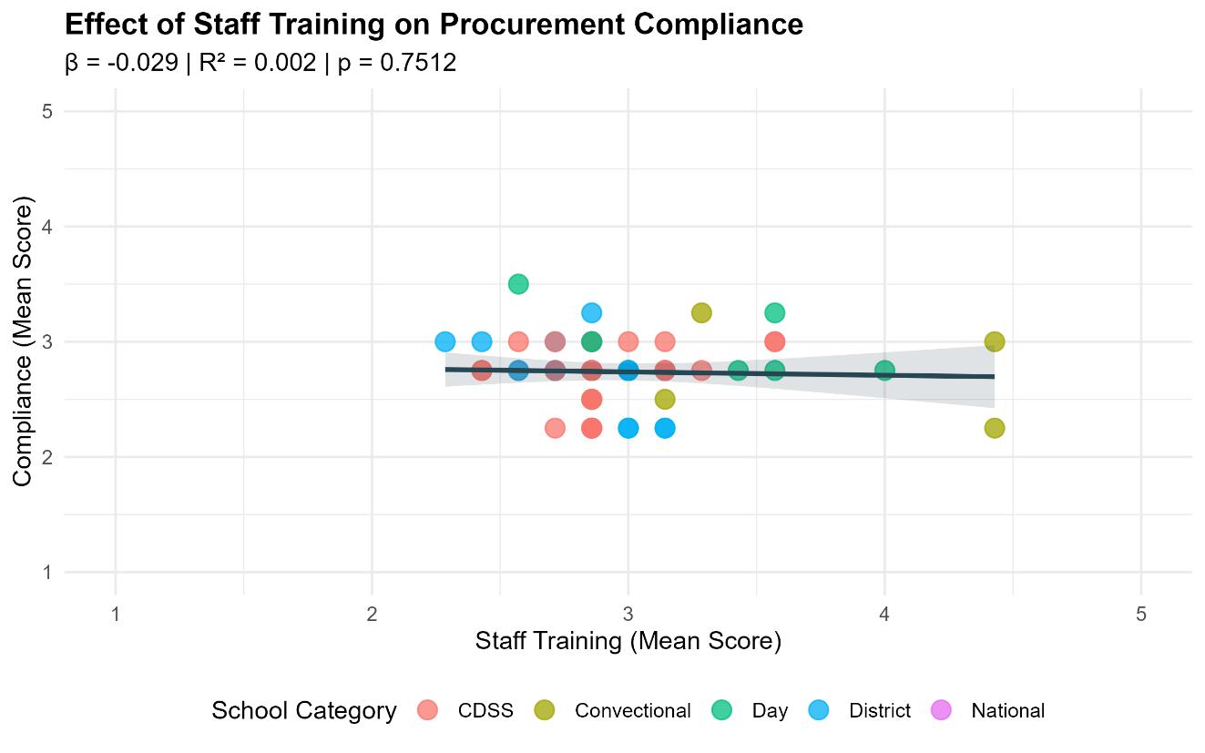
Figure 3: Effect of Staff Training on Procurement Compliance
Effect of Ethics on Procurement Compliance
Ethics returned the highest R² of the three simple regressions (R² = 0.055), with a positive coefficient (beta = 0.15) indicating that schools where IPDC members reported stronger ethical conduct also tended to score marginally higher on compliance. The effect did not reach the 0.05 significance threshold (p = 0.066) and should not be treated as a confirmed relationship. Figure 3 shows a modest positive slope that widens considerably at higher ethics scores, a pattern consistent with the ceiling effect in Table 2 where most responses were already clustered near the top of the scale. With little variability at the upper end, the regression has limited data on which to stabilise an estimate.
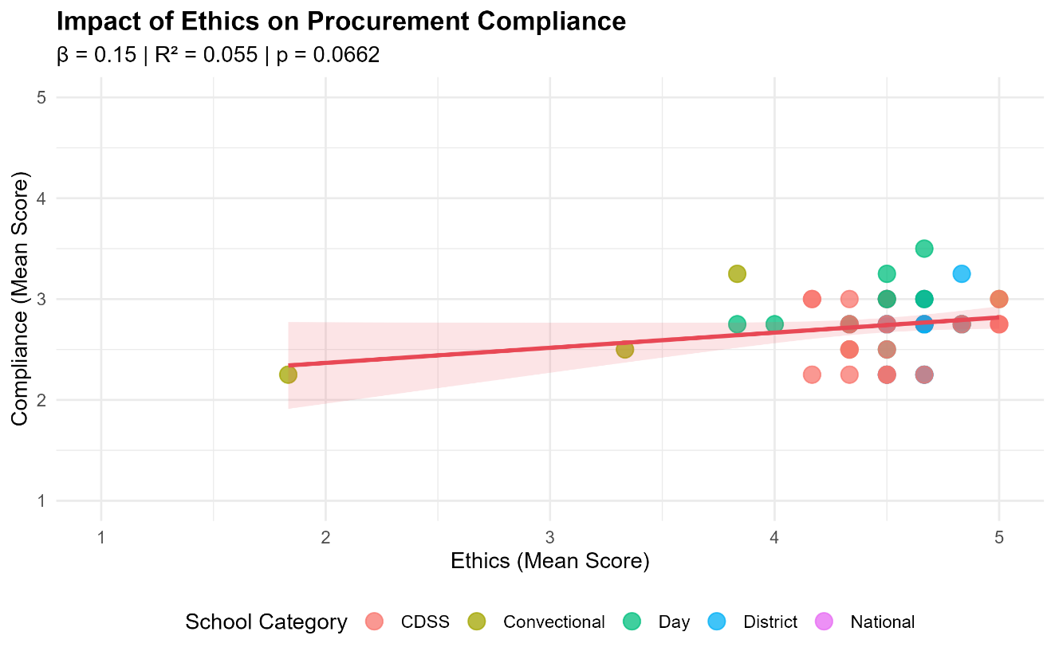
Figure 4: Impact of Ethics on Procurement Compliance
Effect of Top Management Support on Procurement Compliance
Top management support showed no significant effect on compliance in simple regression (p = 0.573), with less than 1% of compliance variance explained (R² = 0.005). While the coefficient was positive (beta = 0.07), Figure 4 shows a confidence interval that spans both positive and negative gradients at higher support scores, making the direction itself uncertain. CDSS schools, which provided the largest block of respondents, were spread across the full range of management support scores with no visible trend. Considered on its own, management support did not predict compliance in Rumphi District schools.
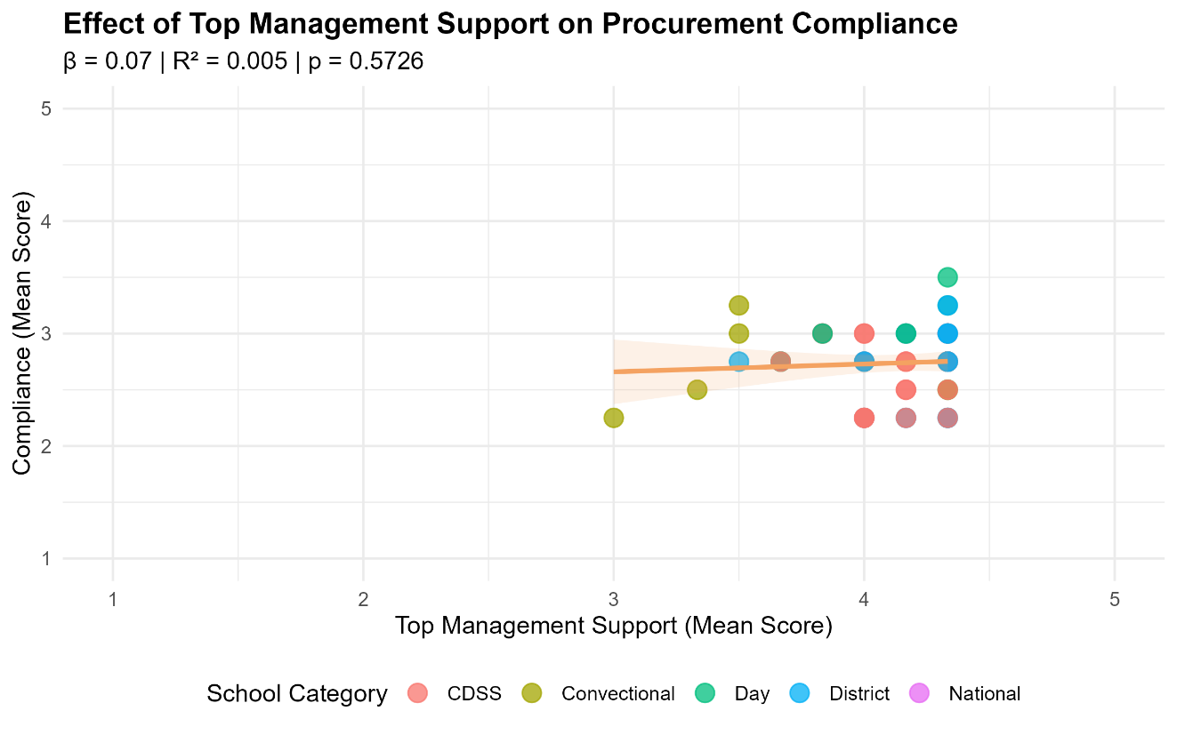
Figure 5: Effect of Top Management Support on Procurement Compliance

4.6 Regression Assumption Checks
Before interpreting the multiple regression model, the assumption of normally distributed residuals was examined. Figure 4 displays the Q-Q (quantile-quantile) plot of residuals from the multiple regression model, in which each point represents a standardised residual plotted against its theoretical normal quantile. Points closely following the diagonal reference line indicate that the residuals conform to a normal distribution. Visual inspection of Figure 4 reveals that the points track the reference line well across the central range, with only minor deviations at the tails, which is expected with a sample of this size.
This visual assessment was confirmed by the Shapiro-Wilk test (W = 0.989, p = 0.862). Since p > 0.05, the null hypothesis of normality cannot be rejected, confirming that the residuals are approximately normally distributed. The normality assumption for multiple regression is therefore satisfied, and the interpretation of model coefficients can proceed with confidence.
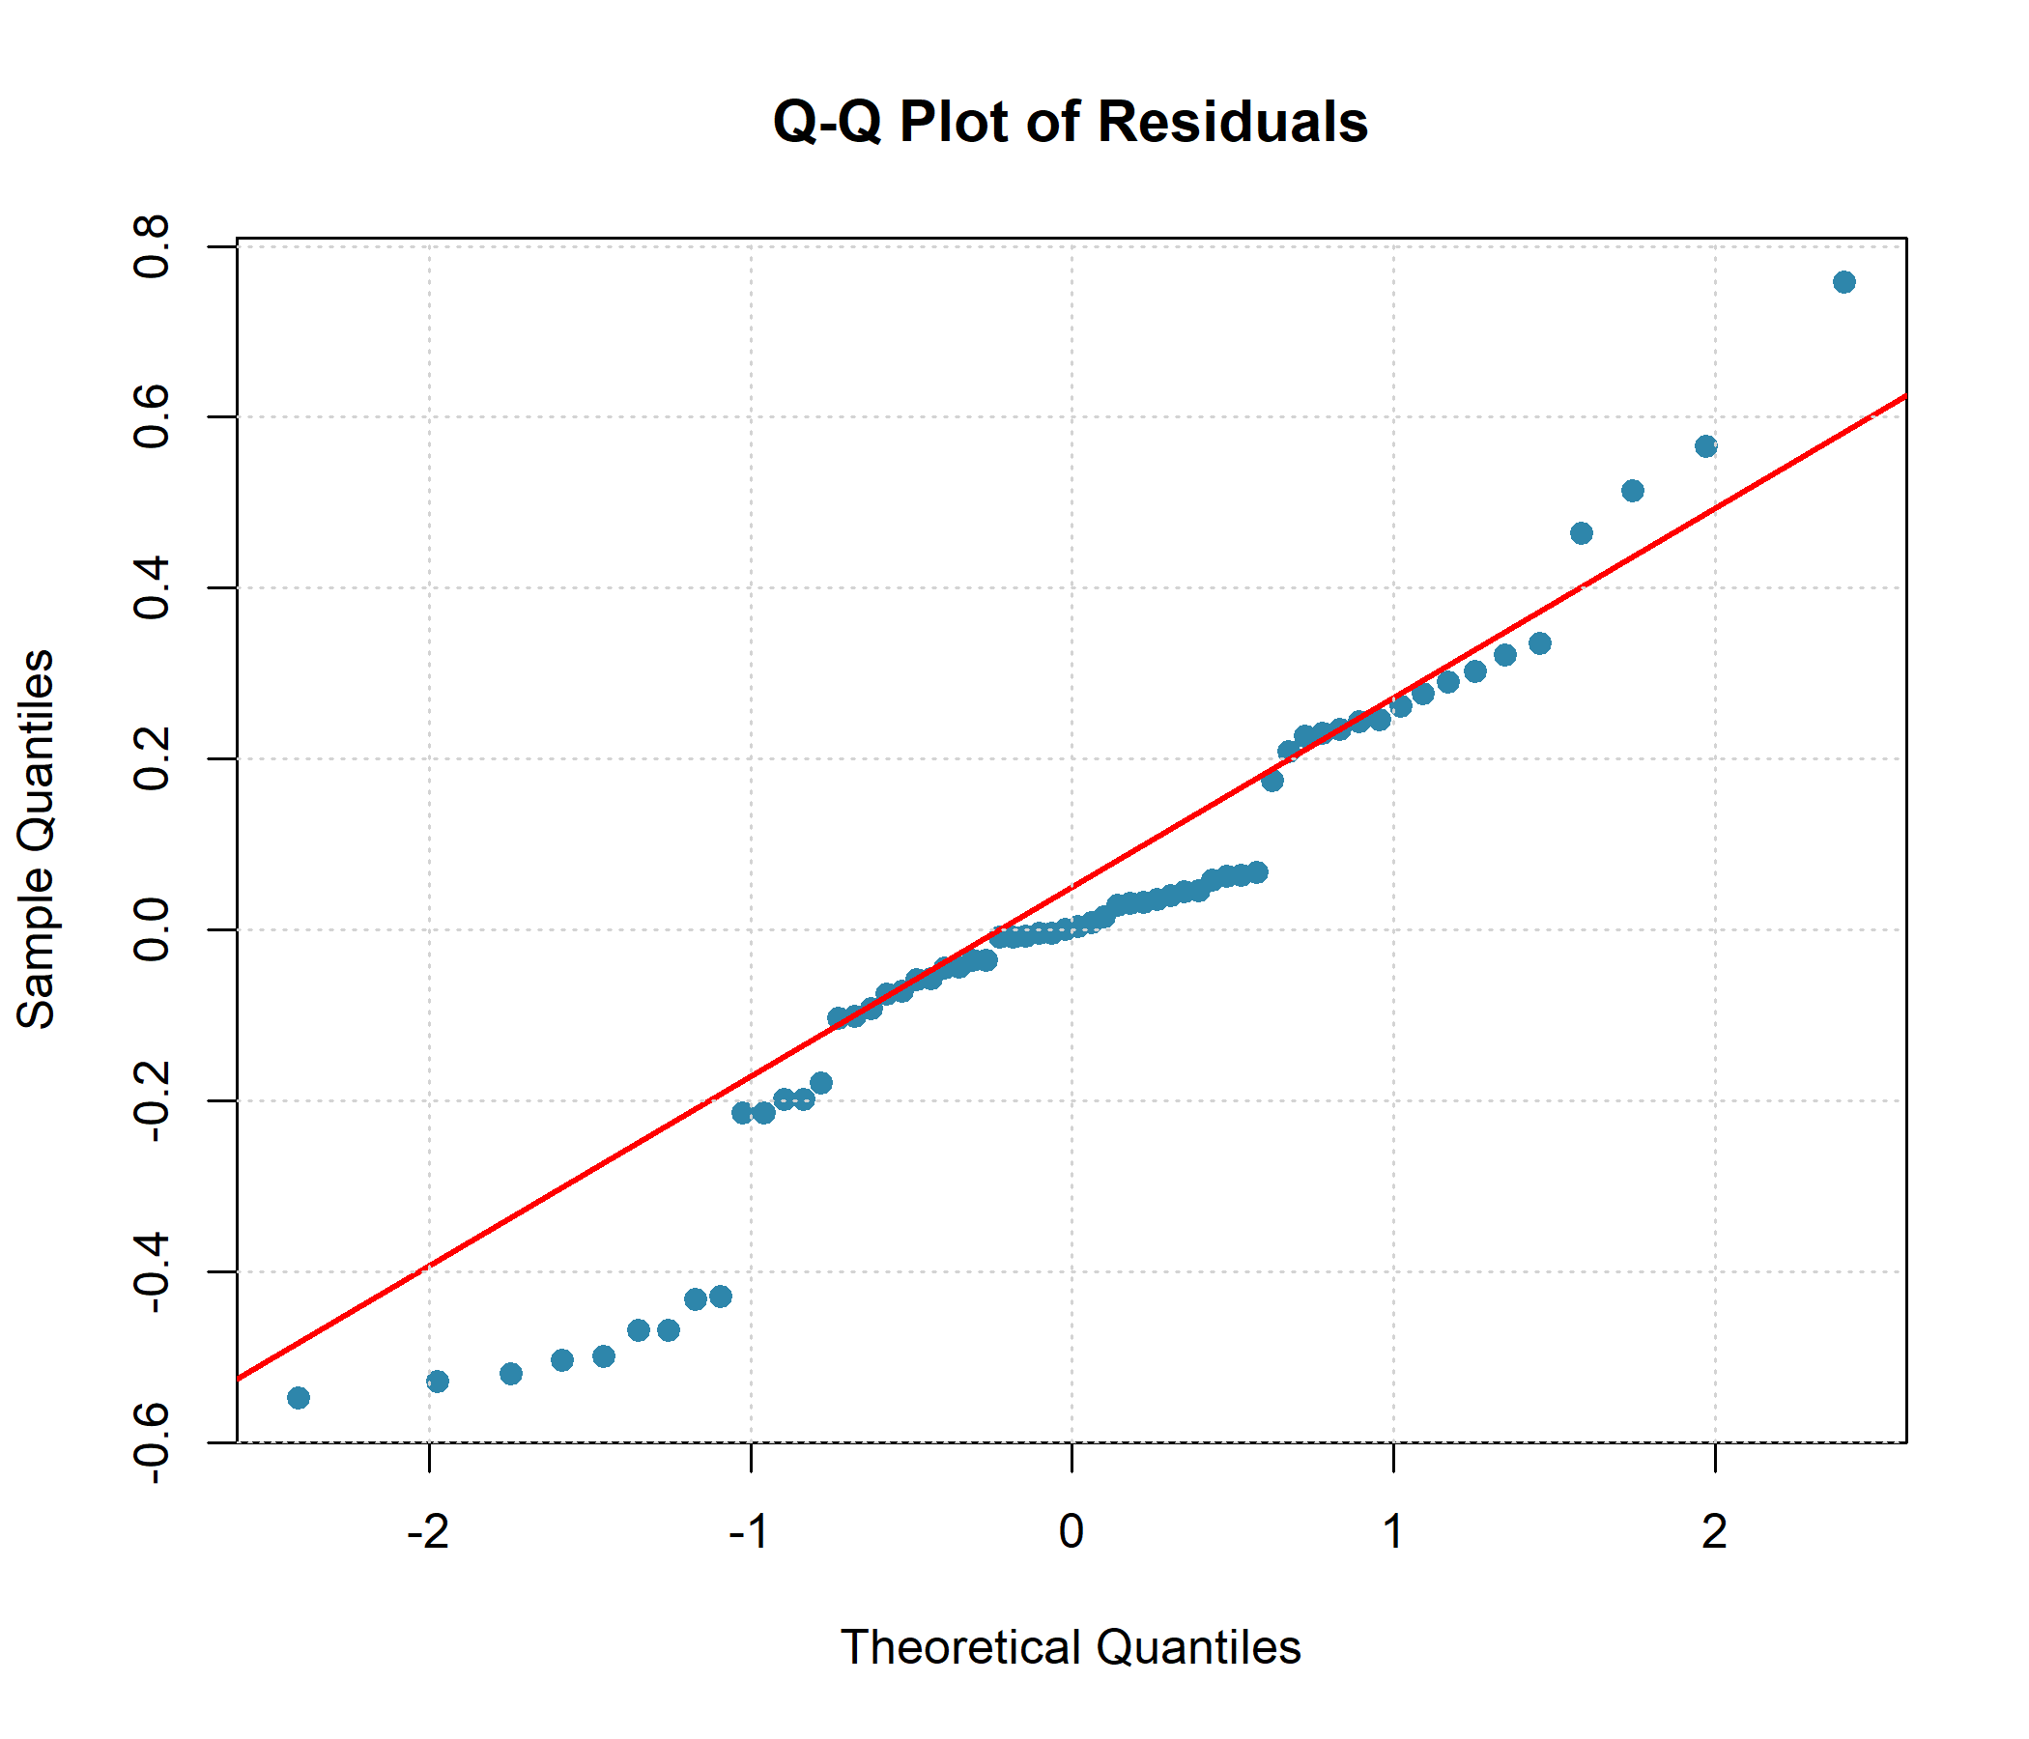
Figure 6: Q-Q Plot of Residuals from the Multiple Regression Model

4.7 Multiple Regression Results
To examine the independent contribution of each predictor while controlling for the others, a multiple regression model was fitted with procurement compliance as the dependent variable and staff training, ethics, top management support, and awareness as predictors. The full model results are presented in Table 5.
The overall model was statistically significant (F(4, 57) = 8.177, p < 0.001) and explained 36.5% of the variance in procurement compliance (R² = 0.365), with an adjusted R² of 0.320 to account for the number of predictors. This indicates that the four-predictor model provides a substantively meaningful account of compliance variation beyond what would be expected by chance.
Among the four predictors, awareness was the only variable to exert a statistically significant unique effect on procurement compliance when controlling for all others (B = 0.539, SE = 0.104, t = 5.162, 95% CI [0.330, 0.747], beta = 0.580, p < 0.001). The standardised coefficient of 0.580 is large and suggests that for each one-standard-deviation increase in awareness, compliance increases by approximately 0.58 standard deviations, holding the other predictors constant. This positions awareness as by far the strongest individual predictor in the model.
Ethics maintained a positive direction in the full model but fell short of conventional significance (p = 0.103), a weaker result than its simple regression suggested. Once awareness is included as a predictor, ethics no longer accounts for unique variance in compliance, which points to some shared ground between what ethics and awareness each capture in this sample. Top management support flipped sign in the full model, producing a negative coefficient (p = 0.086) where the simple regression had returned a positive one. This reversal likely reflects its strong positive correlation with ethics (r = 0.65): when ethics is held constant, management support absorbs part of its opposing prediction and pulls in the other direction. Staff training remained non-significant (p = 0.287), consistent with the simple regression result. Full coefficients, standard errors, and confidence intervals for all predictors are reported in Table 5.
Taken together, the multiple regression results indicate that awareness of procurement regulations is the dominant driver of compliance in public secondary schools in Rumphi District. The other three predictors, while substantively plausible, do not independently account for significant unique variance in compliance once awareness is controlled for.
Table 5: Multiple Regression Analysis Predicting Procurement Compliance
Variable | B | SE | t | 95% CI [LL, UL] | β | p
Intercept | 1.65 | 0.65 | 2.53 | [0.34, 2.95] | — | 0.014
Staff Training | -0.10 | 0.09 | -1.07 | [-0.28, 0.08] | -0.14 | 0.287
Ethics | 0.15 | 0.09 | 1.66 | [-0.03, 0.33] | 0.24 | 0.103
Top Management Support | -0.24 | 0.14 | -1.75 | [-0.53, 0.04] | -0.26 | 0.086
Awareness | 0.54 | 0.10 | 5.16 | [0.33, 0.75] | 0.58 | < .001
Note. R² = 0.365, adjusted R² = 0.320, F(4, 57) = 8.18, p < .001.

4.8 Summary of Results
Five analytical stages produced a coherent picture. The sample was predominantly male, bachelor-educated, and almost entirely without professional procurement body membership. Perceptions of ethics and management support were comparatively strong, yet actual compliance scores sat below the scale midpoint. At the bivariate level, awareness of procurement regulations was the only predictor to correlate significantly with compliance (r = 0.56, p < 0.001). Simple regressions confirmed that neither staff training nor management support predicted compliance, and the ethics effect, while positive in direction, did not clear the 0.05 threshold. In the multiple regression model, awareness remained the sole significant predictor (beta = 0.580, p < 0.001), with the four-predictor model accounting for 36.5% of compliance variance. What these results mean for the study objectives and how they relate to the existing literature is taken up in Chapter Five.
References to add:
Clark, L., & Watson, D. (2019). Constructing Validity: New Developments in Creating Objective Measuring Instruments. Psychological Assessment, 31, 1412–1427. https://doi.org/10.1037/pas0000626
Churchill, G. A. (1979). A Paradigm for Developing Better Measures of Marketing Constructs. Journal of Marketing Research, 16, 64–73. https://doi.org/10.1177/002224377901600110
DeVellis, R. F. (2017). Scale development: Theory and applications (4th ed.). SAGE Publications.
George, D., & Mallery, P. (2021). IBM SPSS Statistics 27 step by step: A simple guide and reference (17th ed.). Routledge. DOI: 10.4324/9781003205333 (George & Mallery, 2021)
Saunders, M. N. K., Lewis, P., & Thornhill, A. (2019). Research methods for business students (8th ed.). Pearson.

