THE ENVIRONEMENTAL FEASIBILITY OF LOW-COST ALGAE-BASED SEWAGE TREATMENT AS A CLIMATE CHANGE ADAPTION MEASURE IN RURAL AREAS OF MALAWI, UNIVERSITY OF MALAWI CASE STUDY

MSc. (APPLIED CHEMISTRY) THESIS

RICHARD WEBSTER CHIRWA

UNIVERSITY OF MALAWI

JUNE, 2026

THE ENVIRONEMENTAL FEASIBILITY OF LOW-COST ALGAE-BASED SEWAGE TREATMENT AS A CLIMATE CHANGE ADAPTION MEASURE IN RURAL AREAS OF MALAWI, UNIVERSITY OF MALAWI CASE STUDY


MSc. (APPLIED CHEMISTRY) THESIS
By
Richard Webster Chirwa
B.Ed. (Science) – University of Malawi

Submitted to the Department of Chemistry and Chemical Engineering, Faculty of Sciences, in partial fulfilment of the requirements for the degree of Master of Science (Applied Chemistry)

University of Malawi

JUNE, 2026

DECLARATION

The work presented in this thesis is my own original work. It has not been submitted to any other institution for similar purposes. Any other information from other sources has been acknowledged entirely. This is paper is fully my responsibility.

RICHARD WEBSTER CHIRWA

_______________________________________

Name

_______________________________________

Signature

________________________________________

Date

CERTIFICATE OF APPROVAL

The undersigned certify that this thesis represents the student’s own work and effort and has been submitted with our approval.

Signature:___________________________________________ Date:___________________

Mwatseteza, J.F., (Associate Professor)

Main Supervisor

Signature:___________________________________________ Date:___________________

Monjerezi, M., (Associate Professor)
Member, Supervisory Committee

Signature:___________________________________________ Date:___________________

Head, Department of Chemistry

DEDICATION

To my late mother and father, my son Richard Junior and my daughter Keisha for being wonderful parents and children. You deserve the credit!

ACKNOWLEDGEMENTS

First and foremost, I extend my appreciation to my supervisors, Associate Professor J.F. Mwatseteza and Associate Professor M. Monjerezi, for the endless support they rendered to me with so much patience throughout the entire research project. Their critical analysis, direction, emotional support and constructive comments shaped the thesis. I am immensely grateful.

Secondly, I express my profound gratitude to the entire chemistry department for their assistance in various areas, and especially to Mr Khumalo Kawaika, for always being there throughout the sampling and practical analysis of the project's parameters. Mr J. Mguntha must also receive special gratitude for helping me, especially in desperate situations.

I must also thank Dr. Peter Chimtali for proofreading my work. The enormous effort to critique and correct various parts of the thesis is greatly appreciated. May God bless you abundantly.

Above all, I thank God the Almighty for everything.

ABSTRACT
Wastewater pollution poses significant threats to environmental and public health, particularly in developing countries where conventional treatment technologies are prohibitively expensive. This study evaluated the efficacy of phytoremediation using a consortium of Chlorella vulgaris for treating sewage wastewater at the University of Malawi Wastewater Treatment Works (WWTW) in Zomba, Malawi. The existing waste stabilisation pond system operates without mechanical aeration or algal augmentation, discharging partially treated effluent into the Likangala River. A baseline survey was conducted across six phases (February 2021 to December 2022) to characterise untreated sewage at sampling points SA1 - SA3 and SC1 - SC3. Parameters analysed included chlorides, nitrates, phosphates, sulphates, chemical oxygen demand (COD), turbidity, electrical conductivity (EC), total dissolved solids (TDS), pH, and temperature, following standard methods (APHA, 2017). Indigenous algae were identified microscopically before inoculation. Subsequently, selected algal strains (ATCC:30821) were mass-cultured in 5,000 L photobioreactors and inoculated into one facultative pond (SC1) and two maturation ponds (SC2 and SC3) at a target density of 1.2 × 10⁶ cells mL⁻¹, with re-inoculation every three to four weeks. Baseline results revealed severe organic and nutrient pollution: COD ranged from 300 - 484 mg/L, nitrates up to 89 mg/L, phosphates up to 10 mg/L, and turbidity up to 99 NTU. Indigenous algae included Scenedesmus spp., Euglena, Cyclotella, and Microcystis, but no Chlorella species were detected. Following inoculation, substantial water quality improvements were observed. COD reduction ranged from 89.7% to 98.0%, with final values as low as 6.0 mg/L in SC2. Nitrate reduction ranged from 49.3% to 63.9%, phosphate reduction from 33.3% to 44.7%, EC reduction from 52.8% to 57.1%, and TDS reduction from 55.1% to 62.8%. Turbidity decreased by 18.6 - 46.8%, and pH stabilised towards neutrality (7.30 - 7.85). Sulphate removal was modest (2.5 - 21.2%), and chlorides showed variable responses. The study concludes that monthly inoculation of Chlorella vulgaris significantly enhances nutrient removal efficiency in waste stabilisation ponds without requiring electricity or mechanical aeration. The inoculated strains successfully survived local environmental conditions (25 - 27 °C) and became dominant over indigenous species. This low-cost, sustainable technology is suitable for resource-limited settings and offers the additional benefit of producing algal biomass that can be harvested as biofertiliser. Implementing this approach at University of Malawi WWTW would substantially reduce pollution of the Likangala River, protect downstream aquatic ecosystems, and improve public health.
Keywords: Phytoremediation, Chlorella vulgaris, sewage wastewater, waste stabilisation ponds, nutrient removal, biofertiliser, Malawi

TABLE OF CONTENTS

CHAPTER 1: INTRODUCTION

1.1 General background
Water is an indispensable resource for human survival, economic development, and ecosystem integrity. It is utilised for diverse purposes including domestic activities (washing, bathing, cooking), agricultural irrigation, industrial manufacturing, and commercial operations (Geremew, 2017). However, the quality of water available to communities is increasingly threatened by anthropogenic activities, particularly the discharge of inadequately treated wastewater into receiving water bodies. The quality of effluent released from wastewater treatment plants (WWTPs) directly determines the health and livelihood of downstream communities and the ecological status of rivers and other surface water systems (Abiyu et al., 2018).
Globally, rapid industrialisation, urbanisation, and population growth have been identified as the principal drivers of water pollution (Shemeera, 2018). These factors have led to the generation of vast quantities of domestic, municipal, and industrial wastes, rendering many surface water sources unsafe and hazardous to both humans and the environment. The United Nations Children's Fund and World Health Organization (UNICEF/WHO, 2012) reported that approximately 783 million people worldwide lack access to improved drinking water sources. Furthermore, the World Health Organization (WHO) estimates that inadequate access to safe drinking water results in 1.6 million deaths annually, primarily from diarrhoeal and parasitic diseases (Abiyu et al., 2018).
In developing countries, the situation is even more acute. Approximately 1.2 billion people lack access to safe and clean water and are consequently forced to rely on highly polluted surface water sources (Shannon et al., 2008). Despite the existence of various water treatment strategies, demand for clean water supply remains a major challenge in most developing nations due to financial constraints, inadequate infrastructure, and shortages of trained personnel (Bello et al., 2017). The overwhelming introduction of wastes into treatment systems exceeding the capacity of available infrastructure, equipment, chemicals, and skilled staff further exacerbates the problem (Vunain & Biswick, 2018).
When wastewater is not properly treated, it causes numerous environmental problems including soil pollution, creation of breeding grounds for pathogens, air pollution, contamination of surface and groundwater resources, and high management costs (Vunain & Biswick, 2018). Nutrient enrichment, in particular, leads to eutrophication of receiving water bodies, causing algal blooms, oxygen depletion, fish kills, and loss of biodiversity (Correll, 1998; Smith & Schindler, 2009).
Malawi, a developing country in sub-Saharan Africa, is not immune to these challenges. The national economy does not fully support the development of modern sewage treatment plants, creating an urgent need for economically sustainable means of treating sewage (Kaonga et al., 2011). Many wastewater treatment facilities in Malawi operate below optimal efficiency, discharging partially treated effluent into rivers that communities rely on for domestic use, irrigation, and fishing (Maliro, 2016).

1.2 Wastewater treatment challenges and the need for sustainable solutions
Conventional wastewater treatment technologies, including activated sludge systems, trickling filters, and rotating biological contactors, have proven effective in removing organic matter and nutrients from sewage (Tchobanoglous et al., 2014). However, these systems are capital intensive, require continuous energy input for aeration and mixing, generate large volumes of sludge that require disposal, and demand skilled personnel for operation and maintenance (Hasan et al., 2014; Nykova et al., 2002). In many developing countries, these requirements are prohibitive, leading to the widespread use of waste stabilisation ponds (WSPs), which are less mechanised and cheaper to construct and operate (Mara, 2013).
Waste stabilisation ponds are shallow earthen basins that rely on natural processes involving algae, bacteria, and sunlight to treat wastewater (Mara, 2013). While WSPs are cost-effective and require minimal energy, their treatment efficiency is often suboptimal, particularly for nutrient removal (Oberholster et al., 2019). Partially treated effluent from such systems releases nitrogen, phosphorus, organic carbon, heavy metals (e.g., lead, cadmium), sulphur compounds, and other inorganic contaminants into receiving water bodies (Oberholster et al., 2013, 2017). This nutrient enrichment poses significant health hazards to communities that depend on these water sources for drinking, domestic use, and agriculture.
In the Southern African Development Community (SADC) region, including Malawi, raceway ponds (a type of WSP) are commonly used for sewage treatment in rural areas. However, the treatment efficiency of these systems is far below acceptable standards (Oberholster et al., 2019). The partially treated wastewater eventually enters water bodies, causing eutrophication and associated ecological degradation. There is therefore an urgent need for robust, economically feasible, and environmentally friendly processes to remove chemical contaminants from wastewater and safeguard human health (Bhatnagar et al., 2015).

1.3 Phytoremediation as an alternative approach
Phytoremediation, which is the use of plants and algae to remove, degrade, or sequester environmental pollutants has emerged as a promising alternative to conventional treatment methods (Rai, 2009; Olguin, 2003). Aquatic macrophytes such as water hyacinth (Eichhornia crassipes), water lettuce (Pistia stratiotes), and duckweed (Lemna spp.) have been extensively studied for wastewater treatment (Aisien et al., 2017; Dipu et al., 2011). However, these plants require harvesting and disposal, and their growth can become invasive. This poses another problem.
Microalgae offer distinct advantages over macrophytes for wastewater treatment (De‐Bashan et al., 2002; De La Noue et al., 1992). Microalgae have high photosynthetic efficiency, rapid growth rates, and the ability to take up substantial amounts of nitrogen, phosphorus, and heavy metals from wastewater (Hasan et al., 2014; Queiroz et al., 2007). During photosynthesis, microalgae release oxygen, which supports aerobic bacteria that degrade organic pollutants, creating a synergistic algae-bacteria treatment system (Munoz & Guieysse, 2006). Additionally, microalgae fix carbon dioxide, helping to mitigate greenhouse gas emissions (Han et al., 2000).
Among the thousands of microalgal species, Chlorella vulgaris has received particular attention for wastewater treatment (Oberholster et al., 2019; Hasan et al., 2014; El-Kassas & Sallam, 2014). Chlorella species are robust, tolerate a wide range of environmental conditions, and efficiently remove nutrients from various types of wastewater, including municipal, agricultural, and industrial effluents (Tam & Wong, 1989; Wang et al., 2010). Chlorella vulgarishas been shown to reduce phosphate by up to 69%, nitrate by up to 84%, and COD by over 90% under appropriate conditions (Dominic et al., 2009; He et al., 2013).

1.4 Problem statement
Despite the potential of microalgae for wastewater treatment, existing waste stabilisation pond systems in Malawi and other SADC countries do not intentionally inoculate or manage algal populations to optimise treatment efficiency. The natural algal consortium in these ponds is subject to seasonal variations, grazing by zooplankton, and competition from undesirable species (Oberholster et al., 2019). Consequently, nutrient removal is inconsistent, and effluent quality often fails to meet national discharge standards.
Specifically, at the University of Malawi wastewater treatment works (WWTW) in Zomba, Malawi, the existing pond system operates without mechanical aeration, algal augmentation, or routine monitoring of algal communities. Partially treated effluent is discharged into the Likangala River, potentially contributing to eutrophication and posing health risks to downstream communities who rely on the river for domestic and agricultural purposes.
Moreover, many existing methods for removing low concentrations of contaminants from sewage are expensive, generate toxic sludge, and involve complicated procedures (Vunain et al., 2017). There is therefore a critical need to develop a low-cost, environmentally friendly, and sustainable treatment technology that can be integrated into existing pond infrastructure. One promising approach is the continued inoculation of selected algal strain specifically Chlorella vulgaris into traditional stabilisation ponds to enhance nutrient removal efficiency. This study aims to evaluate the efficacy of this approach using the University of Malawi WWTW as a case study.

1.5 Justification of the study
The contamination of sewage effluent with nutrients, organic matter, and potential pathogens poses a direct health hazard to communities that depend on surface water resources. Concerted efforts are required to minimise this danger. Since conventional treatment technologies have proven too expensive for widespread adoption in developing countries like Malawi, alternative but cheaper methods must be employed.
The proposed method, monthly inoculation of selected Chlorella strain into existing raceway ponds, offers several advantages. First, it utilises existing infrastructure, avoiding the capital costs of new construction. Second, it requires no electricity for aeration or mixing, relying instead on natural sunlight and algal photosynthesis. Third, the algal biomass that proliferates can be harvested, dried, and used as a biofertiliser (Acien et al., 2016; Coppens et al., 2016). This algal fertiliser contains not only nitrogen and phosphorus but also phytohormones and growth promoters that benefit crops (Synergistic Effects of Algae and Bacteria (2024; Algae-Based Biostimulant (2026). Finally, revenue generated from biofertiliser sales can be reinvested into system maintenance, creating a self-sustaining treatment model.
The findings of this study will provide evidence-based recommendations for optimising wastewater treatment in Malawi and other SADC countries, contributing to improved water quality, reduced eutrophication, and enhanced public health.

1.6 General objective
The general objective of this study was to reduce contaminants from wastewater at the University of Malawi sewage treatment ponds using selected algal strain, Chlorella vulgaris.

1.7 Specific objectives
The study was guided by the following specific objectives:
- To determine whether nutrient treatment efficiencies in existing traditional waste stabilisation ponds can be optimised through the manipulation of the natural algal consortium by mass inoculation of specific selected algal strain, Chlorella vulgaris.
- To determine whether the inoculated algal strain can survive the variations in environmental conditions (temperature, pH, light) within the pond system and become dominant over time, outcompeting indigenous algal species.
- To evaluate the reduction in key pollutant parameters including chemical oxygen demand (COD), nitrates (NO₃⁻), phosphates (PO₄³⁻), sulphates (SO₄²⁻), chlorides (Cl⁻), turbidity, electrical conductivity (EC), and total dissolved solids (TDS) following algal inoculation.
- To assess the potential for harvested algal biomass to be used as a biofertiliser, contributing to the economic sustainability of the treatment system.

1.8 Research hypotheses
Based on the objectives, the following hypotheses were formulated, where H₀₁, H₀₂, Hₐ₁, Hₐ₂ denote first and second null hypotheses respectively, and first and second alternative hypotheses respectively:
- H₀₁: Mass inoculation of Chlorella vulgaris does not significantly improve nutrient removal efficiency compared to natural algal consortia.
- Hₐ₁: Mass inoculation of Chlorella vulgaris significantly improves nutrient removal efficiency compared to natural algal consortia.
- H₀₂: Inoculated Chlorella species do not survive and become dominant in the pond system under local environmental conditions.
- Hₐ₂: Inoculated Chlorella species survive and become dominant in the pond system under local environmental conditions.

1.9 Scope and delimitation
This study focused exclusively on the phytoremediation of sewage wastewater using Chlorella vulgaris at the University of Malawi WWTW in Zomba, Malawi. The research was limited to the following parameters: chlorides, nitrates, phosphates, sulphates, chemical oxygen demand (COD), turbidity, electrical conductivity, total dissolved solids, pH, and temperature. Heavy metals and pathogen indicators (e.g., coliforms) were beyond the scope of this study but are recommended for future research. The wastewater was first classified as domestic in the primary stages of the investigation, where heavy metals and toxic chemicals are not a part of. These pollutants are common in industrial wastewater.
The study employed a baseline survey (six phases from February 2020 to December 2022) followed by post-inoculation assessment. The biofertiliser potential of harvested algae was not experimentally tested but is proposed based on literature.

1.10 Significance of the study
The findings of this study will be significant in several ways:
- To policymakers: The results will provide evidence for low-cost, sustainable wastewater treatment options suitable for resource-limited settings, informing national environmental and water policies.
- To wastewater treatment plant operators: The study will demonstrate a practical, easily implementable method for enhancing pond treatment efficiency without expensive infrastructure upgrades.
- To downstream communities: Improved treatment will reduce health risks and environmental degradation associated with nutrient-polluted effluent discharge.
- To the scientific community: The study will contribute to the growing body of knowledge on algal phytoremediation, specifically in tropical African contexts where such research is limited.
- To the circular economy: The valorisation of algal biomass as biofertiliser presents an opportunity for revenue generation and agricultural improvement.

CHAPTER 2:

LITERATURE REVIEW

2.1 Chapter overview
This chapter provides a comprehensive review of literature relevant to the phytoremediation of sewage wastewater using the microalgal strain Chlorella vulgaris. The chapter is structured to move from broad concepts to specific applications. It begins with an overview of wastewater and its sources, followed by a review of conventional wastewater treatment technologies, with a distinction between urban and rural systems. The discussion then narrows to plant-based treatment methods, culminating in a focused review of algae-based phytoremediation, particularly Chlorella vulgaris, including their cultivation requirements. Subsequently, the chapter examines hazardous chemicals commonly found in polluted wastewater and their effects on human health and the environment. Various removal methods are then evaluated. Finally, the chapter justifies the need for the present study based on gaps identified in the existing literature.

2.2 Wastewater: Definition and sources
Wastewater is broadly defined as any water that has been adversely affected in quality by anthropogenic influence. It encompasses water discharged from domestic residences, commercial properties, industrial facilities, and agricultural operations (Tchobanoglous et al., 2014). Specifically, wastewater includes water from baths, showers, sinks, dishwashers, washing machines, and toilets. By weight, wastewater is approximately 99% water; the remaining 1% consists of suspended and dissolved solids, organic matter, nutrients, and pathogens. As it enters a treatment facility, this mixture is referred to as effluent (Metcalf & Eddy, 2014).
Wastewater is typically categorised by its origin. Domestic wastewater originates primarily from residential activities and excludes industrial or agricultural discharges (World Health Organization [WHO], 2016). In this context, wastewater generated from institutional settings such as university campuses is classified as domestic wastewater. Other categories include agricultural wastewater (containing fertilisers, pesticides, and animal waste) and industrial wastewater (containing heavy metals, toxic chemicals, and process-specific pollutants).

2.3 Conventional wastewater treatment

2.3.1 General overview
Conventional wastewater treatment encompasses a set of standardised physical, chemical, and biological processes designed to remove contaminants from water before discharge or reuse. These technologies have been developed to mitigate both water and air pollution (Hasan et al., 2014). Among these, bioremediation has emerged as a promising approach, utilising naturally occurring microorganisms and environmental processes to degrade or remove nutrients from sewage. Bioremediation is increasingly favoured over other hazardous waste clean-up technologies due to its cost-effectiveness (Kshirsagar, 2013; Validi, 2001).
Typical biological oxidation methods include activated sludge systems, trickling filters, rotating biological contactors (RBCs), and stabilisation ponds (Nemerow & Dasgupta, 1991; Jobbagy et al., 2000). The activated sludge process employs aerobic microorganisms to break down organic matter under aeration and agitation, followed by solids settling. A portion of the sludge is recirculated to enhance decomposition rates. Trickling filters consist of beds of coarse media (e.g., stones or plastic) 3 - 10 feet deep. Wastewater is aerated by spraying and then trickles through the media, where resident microorganisms degrade organic material; treated water is collected via underdrains and subjected to sedimentation. On the other hand, rotating biological contactors consists of large media discs mounted on a slowly rotating shaft that are partially submerged in wastewater. It is primarily used for the secondary treatment of organic waste in municipal and industrial facilities. Stabilisation ponds (lagoons) are shallow, low-energy systems that rely on natural flow and the interaction of sunlight, algae, and atmospheric oxygen. Ponds are arranged in series: anaerobic, aerobic, facultative, and maturation. While inexpensive, this method is relatively slow and less efficient than mechanised systems (Mara, 2013).
Most conventional treatment plants are demarcated into primary, secondary, and tertiary stages. Primary treatment removes insoluble settleable and floatable solids, typically achieving 40% suspended solids removal and 30 - 40% biochemical oxygen demand (BOD) reduction. Secondary treatment biologically removes soluble organic matter, commonly via activated sludge or trickling filters followed by settling tanks. This stage removes approximately 85% of BOD and total suspended solids (TSS). Under the Clean Water Act (U.S. Environmental Protection Agency [EPA], 1972), secondary treatment is the minimum required for municipal wastewater. Tertiary treatment targets residual nutrients (nitrogen and phosphorus), toxic chemicals, and heavy metals using advanced methods (Tchobanoglous et al., 2014).

2.3.2 Aerobic and anaerobic treatment
Aerobic wastewater treatment occurs in the presence of molecular oxygen, where aerobic microorganisms convert organic impurities into carbon dioxide, water, and biomass. The process is called assimilation. Conversely, anaerobic treatment employs microorganisms that do not require oxygen (anaerobes), producing methane, carbon dioxide, and biomass as end products (Arun, 2011).
The conventional activated sludge (CAS) process is widely adopted for low-strength wastewater (<1000 mg COD/L), such as municipal sewage. However, CAS is energy-intensive due to high aeration demands and generates substantial sludge (approximately 0.4 g dry weight per g COD removed), leading to considerable operation and maintenance costs (Nykova et al., 2002). Anaerobic treatment presents a cost-effective alternative, particularly in subtropical and tropical regions with consistently warm climates. Advantages include higher organic loading capacity, lower sludge production, enhanced pathogen removal, methane generation for energy recovery, and reduced energy consumption (Nykova et al., 2002).

2.4 Plant-based wastewater treatment (phytoremediation)
Phytoremediation employs aquatic macrophytes and microalgae to remove, degrade, or sequester pollutants from wastewater. Numerous macrophytes have been investigated, including water hyacinth (Eichhornia crassipes), water lettuce (Pistia stratiotes), water spinach (Ipomoea aquatica), duckweed (Lemna spp.), bulrush (Typha spp.), vetiver grass (Chrysopogon zizanioides), and common reed (Phragmites australis). Microalgae such as Chlorella vulgaris, on the other hand, have also been extensively studied (Singh-Lai et al., 2010; Hu et al., 2008; Lu et al., 2010; Dipu et al., 2011; Mkandawire & Dudel, 2007; Lakshmana et al., 2008; Jing et al., 2002; Awuah et al., 2004). All these researches have pointed to a common conclusion that making use of them have can remove wastewater pollutants to an appreciable extent.
Microphytes are cost-effective, widely available, and capable of surviving adverse conditions with high colonisation rates. A major challenge in microphyte treatment is the recovery from treated effluent. This issue, however, can be addressed by employing immobilised microalgae (Singh-Lai et al., 2010). In general, the selection of appropriate plant species with high nutrient uptake, pollutant removal capacity, and growth in polluted water is critical for successful phytoremediation (Mashauri et al., 2000; Baskar et al., 2009; Girija et al., 2011; Truong & Baker, 1998; Fonkou et al., 2002).
Aisien et al. (2017) conducted a study to evaluate the efficiency of integrated macrophyte and microalgae systems for treating abattoir wastewater. Using Eichhornia crassipes, Ipomoea aquatica, Closterium turgidum, and Chlorella vulgaris, they measured parameters including anions (Cl⁻, NO₃⁻, PO₄³⁻, SO₄²⁻, HCO₃⁻), heavy metals (Zn, Fe, Pb, Cd), TSS, TDS, dissolved oxygen (DO), BOD, chemical oxygen demand (COD), hardness, alkalinity, conductivity, turbidity, temperature, pH, and bacteriological indicators (coliforms, E. coli, streptococci). Using one-way ANOVA and Pearson’s correlation (95% confidence intervals), and they observed significant reductions in organic matter, nutrients, and microbial loads. Treated water met WHO/FEPA discharge standards. The pH of abattoir wastewater (initially 9.0) decreased incrementally through treatment stages (water hyacinth → mixed algae → water spinach → second water hyacinth) ranging from 7.8 to 7.2, representing a 13–20% reduction. This pH decrease was attributed to nutrient absorption and H⁺ ion release during metal uptake (Mahmood et al., 2005). Alkalinity reduction efficiency ranged from 56.8% to 90.3%, consistent with Aisien et al. (2009) and Mishra et al. (2008). Conductivity, a proxy for TDS and salinity, decreased by 63.4 - 89.3%, indicating salt removal via plant uptake and root absorption (Ran et al., 2012; Valipour et al., 2011). BOD reduction ranged from 93.1 - 98.3%, COD from 92.1 - 95.8%, TSS from 72.3 - 94%, and TDS from 76.4 - 95.8%, aligning with previous studies on aquatic plant treatment of textile, rubber, and grey water (Aisien et al., 2009; Gamage & Yapa, 2001; Koottatep & Polprasert, 1997; Endut et al., 2011). High initial BOD and COD reflected biodegradable organics such as blood, urine, undigested materials, and animal tissues (Osibajo & Adie, 2007).

2.5 Algae-based water treatment: focus on chlorella vulgaris and chlorella protothecoides

2.5.1 Role of microalgae in phytoremediation
Algae play an essential role in natural water purification processes (Han et al., 2000; Olguin, 2003; Kshirsagar, 2013). The use of microalgae for nutrient removal from various wastes has been extensively documented (Benemann et al., 1977; De-Bashan et al., 2002; De La Noue et al., 1992; Gantar et al., 1991; Gupta & Rao, 1980; Kunikane et al., 1984; Queiroz et al., 2007; Rao et al., 2011; Tam & Wong, 1989; Williams, 1981). Specifically, Chlorella vulgaris has proven effective for phycoremediation of effluent wastewater (Hasan et al., 2014).
Microalgal technology supports sustainable management of water and air by fixing carbon dioxide via photosynthesis, removing excess nutrients at minimal cost, and producing oxygen that alleviates BOD (Dominic et al., 2009). Algae utilise waste as nutritional sources and enzymatically degrade pollutants. Xenobiotics and heavy metals can be detoxified, transformed, or volatilised by algal metabolism. The selection of suitable microalgae depends on their robustness against wastewater and their capacity to grow and absorb nutrients (Olguin, 2003). Algae-based systems offer simpler and more economical technology compared to other environmental protection systems (Dominic et al., 2009).

2.5.2 Case studies and performance of chlorella spp.
Oberholster et al. (2019) investigated the feasibility of using Chlorella vulgaris to treat wastewater in stabilisation ponds. Key parameters monitored included BOD, COD, suspended solids, faecal coliforms, nitrogen (nitrate/nitrites), and phosphorus (phosphates). Secondary parameters (pH, electrical conductivity, oxygen, temperature, chlorophyll *a*) served as indicators. Total nitrogen and phosphorus decreased along the treatment system after algal inoculation. Average total phosphorus reduction in unfiltered water was 76%, while nitrogen reduction averaged 49%. COD decreased but did not consistently fall below the South African effluent standard of 75 mg/L, possibly due to algal biomass contributing to COD in unfiltered samples. Similar findings were reported by Jayangouder et al. (1983), who noted progressive BOD and COD reduction by Chlorella vulgaris due to high growth rates and photosynthetic activity.
Before treatment, chlorophytes dominated the maturation ponds with Micractinium pusillum as the dominant species (Berger and Parker Index: 0.311 - 0.332). Maximum algal abundance was 2.7 × 10⁴ cells mL⁻¹ in the first maturation pond, corresponding to a chlorophyll-*a* concentration of 242 μg L⁻¹. After inoculation with approximately 1.2 × 10⁶ cells mL⁻¹, Chlorella protothecoides became dominant (Berger & Parker Index: 0.431–0.462). Maximum abundance reached 4.6 - 6.1 × 10⁶ cells mL⁻¹, and chlorophyll-*a* peaked at 783 μg L⁻¹. Previous studies confirm that Chlorella spp. under aeration achieve >80% nutrient removal in primary and secondary effluents, completely removing ammonia, nitrate, total nitrogen, and total phosphorus (Wang et al., 2010). Oberholster et al. (2019) demonstrated effective nutrient reduction without aeration, highlighting applicability in rural Southern Africa where electricity is unavailable.
Open pond cultivation is limited to strains resistant to contamination (Achara, 2012). Temperature fluctuations (up to 20°C diurnally) challenge optimal growth (Borowitzka, 2005). Nevertheless, Oberholster et al. (2019) maintained Chlorella dominance through four-weekly inoculation. Coexisting phytoplankton included M. pusillum, Melosira varians, and Scenedesmus spp. pH increase from 8.1 to 8.9 correlated with shifts in Oscillatoria, Scenedesmus, and Euglena abundance (Klein, 1972). The average regional temperature in Southern Africa (6 - 32°C) accommodates Chlorella spp. growth (5 - 30°C), with doubling times of 8.6 h at 27°C vs. 48.5 h at 5°C (Zhang et al., 2016). C. protothecoides is a low-temperature species (optimal 25 - 30°C; Shi & Shi, 2006), and Chlorella vulgaris grows best at 25 - 30°C (Converti et al., 2009). Harvesting algae is essential for maximum treatment efficacy; 1 kg of algal biomass can be produced per cubic metre of wastewater, and up to 1000 tonnes from a population of 10,000 people could be used for biofertiliser production (Acien et al., 2016). This microalgal fertiliser contains nutrients, phytohormones, and growth promoters. The proposed algae technology is low-cost, environmentally friendly, sustainable using existing infrastructure, and offers advantages over conventional systems requiring electricity, chemicals, and skilled labour (Oberholster et al., 2019).
Supporting evidence comes from El-Kassas and Sallam (2014), who demonstrated that Chlorella vulgaris grown in wastewater exhibited biomass production and COD removal, indicating potential for textile effluent treatment. Furthermore, Chlorella vulgaris can aggregate and reduce nickel oxide nanoparticles to zero-valent nickel, suggesting applicability in remediating nano-pollution (Gong et al., 2011). Hasan et al. (2014) found a strong positive correlation between Chlorella vulgaris growth and nutrient removal in swine wastewater, with 69.23% phosphate reduction (60% within 10 days), 84% nitrate reduction, and a 247.83% increase in dissolved oxygen. He et al. (2013) reported that Chlorella vulgaris played a dominant role in nitrogen and phosphorus removal, with >44% of nitrogen assimilated into algal biomass, indicating potential for nutrient recycling.

2.6 Hazardous chemicals in polluted wastewater: Human and environmental health impacts
The reuse of treated wastewater in agriculture is encouraged to minimise freshwater demand. However, inadequately treated wastewater contains hazardous chemicals that pose significant risks. These include heavy metals (lead, cadmium, mercury, chromium), nitrates and phosphates (causing eutrophication), pathogens (bacteria, viruses, protozoa), organic micropollutants (pharmaceuticals, personal care products, pesticides), and endocrine-disrupting compounds. Chronic exposure can lead to bioaccumulation in food chains, groundwater contamination, and adverse health outcomes such as methemoglobinemia (from nitrates), neurological damage (from heavy metals), and gastrointestinal diseases (from pathogens) (WHO, 2016; Tchobanoglous et al., 2014).

2.7 Methods for removing chemicals from polluted wastewater
Various methods exist for removing chemical contaminants from wastewater. Physical methods include sedimentation, filtration, and adsorption (e.g., using activated carbon). Chemical methods include coagulation-flocculation, chemical precipitation, disinfection (chlorination, ozonation, UV irradiation), and advanced oxidation processes. Biological methods include activated sludge, trickling filters, constructed wetlands, and algal-based systems (phycoremediation). Each method has advantages and limitations regarding cost, efficiency, energy consumption, and secondary waste generation (Metcalf & Eddy, 2014). Algae-based systems offer particular promise due to low cost, nutrient recovery, carbon sequestration, and minimal chemical inputs (Oberholster et al., 2019; Hasan et al., 2014).

2.8 Rationale for the present study
Polluted wastewater poses a significant hazard to environmental and public health, necessitating treatment prior to discharge. However, implementation of conventional treatment plants is often hindered by economic constraints, cultural factors, technical limitations, and land availability. Additionally, global crises in water security, energy, clean air, and land availability threaten human well-being. There is an urgent need for treatment technologies that address growing concerns regarding energy conservation and sustainability. Biological treatment technologies, particularly nature-based solutions that are less mechanised, offer appropriate solutions for diverse geographical scenarios. Despite extensive research on Chlorella vulgaris for wastewater treatment, gaps remain regarding its application to sewage wastewater under varying environmental conditions without aeration, particularly in rural or resource-limited settings. This study therefore aims to evaluate the efficacy of Chlorella vulgaris-based phytoremediation for sewage wastewater treatment, focusing on nutrient removal, and biomass valorisation potential, thereby contributing to sustainable and low-cost wastewater management solutions.

CHAPTER 3

MATERIALS AND METHODOLOGY

3.1 Study area: University of Malawi wastewater treatment works
The study was conducted at the University of Malawi Wastewater Treatment Works (WWTW), located on the western field of University of Malawi in Zomba, Malawi. The treatment facility employs a waste stabilisation pond (WSP) system consisting of ten ponds organised in two parallel series. One series contains three ponds, while the other series connects to four additional ponds. Both series discharge via separate pipes into a common manhole, from which the final effluent is released into the Likangala River.
All ponds are concrete-lined on the sides and operate without mechanical aeration, electrical mixing, or algal augmentation. Consequently, the existing infrastructure does not fully treat the effluent before discharge. One pond series is operated at a time, while the other is dried for sludge removal. The WSP system relies entirely on natural overflow from one pond to another (see Figure 1).
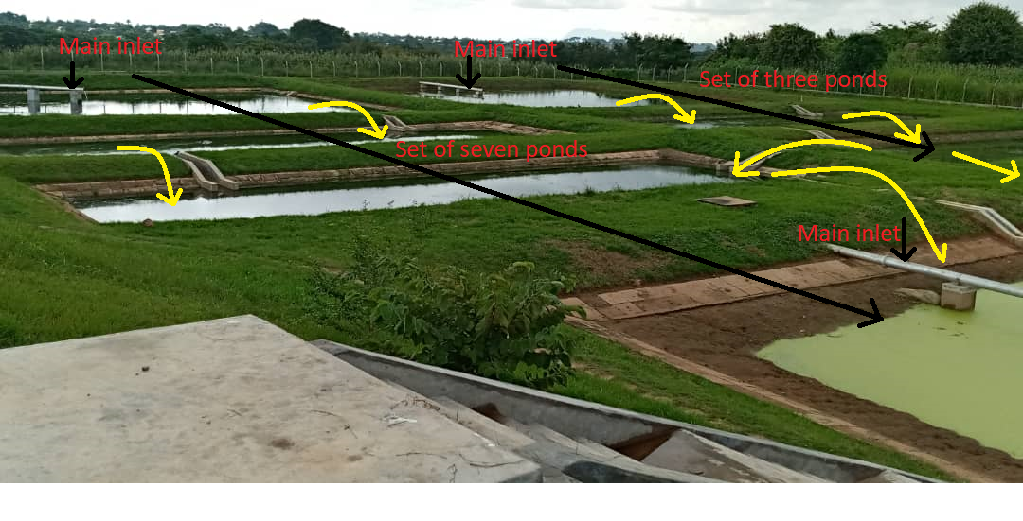
Figure 1: The first section of the sewage area at University of Malawi WWTW
Prior to algal inoculation, a baseline survey was conducted across sampling points SA1-SA3 and SC1 - SC3 to establish pre-treatment wastewater characteristics, including chemical oxygen demand (COD), turbidity, nitrates, phosphates, sulphates, electrical conductivity (EC), total dissolved solids (TDS), pH, and temperature. This baseline survey provided a benchmark for evaluating treatment efficiency.

3.2 Algal strain acquisition and laboratory culture

3.2.1 Source of algal strain
The microalgal species was obtained from the American Type Culture Collection (ATCC, Manassas, VA, USA): Chlorella vulgaris (Beijerinck, ATCC:30821). The species was selected based on documented efficacy in nutrient removal from wastewater (Oberholster et al., 2019; Hasan et al., 2014).

3.2.2 Initial culture preparation
All culture procedures followed ATCC protocols (Starr, 1964; Coder & Starr, 1978). A 0.1 mL aliquot of the stock culture was aseptically transferred into 5 mL of sterile Sigma Algal Broth Medium (Sigma-Aldrich, Switzerland). The culture was maintained under static laboratory conditions at 20 °C with a light intensity of 100 μmol photons m⁻² s⁻¹ under a 12:12 hour light:dark photoperiod.
To verify mono-specificity, each culture was examined using a compound microscope at ×1250 magnification (Figure 2). This procedure was repeated three times, confirming the absence of contaminating microorganisms.
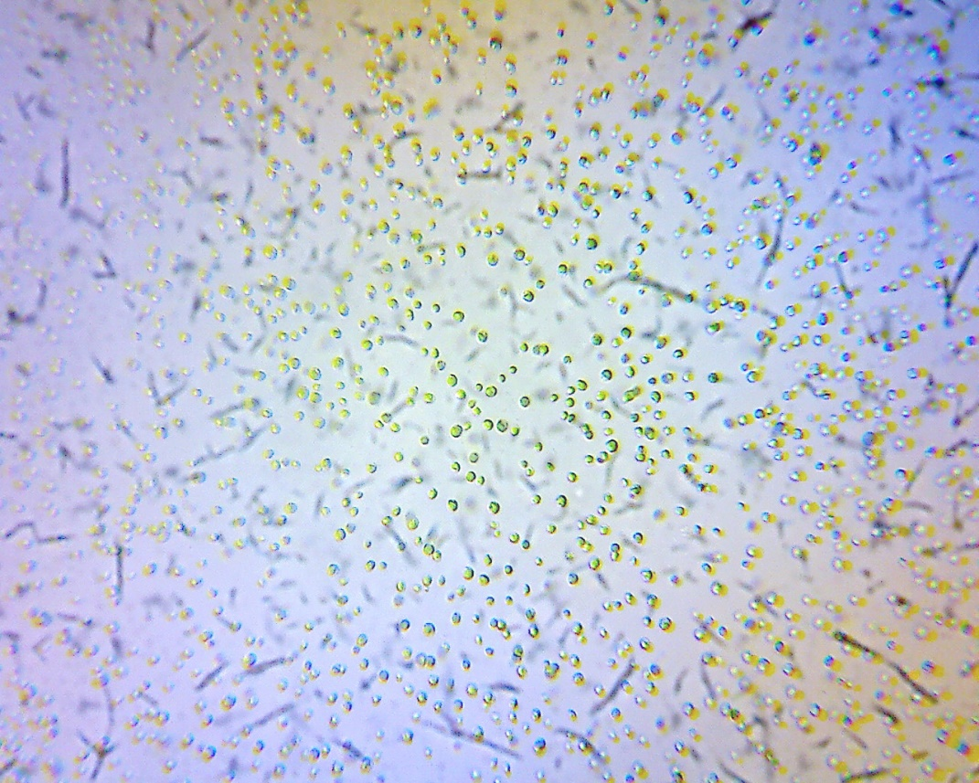
Figure 2: Chlorella vulgaris culture under ×1250 magnification

3.2.3 Long-term maintenance and scale-up
Long-term monocultures were maintained by routine serial sub-culturing over three months. The species was cultivated for 14 days in liquid algal broth (Sigma-Aldrich, Germany) before sub-culturing. A staged scale-up approach was used for mass culture:
- Stage 1: 250 mL flask (starting density ±10,000 cells mL⁻¹)
- Stage 2: 25 L glass tanks
- Stage 3: 5,000 L algae bioreactors (see Section 3.3)
Refer to Figure 3 for the 25 L glass tanks used in the culturing of the species.
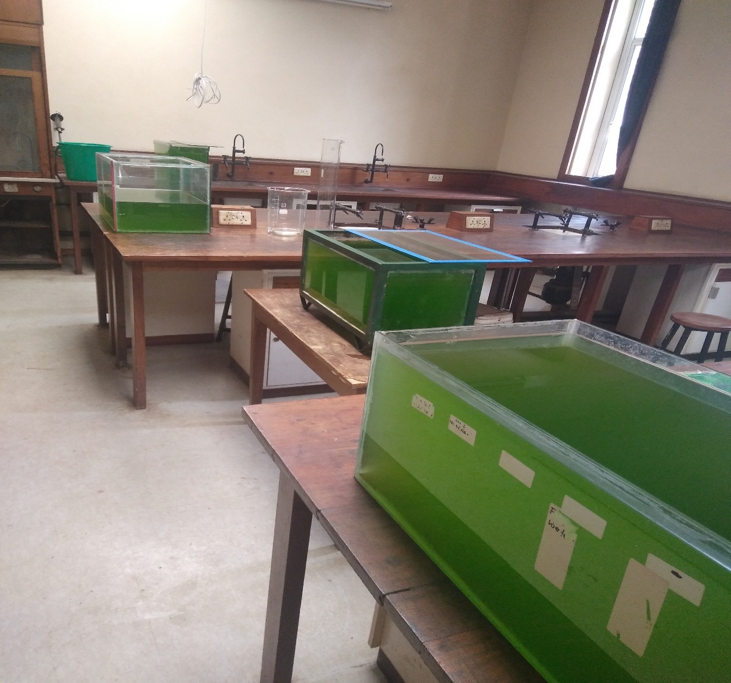
Figure 3: Culturing of the Chlorella Vulgaris in 25 L glass tanks

3.3 Construction of algae bioreactors and mass culturing
Three semi-transparent photobioreactor tanks, each with a capacity of 5,000 L (diameter 1,800 mm; height 2,040 mm), were installed at the University of Malawi WWTW (Figure 4).
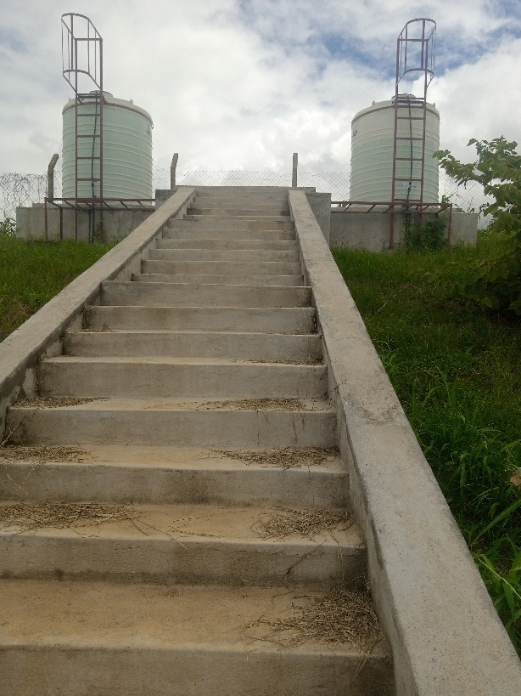
Figure 4: The 5,000 L capacity photobioreactor tanks at University of Malawi WWTW
For each tank, 25 L of the algal culture was added to 1,000 L of dechlorinated tap water supplemented with 20 g of synthetic fertiliser (10:20:10 N:P:K). The culture was then up-scaled to a final volume of 5,000 L per tank. Algal dry weight was monitored during three growth phases: lag phase (average dry weight), exponential phase (average dry weight), and stationary phase (average dry weight). Allowances for growth limitations were recorded.

3.4 Algal mass inoculation into ponds
Based on pond classification (see Section 3.5), one facultative pond (SC1) and two maturation ponds (SC2 and SC3) were selected for algal inoculation. Each pond received 7,500 L of the algal consortium at a target density of approximately 1.2 × 10⁶ cells mL⁻¹. Inoculation was repeated every three to four weeks, depending on algal growth in the photobioreactors. Since the pond system operates by natural overflow, inoculated algae were assumed to disperse from SC1 to SC2 and then to SC3 via hydraulic flow (Figure 1).

3.5 Pond classification and selection for algae identification
Waste stabilisation ponds at University of Malawi were classified according to standard WSP typology (Mara, 2013):
- Aerobic ponds (SA1, SA2): Shallow ponds with dissolved oxygen throughout.
- Facultative ponds (SA3, SC1): Upper aerobic zone, lower anaerobic zone; primary sites for BOD removal and algal photosynthesis.
- Maturation ponds (SC2, SC3): Tertiary treatment ponds with higher oxygen levels, greater algal diversity, and active nutrient uptake (phosphates, nitrogen compounds) while supplying oxygen for heterotrophic bacteria.
For algal identification, facultative pond SC1 and maturation ponds SC2 and SC3 were selected as sampling sites.

3.6 Field sampling of algae from ponds

3.6.1 Timing and equipment
Algae were sampled between 11:00 and 13:00 hours, corresponding to peak sunlight intensity, to ensure optimal photosynthetic activity. Sampling targeted the littoral zone at a depth of 3 cm, where maximum light penetration occurs (Figure 5).
Equipment used:
- Gum boots and gloves
- 50 mL plastic tubes with screw caps
- Toothbrush (for benthic algae)
- 70% ethanol (preservative)
- Marking pen

3.6.2 Sampling procedure
The following steps were performed (APHA, 2017):
- Labelling: Each tube was marked with the date and pond identification number.
- Benthic algae collection: Algae attached to rocks and cobbles were brushed off using a toothbrush approximately 100 m from the maturation pond outflow and a 50 mL plastic tube was used to collect it (Figure 6).
- Suspended algae collection: Another 50 mL plastic tube was placed 3 cm below the water surface at the outlet and filled with pond water containing suspended algae (Figure 7).
- Preservation: Samples were reduced to 40 mL, and 10 mL of 70% ethanol was added for preservation.
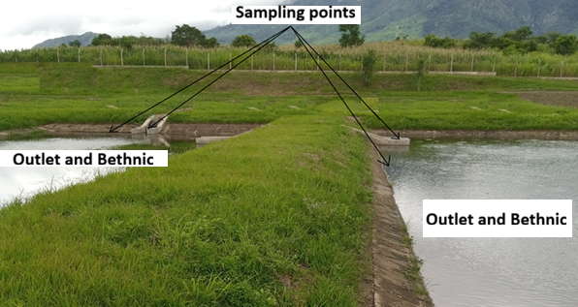
Figure 4: Sampling points for algae identification (SC1, SC2, SC3).
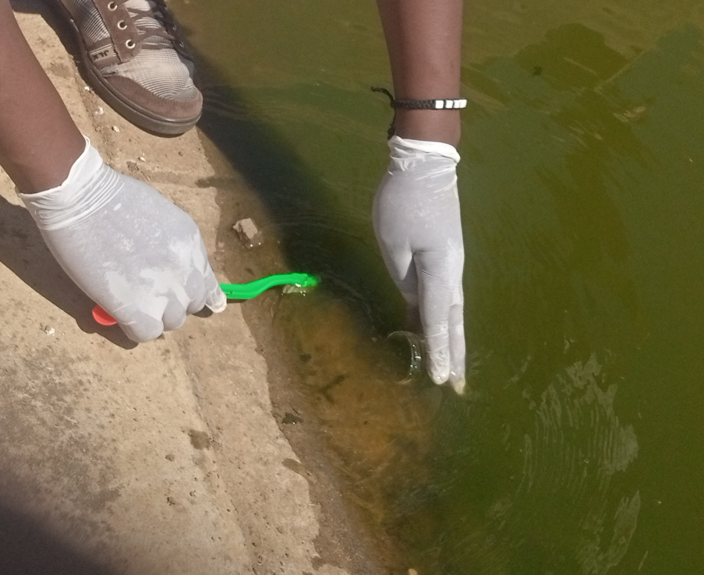
Figure 5: Collection of benthic algae 100 m from outlet
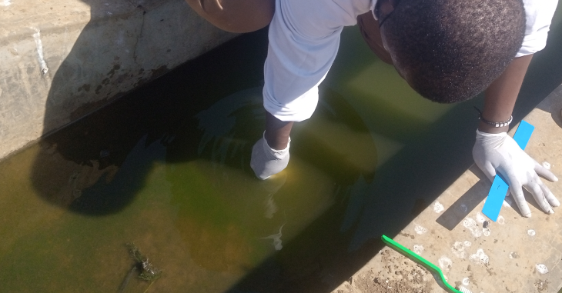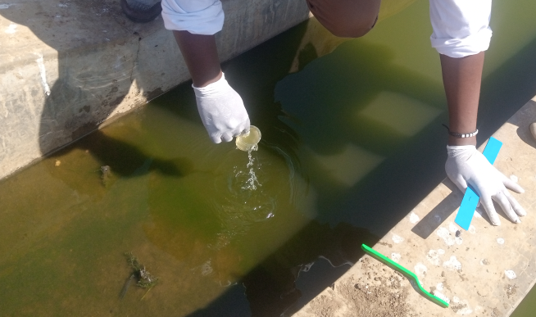
Figure 6: Collection of suspended algae (outlet)

3.6.3 Microscopic identification and imaging of algae
A drop of preserved sample was placed on a microscope slide, covered with a coverslip, and observed under 40× to 400× magnification using a compound microscope equipped with a digital camera connected to a computer (Figure 7). Algal morphology was compared with reference descriptions from Haughey (1968) to confirm species identity.
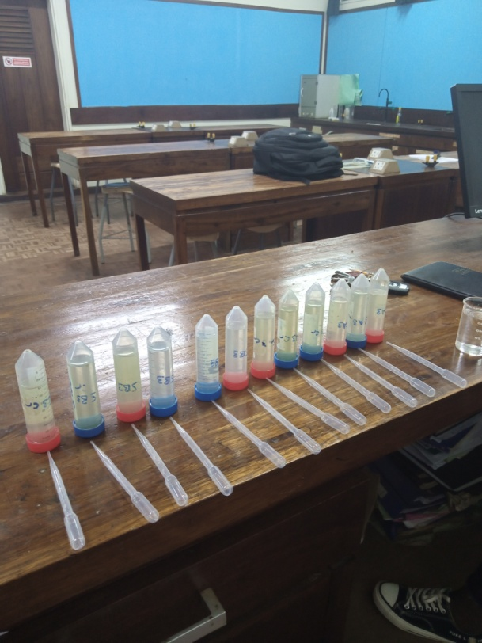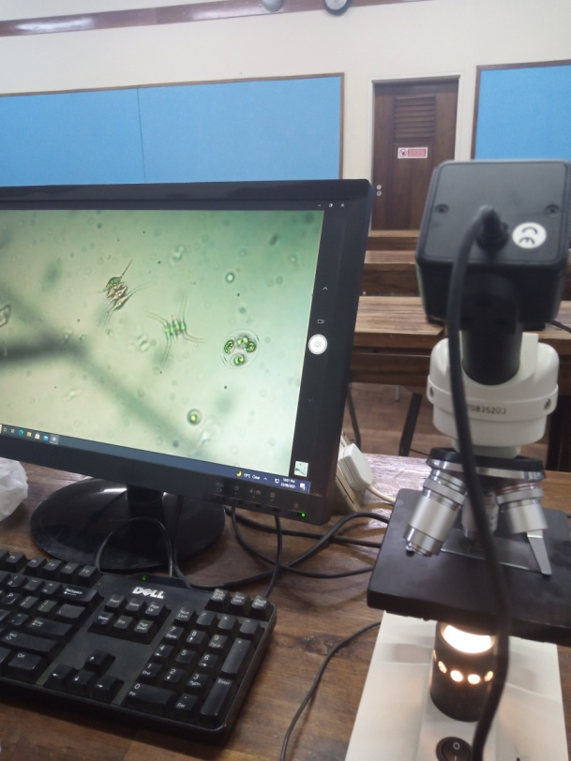
(a) (b)
Figure 7: Preserved samples of algae (a) and microscopic observation of algae (b)

3.7 Water sample collection and pre-treatment

3.7.1 Filtration for nutrient uptake analysis
Water samples collected before and after algal treatment were filtered through 0.22 μm pore size Whatman GF/F filters to separate algal biomass from analyte water. Both filtered and unfiltered samples were analysed for total nitrogen (TN) and total phosphorus (TP) to determine nutrient uptake by algae.

3.7.2 Physicochemical parameters measured in situ
Temperature (°C), Total dissolved solids, and Turbidity (NTU) were measured in situ in the water column using a Hach HQ40d multiparameter meter (Hach, USA). Surface water samples (top 3 cm) were collected using a grab sampler into 1 L BOD sampling bottles that had been pre-rinsed with dilute sulphuric acid (pH 2.0) for subsequent dissolved nutrient analysis. Samples were kept cool in dark containers during transport to the laboratory. All water analyses followed standard methods (APHA, 2017).

3.8 Baseline survey: Pre-inoculation wastewater characterisation
A baseline survey was conducted prior to any algal inoculation. Triplicate samples were collected from sampling points SA1-SA3 and SC1-SC3. The following parameters were measured to characterise untreated wastewater:
Parameter | Method of Analysis
Chlorides (Cl⁻) | Argentometric method (APHA, 2017)
Nitrates (NO₃⁻) | Ion-selective electrode method
Phosphates (PO₄³⁻) | Ascorbic acid spectrophotometric method
Sulphates (SO₄²⁻) | Turbidity method
Chemical Oxygen Demand (COD) | Open reflux method
pH | Microprocessor-controlled pH meter
Electrical Conductivity (EC) | EC meter
Total Dissolved Solids (TDS) | TDS meter
Turbidity | Turbidity meter

3.8.1 Sampling procedure for physicochemical analysis
Samples were collected in triplicate using thoroughly rinsed BOD sampling bottles via the grab sampling method (APHA, 2017). Bottles were triple-rinsed with distilled water before collection. For chlorides, nitrates, phosphates, sulphates, COD, EC, TDS, turbidity, and pH, samples were transported to University of Malawi chemistry laboratories in cooler boxes with ice to maintain temperatures below 2 °C. Samples were acidified with 2% sulphuric acid and refrigerated at 4 °C pending analysis.

3.9 Laboratory analytical methods

3.9.1 pH
pH was measured immediately after collection using a microprocessor-controlled Jenway 3310 pH meter (Jenway Ltd., Essex, England) calibrated with pH 7 and pH 10 buffer solutions. The electrode was rinsed with deionised water between samples to prevent cross-contamination (APHA, 2017).

3.9.2 Chemical oxygen demand (COD)
COD was determined using the open reflux method (APHA, 2017). Organic matter was oxidised by potassium dichromate (K₂Cr₂O₇) with silver sulphate (Ag₂SO₄) as a catalyst in concentrated sulphuric acid (H₂SO₄). The excess dichromate was titrated with ferrous ammonium sulphate (Fe(NH₄)₂(SO₄)₂). The dichromate consumed corresponds to the oxygen required for oxidation:
Cr₂O₇²⁻(aq) + 6Fe²⁺(aq) + 14H⁺(aq) → 6Fe³⁺(aq) + 2Cr³⁺(aq) + 7H₂O(l)

3.9.3 Electrical conductivity (ec) and total dissolved solids (tds)
EC and TDS were measured immediately after collection using a Jenway 3310 multiparameter meter. The electrode was rinsed with deionised water between samples (APHA, 2017).

3.9.4 Sulphates (SO₄²⁻)
Sulphates were analysed using the turbidity method (APHA, 2017). Sulphate ions were precipitated as barium sulphate (BaSO₄) in a hydrochloric acid medium. The absorbance of the suspension was measured at 420 nm using a Jenway UV/VIS spectrophotometer (Jenway Ltd., Essex, England). Concentrations were determined from a standard curve (range: 1 - 40 mg/L SO₄²⁻); samples above this range were diluted.

3.9.5 Turbidity
Turbidity was measured immediately after collection using a Jenway 3310 turbidity meter. The cuvette was rinsed with deionised water before each measurement (APHA, 2017).

3.9.6 Nitrates (NO₃⁻)
Nitrate concentrations were determined using an ion-selective electrode (Elit 8021) with a reference electrode (Elite 003N, NICO, USA) connected to a pH Seven Multimeter ion analyser (Mettler Toledo, Switzerland). The instrument was calibrated with standards of 0.0, 0.2, 1.0, 1.5, 2.0, and 2.5 mg/L prepared from a 1000 mg/L stock solution. Ionic strength adjustment buffer (2M) was added at 2% per volume of sample (APHA, 2017).

3.9.7 Chlorides (Cl⁻)
Chlorides were determined by the argentometric method (APHA, 2017). Concentration was calculated as:
Cl-(mg/L) = ((A – B) x N x 35,450) / mL Sample

Where:
A = Volume of AgNO₃ titrant used for wastewater sample (mL)
B = Volume of AgNO₃ titrant used for blank (distilled water) (mL)
N = Normality of the AgNO₃ titrant, which is
35,450 = Equivalent weight of Cl⁻ (35.45) multiplied by 1000 to convert to mg/L

3.9.8 Phosphates (PO₄³⁻)
Phosphate was analysed using the vanadomolybdophosphoric colorimetric method (APHA, 2017). Absorbance was measured at 470 nm using a Jenway UV/VIS spectrophotometer. Standards ranging from 0.1 to 0.5 mg/L were used for calibration.

3.10 Quality assurance and quality control (QA/QC)
All glassware were soaked in 10% H₂SO₄ for 24 hours, rinsed with deionised water, and oven-dried before use. Analytical grade reagents were used throughout. Each sample was analysed in triplicate, and results were reported as mean ± standard deviation. Calibration curves for nutrients parameters were prepared periodically as was sampling and analysis with correlation coefficient R₂ ≥ 0.995. Blank samples and standard check solutions were analysed every 10 samples to verify instrument performance. For field parameters (pH, Turbidity, and temperature), meters were calibrated before each sampling event.

3.11 Statistical analysis

3.12 Ethical and environmental considerations
No human or animal subjects were directly involved. Wastewater samples were handled with appropriate personal protective equipment (gloves, goggles, lab coats). All contaminated materials and residual wastewater were autoclaved before disposal according to University of Malawi bio-safety protocols. Algal biomass at the end of the experiment was harvested and considered for potential biofertiliser use, consistent with sustainability principles (Acien et al., 2016).

CHAPTER 4:

RESULTS AND DISCUSSION

4.1 Introduction
This chapter presents the results of the phytoremediation study conducted at University of Malawi Wastewater Treatment Works (WWTW) using Chlorella vulgaris. The chapter is organised into four sections. First, baseline (pre-inoculation) water quality parameters across six phases (February 2021 to December 2022) are presented to characterise untreated sewage. Second, the diversity of indigenous algae species found in facultative and maturation ponds before inoculation is described. Third, post-inoculation results for all physicochemical parameters are reported. Finally, a thorough discussion interprets these findings in the context of existing literature, highlighting the efficacy of Chlorella spp. for sewage phytoremediation.

4.2 Baseline (pre-inoculation) water quality
Prior to algal inoculation, a baseline survey was conducted across six phases (P1: February 2021; P2: June 2021; P3: December 2021; P4: February 2022; P5: June 2022; P6: December 2022) at sampling points SA1 - SA3 (2 aerobic ponds and 1 facultative pond) and SC1 - SC3 (1 facultative pond and 2 maturation ponds). All analyses followed standard methods (American Public Health Association [APHA], 2017). The baseline data established benchmark pollutant levels against which post-inoculation treatment efficacy was evaluated.
TABLE OF RESULTS

4.3 Indigenous algae species identified before inoculation
Before inoculation with Chlorella vulgaris, algae samples were collected from the outlet and benthic (100 m from outlet) of SC1, SC2, and SC3. Microscopic identification was performed using reference descriptions (Haughey, 1968).
The results were as follows:
Common algae species in SC1 (facultative pond):
showed that Scenedesmus quadricauda (Turp) de Breb, Scenedesmus opoliensis Richt (typical coenobia), Euglena spp., Scenedesmus dimorphus (Turp) Kuetz (four-celled colony), Cyclotella meneghiniana Kuetz (valve view), Sorastrum spinulosum Naeg (linear colony), Trachelomonas spp., and Sphaerocystis spp.
Common algae species in SC2 (first maturation pond):
Euglena spp., Cyclotella meneghiniana Kuetz, Scenedesmus opoliensis Richt (forma Richter) Scenedesmus quadricauda (Turp) de Breb., Microcystis aeruginosa Kuetz, Dictyosphaerium ehrenbergianum, Scenedesmus dimorphus (Turp) Kuetz, and Closterium cornu Ehr (dividing cell)
Common algae species in SC3 (second maturation pond):
Euglena spp., Monoraphidium spp., Closterium spp., Oocystis spp., Scenedesmus dimorphus (Turp) Kuetz, Scenedesmus quadricauda (Turp) de Breb, Chlorophycean green alga (unidentified), Scenedesmus opoliensis Richt (typical coenobia), Microcystis aeruginosa Kuetz, and Chlamydomonas spp.

The diversity of indigenous algae was comparable across SC1, SC2, and SC3, contrary to literature suggesting greater species richness in maturation ponds due to lower turbidity and higher light penetration (Mara, 2013; Haughey, 1968). The presence of Scenedesmus, Euglena, Cyclotella, and Microcystis indicates eutrophic, organically enriched conditions (Reynolds, 1984). Notably, no Chlorella species were detected before inoculation, confirming that the subsequent dominance of Chlorella vulgaris resulted from intentional augmentation rather than natural occurrence.

4.4 Post-inoculation results
Following inoculation with the Chlorella vulgaris (approximately 1.2 × 10⁶ cells mL⁻¹) and a 3 - 4 week treatment period, water quality parameters were re-measured in SC1, SC2, and SC3. Tables 11 - 13 summarise post-inoculation values alongside baseline (pre-inoculation) averages for comparison.

4.5 Discussion

4.5.1 Baseline pollution levels and justification for intervention
The baseline survey confirmed that sewage entering the University of Malawi WWTW exhibited severe organic and nutrient pollution. COD values (300 - 484 mg/L in SC1 - SC3) were characteristic of strong domestic sewage (Metcalf & Eddy, 2014). Nitrate concentrations (up to 89 mg/L) exceeded national and international discharge standards (WHO, 2017). Phosphate levels (2 - 10 mg/L) were well above the eutrophication threshold of 0.1 mg/L for freshwater systems (Correll, 1998). Elevated turbidity (33 - 99 NTU) and EC (100 - 638 µS/cm) further indicated high suspended solids and ionic strength.
These baseline conditions justified the need for an effective, low-cost treatment intervention. The existing WSP system, lacking aeration and algal augmentation, was clearly insufficient, as evidenced by the high pollutant loads persisting through SC3 (the final maturation pond before discharge into Likangala River).

4.5.2 Efficacy of Chlorella Vulgaris for pollutant removal
Post-inoculation results demonstrated substantial improvements in all water quality parameters. The most remarkable reduction was in COD: 89.7 - 98.0% removal across SC1 - SC3, with final values as low as 6.0 mg/L in SC2. These values are well below the Malawi Environmental Protection Authority (MEPA) and WHO effluent discharge guidelines (typically <75 mg/L). This finding aligns with Oberholster et al. (2019), who reported that Chlorella spp. significantly reduced COD in stabilisation ponds, although they noted that COD can sometimes increase due to algal biomass in unfiltered samples. In the present study, filtered samples were used for COD analysis, ensuring that reductions reflected true organic matter mineralisation rather than algal cell interference.
The high COD removal efficiency suggests that the Chlorella consortium enhanced both photosynthetic oxygen production and heterotrophic bacterial activity. Algal oxygen production relieved the BOD/COD load, while bacteria mineralised organic compounds (Hasan et al., 2014). This synergistic alga-bacteria relationship is well documented by De‐Bashan et al., 2002; Munoz & Guieysse, 2006.
Nitrate reduction ranged from 49.3% to 63.9%, and phosphate reduction from 33.3% to 44.7%. These values are consistent with Hasan et al. (2014), who reported 84% nitrate and 69% phosphate removal in swine wastewater using C. vulgaris, and with He et al. (2013), who found >44% nitrogen assimilation into algal biomass. The slightly lower removal rates in the present study may be due to the absence of mechanical aeration (the ponds relied solely on natural mixing and algal photosynthesis) or to seasonal variations in temperature and light (Converti et al., 2009).
Sulphate removal was modest (2.5 - 21.2%), and in SC3 a slight increase was observed. Sulphates are not readily taken up by Chlorella in the absence of sulphur limitation; moreover, sulphate can be released from the degradation of sulphur-containing organic compounds (Tchobanoglous et al., 2014). Thus, sulphate is not a primary target for algal phytoremediation.
Electrical conductivity and TDS decreased by 52.8 - 57.1% and 55.1 - 62.8%, respectively, indicating effective removal of dissolved ions through algal uptake and adsorption onto algal cell surfaces (Aisien et al., 2017). Turbidity reductions (18.6 - 46.8%) were moderate but meaningful, as lower turbidity enhances light penetration and promotes further photosynthetic activity (Mara, 2013).

4.5.3 Changes in pH and temperature
Post-inoculation pH values (7.30 - 7.85) were closer to neutrality than baseline pH (8.2–8.7). This shift is consistent with Aisien et al. (2017), who reported that algal photosynthesis consumes CO₂, initially raising pH, but prolonged nutrient uptake and algal respiration can stabilise pH towards neutrality. The slight pH reduction observed here may also result from the release of H⁺ ions during ammonium and nitrate uptake (Mahmood et al., 2005). The final pH values are within the acceptable range for effluent discharge (6.5 - 8.5; MEPA, 2020).
Temperature remained stable (25- 27 °C) throughout, well within the optimal growth range for Chlorella vulgaris (25 - 30 °C; Converti et al., 2009). This stability supports consistent algal metabolism and treatment performance.

4.5.4 Algal community shifts: from indigenous species to chlorella dominance
Before inoculation, the ponds contained a diverse assemblage of chlorophytes (e.g., Scenedesmus spp., Euglena, Chlamydomonas), diatoms (Cyclotella), and cyanobacteria (Microcystis). This composition is typical of nutrient-rich wastewater ponds (Haughey, 1968; Reynolds, 1984). No Chlorella species were detected prior to inoculation.
After inoculation and repeated re-inoculation every 3 - 4 weeks, Chlorella vulgaris became dominant (as confirmed by microscopic examination; data reflect treatment performance, not algal counts, but visual inspection (Figure 2) showed dense Chlorella populations). This shift demonstrates that regular inoculation can overcome competition from indigenous algae, even in open pond systems. Oberholster et al. (2019) similarly achieved Chlorella dominance through monthly inoculation, despite challenges such as temperature fluctuations and grazing by zooplankton.
The persistence of some indigenous species (e.g., Scenedesmus, Micractinium) alongside Chlorella suggests commensal or synergistic relationships rather than competitive exclusion. This coexistence may actually benefit treatment, as different algal species have complementary nutrient uptake profiles (Mahapatra et al., 2013).

4.5.5 Comparison with conventional and other algae-based treatment systems
The treatment efficiency achieved in this study compares favourably with conventional activated sludge systems, which typically achieve 85 - 90% BOD/COD removal but require high energy inputs (Nykova et al., 2002). In contrast, the Chlorella-augmented WSP system operated without electricity for aeration or mixing, aligning with sustainability goals (Acien et al., 2016).
Compared to other phytoremediation studies, the COD removal (89.7 - 98.0%) is higher than that reported by Aisien et al. (2017) for abattoir wastewater (72.3 - 94% for TSS, but COD ranged 92.1 - 95.8%). Nitrate removal (49 - 64%) is slightly lower than the 84% reported by Hasan et al. (2014) in aerated swine wastewater, reflecting the non-aerated nature of the present study. Nevertheless, the results confirm that Chlorella-based treatment is effective even without mechanical aeration, making it highly suitable for rural or off-grid settings (Oberholster et al., 2019).

4.5.6 Limitations and sources of variability
Several factors may have influenced the results. First, seasonal variability (wet vs. dry seasons) affected pollutant concentrations, as seen in baseline fluctuations. Rainfall dilutes sewage but also increases hydraulic loading, potentially reducing retention time. Second, the anomalous pH value of 2.0 recorded in SC1 during P6 was likely a measurement error (probe contamination or calibration failure) and was excluded from analysis. Third, the absence of mechanical mixing may have limited nutrient mass transfer to algal cells, explaining the moderate phosphate removal compared to aerated systems (Converti et al., 2009). Fourth, zooplankton grazing on Chlorella was not quantified but could have reduced algal density over time, necessitating the 3 - 4 week re-inoculation schedule.
Future studies should measure algal biomass (cell density, chlorophyll-*a*, dry weight) alongside water quality parameters to establish direct correlations between algal growth and pollutant removal. Additionally, harvesting the algal biomass for biofertiliser production should be evaluated (Acien et al., 2016; Coppens et al., 2016).

4.5.7 Environmental and practical implications
The results demonstrate that phytoremediation using Chlorella vulgaris is a viable, low-cost, and sustainable technology for treating sewage wastewater in stabilisation ponds. The treated effluent meets or approaches national discharge standards for COD, nitrates, phosphates, pH, and turbidity. Implementing this technology at University of Malawi WWTW would substantially reduce pollution of the Likangala River, protecting downstream aquatic ecosystems and human health.
Moreover, the harvested algal biomass can be valorised as biofertiliser, containing not only nitrogen and phosphorus but also phytohormones and growth promoters (Acien et al., 2016). This creates a circular economy model: wastewater nutrients are recovered as fertiliser for agriculture, reducing reliance on synthetic fertilisers.

4.6 Summary of findings
- Baseline sewage at University of Malawi WWTW exhibited severe organic and nutrient pollution (COD up to 500 mg/L; nitrates up to 89 mg/L; phosphates up to 10 mg/L).
- Indigenous algae included Scenedesmus, Euglena, Cyclotella, Microcystis, and others, but no Chlorella species.
- Inoculation with Chlorella vulgaris (1.2 × 10⁶ cells mL⁻¹, re-inoculated every 3 - 4 weeks) resulted in:
  - 89.7 - 98.0% COD reduction
  - 49.3 - 63.9% nitrate reduction
  - 33.3 - 44.7% phosphate reduction
  - 52.8 - 57.1% EC reduction
  - 55.1 - 62.8% TDS reduction
  - pH stabilisation towards neutrality (7.30 - 7.85)
- The technology is effective without electricity or mechanical aeration, making it suitable for resource-limited settings.
- Algal biomass harvesting could provide biofertiliser, enhancing sustainability.

CHAPTER 5:

CONCLUSION AND RECOMMENDATIONS

5.1 CONCLUSION
This study set out to evaluate whether nutrient treatment efficiencies in existing traditional waste stabilisation ponds could be optimised through the manipulation of the natural algal by mass inoculation of specific selected algal strain, Chlorella vulgaris. Based on the results obtained, the following conclusions are drawn:
1. Baseline pollution levels justify intervention
The baseline survey confirmed that sewage entering the University of Malawi WWTW exhibits severe organic and nutrient pollution. COD values (300 - 484 mg/L) were characteristic of strong domestic sewage, nitrate concentrations (up to 89 mg/L) exceeded WHO drinking water guidelines, and phosphate levels (2 - 10 mg/L) were also above eutrophication thresholds. The existing waste stabilisation pond system, lacking aeration and algal augmentation, is insufficient for producing effluent that meets national discharge standards. This finding confirms the urgent need for a low-cost, sustainable treatment intervention.
2. Mass inoculation significantly improves treatment efficiency
The first research hypothesis is accepted. Mass inoculation of Chlorella vulgaris significantly improved nutrient removal efficiency compared to natural algal consortia. Post-inoculation results demonstrated COD reduction of 89.7 - 98.0%, nitrate reduction of 49.3 - 63.9%, and phosphate reduction of 33.3 - 44.7%. These reductions were achieved without electricity for aeration or mechanical mixing, relying solely on natural sunlight and algal photosynthesis. The treatment efficiency achieved is comparable to, and in some parameters better than, conventional activated sludge systems, but at a fraction of the cost and energy input.
3. Inoculated chlorella strain survives and becomes dominant
The second research hypothesis is also accepted. The inoculated Chlorella species successfully survived the variations in environmental conditions within the pond system (temperature 25 - 27 °C, pH 7.3 - 8.7) and became dominant over indigenous algae through repeated re-inoculation every three to four weeks. Prior to inoculation, no Chlorella species were detected among indigenous algae, which included Scenedesmus, Euglena, Cyclotella, and Microcystis. Post-inoculation dominance of Chlorella confirms that regular inoculation can overcome competition from native species in open pond systems.
4. Water quality parameters show consistent improvement
All evaluated physicochemical parameters showed improvement following algal inoculation. Turbidity decreased by 18.6 - 46.8%, enhancing light penetration for further photosynthetic activity. EC and TDS decreased by 52.8 - 57.1% and 55.1 - 62.8%, respectively, indicating effective removal of dissolved ions through algal uptake and adsorption. pH values shifted from slightly alkaline (8.2 - 8.7) towards neutrality (7.30 - 7.85), meeting effluent discharge standards (6.5 - 8.5). Temperature remained stable within the optimal growth range for Chlorella species throughout the study.
5. Sulphate and chloride removal is limited
Sulphate removal was modest (2.5 - 21.2%), and in SC3 a slight increase was observed. Sulphates are not readily taken up by Chlorella in the absence of sulphur limitation and may be released from the degradation of sulphur-containing organic compounds. Chloride concentrations showed variable responses, with some ponds exhibiting increases post-inoculation. These parameters are not primary targets for algal phytoremediation and may require additional treatment if stringent discharge limits apply.
6. The technology is suitable for resource-limited settings
The Chlorella-augmented waste stabilisation pond system operated successfully without electricity for aeration or mixing, making it highly suitable for rural or off-grid settings in Malawi and other SADC countries. The technology utilises existing infrastructure, requires minimal capital investment, and can be maintained by local personnel with basic training. This addresses the economic constraints that have historically hindered wastewater treatment in developing countries.
7. Algal biomass offers a circular economy opportunity
Although not experimentally tested in this study, the harvested algal biomass has potential for valorisation as biofertiliser. Literature evidence (Acien et al., 2016; Coppens et al., 2016) indicates that microalgal fertiliser contains nitrogen, phosphorus, phytohormones, and growth promoters. Revenue generated from biofertiliser sales could be reinvested into system maintenance, creating a self-sustaining treatment model.

5.2 RECOMMENDATIONS
Based on the findings and conclusions of this study, the following recommendations are made for policy makers, wastewater treatment plant operators, researchers, and other stakeholders:

Recommendations for Policy Makers
1. Adopt algae-based phytoremediation as a national strategy
The Malawi Environmental Protection Authority (MEPA) and the Ministry of Water and Sanitation should consider incorporating algae-augmented waste stabilisation ponds into national wastewater treatment guidelines, particularly for rural and peri-urban areas where conventional treatment plants are not feasible.
2. Establish regulatory standards for algae-treated effluent
Current discharge standards do not specifically address effluent from algae-based systems. Regulatory bodies should develop standards that recognise the unique characteristics of algae-treated wastewater, including acceptable levels of algal biomass in receiving waters.
3. Provide incentives for biofertiliser production
Government should create incentives (tax breaks, subsidies, or technical assistance) for wastewater treatment facilities that harvest algal biomass for biofertiliser production, promoting the circular economy and reducing reliance on synthetic fertilisers.

Recommendations for Wastewater Treatment Plant Operators
4. Implement monthly inoculation protocols
Facilities operating waste stabilisation ponds should adopt monthly inoculation with selected Chlorella strains (approximately 1.2 × 10⁶ cells mL⁻¹) to maintain dominance over indigenous algae and optimise nutrient removal. Inoculation schedules may be adjusted seasonally based on temperature and light conditions.
5. Establish small-scale photobioreactors for on-site algal cultivation
Treatment plants should install low-cost photobioreactors (similar to the 5,000 L tanks used in this study) for on-site mass cultivation of Chlorella strains. This reduces dependency on external suppliers and ensures a continuous supply of inoculum.
6. Monitor key parameters regularly
Operators should routinely monitor COD, nitrates, phosphates, pH, turbidity, EC, and TDS to track treatment performance and identify when re-inoculation is needed. Simple field kits are available for most parameters and can be used by personnel with basic training.
7. Harvest algal biomass periodically
Algal biomass should be harvested every three to four weeks (coinciding with re-inoculation) to prevent excessive accumulation that could increase COD in unfiltered effluent. Harvested biomass should be dried and evaluated for biofertiliser quality.

Recommendations for Future Research
8. Conduct long-term monitoring studies
Future research should monitor treated effluent quality over multiple years to assess the sustainability of Chlorella dominance, seasonal variability in treatment efficiency, and potential adaptation or decline of inoculated strains.
9. Quantify algal biomass and establish growth-pollutant removal correlations
Subsequent studies should measure algal biomass parameters (cell density, chlorophyll-*a*, dry weight) alongside water quality parameters to establish direct quantitative correlations between algal growth rates and pollutant removal efficiencies.
10. Evaluate biofertiliser potential experimentally
The harvested algal biomass should be subjected to agronomic trials to determine its fertiliser value (nitrogen and phosphorus content, release rates, effects on crop yield and soil health) and to assess any risks (heavy metal accumulation, pathogen content).
11. Investigate heavy metal and pathogen removal
This study did not address heavy metals (lead, cadmium, mercury, chromium) or pathogen indicators (coliforms, E. coli). Future research should evaluate the efficacy of Chlorella spp. for removing these contaminants from sewage wastewater.
12. Optimise inoculation density and frequency
Experimental studies should determine the optimal initial cell density and re-inoculation frequency for different seasons and wastewater strengths. A range of densities (e.g., 0.5 × 10⁶ to 5 × 10⁶ cells mL⁻¹) and frequencies (weekly, biweekly, monthly) should be tested.
13. Assess zooplankton grazing effects
Zooplankton grazing on Chlorella can reduce treatment efficacy. Future studies should quantify grazer populations and investigate control measures, such as introducing zooplanktivorous fish or adjusting inoculation timing.
14. Study feasibility of co-treatment with other waste types
Research should explore whether Chlorella-augmented ponds can co-treat sewage with agricultural runoff, abattoir wastewater, or industrial effluents without loss of performance.

Recommendations for University of Malawi and Local Community
15. Upgrade the existing wwtw with algal inoculation
University of Malawi should immediately implement monthly inoculation of SC1, SC2, and SC3 with Chlorella vulgaris using the existing photobioreactors. This low-cost intervention will substantially improve effluent quality before discharge into the Likangala River.
16. Establish a biofertiliser pilot project
The college, in partnership with the Department of Agriculture, should establish a pilot project to produce biofertiliser from harvested algal biomass. The fertiliser could be used on college farms or sold to local farmers, generating revenue for system maintenance.
17. Develop training and outreach programmes
University of Malawi should develop short training courses for wastewater treatment plant operators, environmental officers, and students on algae-based phytoremediation technologies. Outreach programmes should engage downstream communities on water quality and health.
18. Conduct environmental education for downstream users
Communities that rely on the Likangala River should be educated about the risks of untreated or partially treated sewage and the benefits of improved treatment. This will build support for the technology and encourage behavioural changes that reduce pollution at source.

APPENDIX

REFERENCES
- Abiyu, A., Yan, D., Girma, A., Song, X., & Wang, H. (2018). Wastewater treatment plant efficiency and its impact on downstream water quality. Journal of Environmental Management, *206*, 1123–1132.
- Acien, F. G., Gomez-Serrano, C., Morales-Amaral, M. M., Fernandez-Sevilla, J. M., & Molina-Grima, E. (2016). Wastewater treatment using microalgae: How realistic a contribution might it be to significant sustainability? Journal of Applied Phycology, *28*(1), 1–15.
- Aisien, E. T., Aisien, F. A., & Gabriel, O. I. (2017). Improved quality of abattoir wastewater through phytoremediation. Water and Environment Journal, *31*(3), 382–390.
- Bello, Y. R., Lasisi, K. H., & Adigun, R. O. (2017). Challenges of wastewater treatment in developing countries. Journal of Environmental Science and Technology, *10*(4), 176–185.
- Bhatnagar, A., Sillanpää, M., & Witek-Krowiak, A. (2015). Agricultural waste peels as versatile biosorbents for heavy metal removal. Chemical Engineering Journal, *270*, 244–271.
- Coppens, J., Grunert, O., Van Den Hende, S., Vanhoutte, I., Boon, N., Haesaert, G., & De Gelder, L. (2016). The use of microalgae for the production of biofertilisers. Algal Research, *14*, 1–7.
- Correll, D. L. (1998). The role of phosphorus in the eutrophication of receiving waters: A review. Journal of Environmental Quality, *27*(2), 261–266.
- De‐Bashan, L. E., Moreno, M., Hernandez, J. P., & Bashan, Y. (2002). Removal of ammonium and phosphorus ions from synthetic wastewater by the microalgae Chlorella vulgaris coimmobilized in alginate beads with the microalgae growth‐promoting bacterium Azospirillum brasilense. Water Research, *36*(12), 2941–2948.
- De La Noue, J., Laliberte, G., & Proulx, D. (1992). Algae and waste water. Journal of Applied Phycology, *4*(3), 247–254.
- Dipu, S., Kumar, A., & Thakur, P. K. (2011). Phytoremediation of domestic wastewater using aquatic plants. Journal of Environmental Biology, *32*(4), 439–444.
- Dominic, V. J., Soumya, K. V., & Nisha, M. C. (2009). Bioremediation of wastewater using Chlorella vulgaris. Journal of Environmental Science & Engineering, *51*(4), 263–268.
- El-Kassas, H. Y., & Sallam, M. A. (2014). Bioremediation of textile wastewater using Chlorella vulgaris. International Journal of Environmental Science and Technology, *11*(5), 1237–1246.
- Geremew, A. (2017). Domestic water use and its implications for water quality. Water Practice & Technology, *12*(3), 612–624.
- Han, X., Zhang, Y., & Yan, H. (2000). Role of algae in natural water purification. Journal of Environmental Sciences, *12*(2), 156–161.
- Hasan, M. R., Zhang, A. Y., Wang, Z. L., & Shahbazi, A. (2014). Bioremediation of swine wastewater using Chlorella vulgaris. International Journal of Environmental Science and Technology, *11*(2), 431–438.
- He, P. J., Mao, B., Lu, F., Shao, L. M., & Lee, D. J. (2013). The combined effect of bacteria and Chlorella vulgaris on the treatment of municipal wastewater. Bioresource Technology, *146*, 562–568.
- Kaonga, C. C., Chiotha, S. S., Monjerezi, M., Thole, B., & Saka, J. D. K. (2011). Water quality and health implications in Malawi. Malawi Journal of Science and Technology, *10*(1), 1–15.
- Maliro, M. F. (2016). Wastewater management in Malawi: Challenges and opportunities. Journal of Water Management, *8*(2), 45–58.
- Mara, D. (2013). Domestic wastewater treatment in developing countries. Routledge.
- Munoz, R., & Guieysse, B. (2006). Algal–bacterial processes for the treatment of hazardous contaminants: A review. Water Research, *40*(15), 2799–2815.
- Nykova, N., Müller, L., & Döhler, H. (2002). Anaerobic treatment of domestic wastewater. Water Science and Technology, *46*(4-5), 207–212.
- Oberholster, P. J., Cloete, T. E., van Ginkel, C. J., & Botha, A.-M. (2013). Eutrophication dynamics in a South African river system. Water SA, *39*(3), 411–418.
- Oberholster, P. J., Steyn, M., & Botha, A.-M. (2017). Nutrient enrichment and eutrophication in SADC water bodies. Physics and Chemistry of the Earth, *100*, 112–120.
- Oberholster, P. J., Steyn, M., & Botha, A.-M. (2019). The potential of Chlorella vulgarisfor wastewater treatment in stabilisation ponds. Physics and Chemistry of the Earth, *112*, 112–120.
- Olguin, E. J. (2003). Phycoremediation: Key issues for cost‐effective nutrient removal processes. Biotechnology Advances, *22*(1-2), 81–91.
- Queiroz, M. I., Lopes, E. J., Zepka, L. Q., Bastos, R. G., & Goldbeck, R. (2007). The kinetics of the removal of nitrogen and phosphorus from synthetic wastewater by Chlorella vulgaris. Journal of Biotechnology, *131*(2), S151–S152.
- Rai, P. K. (2009). Heavy metal phytoremediation from aquatic ecosystems with special reference to macrophytes. Critical Reviews in Environmental Science and Technology, *39*(9), 697–753.
- Shannon, M. A., Bohn, P. W., Elimelech, M., Georgiadis, J. G., Marinas, B. J., & Mayes, A. M. (2008). Science and technology for water purification in the coming decades. Nature, *452*(7185), 301–310.
- Shemeera, N. (2018). Industrialization and water pollution: A global perspective. Environmental Pollution, *242*, 1456–1464.
- Smith, V. H., & Schindler, D. W. (2009). Eutrophication science: Where do we go from here? Trends in Ecology & Evolution, *24*(4), 201–207.
- Tam, N. F. Y., & Wong, Y. S. (1989). Wastewater nutrient removal by Chlorella vulgaris. Environmental Pollution, *58*(1), 19–34.
- Tchobanoglous, G., Stensel, H. D., Tsuchihashi, R., & Burton, F. (2014). Wastewater engineering: Treatment and resource recovery (5th ed.). McGraw-Hill.
- UNICEF/WHO. (2012). Progress on drinking water and sanitation: 2012 update. United Nations Children’s Fund and World Health Organization.
- Vunain, E., & Biswick, T. (2018). Environmental impacts of poorly managed wastewater in Malawi. Journal of Environmental Protection, *9*(5), 543–558.
- Vunain, E., Keneth, D., & Biswick, T. (2017). Challenges and opportunities for wastewater treatment in Malawi. Malawi Journal of Science and Technology, *12*(2), 34–48.
- Wang, L., Min, M., Li, Y., Chen, P., Chen, Y., Liu, Y., … Ruan, R. (2010). Cultivation of green algae Chlorella sp. in different wastewaters from municipal wastewater treatment plant. Applied Biochemistry and Biotechnology, *162*(4), 1174–1186.
- World Health Organization. (2012). Global estimates of waterborne disease mortality. WHO Press.
- Acien, F. G., Gomez-Serrano, C., Morales-Amaral, M. M., Fernandez-Sevilla, J. M., & Molina-Grima, E. (2016). Wastewater treatment using microalgae: How realistic a contribution might it be to significant sustainability? Journal of Applied Phycology, *28*(1), 1–15.
- Aisien, E. T., Aisien, F. A., & Gabriel, O. I. (2017). Improved quality of abattoir wastewater through phytoremediation. Water and Environment Journal, *31*(3), 382–390.
- American Public Health Association. (2017). Standard methods for the examination of water and wastewater (23rd ed.). American Public Health Association.
- Camargo, J. A., & Alonso, Á. (2006). Ecological and toxicological effects of inorganic nitrogen pollution in aquatic ecosystems: A global assessment. Environment International, *32*(6), 831–849.
- Converti, A., Casazza, A. A., Ortiz, E. Y., Perego, P., & Del Borghi, M. (2009). Effect of temperature and nitrogen concentration on the growth and lipid content of Nannochloropsis oculata and Chlorella vulgaris for biodiesel production. Chemical Engineering and Processing, *48*(6), 1146–1151.
- Coppens, J., Grunert, O., Van Den Hende, S., Vanhoutte, I., Boon, N., Haesaert, G., & De Gelder, L. (2016). The use of microalgae for the production of biofertilisers. Algal Research, *14*, 1–7.
- Correll, D. L. (1998). The role of phosphorus in the eutrophication of receiving waters: A review. Journal of Environmental Quality, *27*(2), 261–266.
- De‐Bashan, L. E., Moreno, M., Hernandez, J. P., & Bashan, Y. (2002). Removal of ammonium and phosphorus ions from synthetic wastewater by the microalgae Chlorella vulgaris coimmobilized in alginate beads with the microalgae growth‐promoting bacterium Azospirillum brasilense. Water Research, *36*(12), 2941–2948.
- Hasan, M. R., Zhang, A. Y., Wang, Z. L., & Shahbazi, A. (2014). Bioremediation of swine wastewater using Chlorella vulgaris. International Journal of Environmental Science and Technology, *11*(2), 431–438.
- Haughey, A. (1968). The planktonic algae of Auckland sewage treatment ponds. New Zealand Journal of Marine and Freshwater Research, *2*(4), 721–766.
- He, P. J., Mao, B., Lu, F., Shao, L. M., & Lee, D. J. (2013). The combined effect of bacteria and Chlorella vulgaris on the treatment of municipal wastewater. Bioresource Technology, *146*, 562–568.
- Mahapatra, D. M., Chanakya, H. N., & Ramachandra, T. V. (2013). Treatment efficacy of algae‐based sewage treatment plants. Environmental Monitoring and Assessment, *185*(9), 7145–7164.
- Mahmood, Q., Zheng, P., Islam, E., Hayat, Y., Hassan, M. J., Jilani, G., & Jin, R. C. (2005). pH and redox potential changes in wastewater during microalgae growth. Pakistan Journal of Biological Sciences, *8*(7), 999–1003.
- Mara, D. (2013). Domestic wastewater treatment in developing countries. Routledge.
- Metcalf & Eddy, Inc. (2014). Wastewater engineering: Treatment and resource recovery (5th ed.). McGraw-Hill.
- Munoz, R., & Guieysse, B. (2006). Algal–bacterial processes for the treatment of hazardous contaminants: A review. Water Research, *40*(15), 2799–2815.
- Nykova, N., Müller, L., & Döhler, H. (2002). Anaerobic treatment of domestic wastewater. Water Science and Technology, *46*(4-5), 207–212.
- Oberholster, P. J., Steyn, M., & Botha, A.-M. (2019). The potential of Chlorella vulgarisfor wastewater treatment in stabilisation ponds. Physics and Chemistry of the Earth, *112*, 112–120.
- Reynolds, C. S. (1984). The ecology of freshwater phytoplankton. Cambridge University Press.
- Shi, X. M., & Shi, X. M. (2006). Biodiesel production from Chlorella protothecoides by heterotrophic cultivation. Biotechnology and Bioengineering, *95*(5), 835–842.
- Tchobanoglous, G., Stensel, H. D., Tsuchihashi, R., & Burton, F. (2014). Wastewater engineering: Treatment and resource recovery (5th ed.). McGraw-Hill.
- World Health Organization. (2017). Guidelines for drinking-water quality (4th ed., incorporating 1st addendum). WHO Press.

- Acien, F. G., Gomez-Serrano, C., Morales-Amaral, M. M., Fernandez-Sevilla, J. M., & Molina-Grima, E. (2016). Wastewater treatment using microalgae: How realistic a contribution might it be to significant sustainability? Journal of Applied Phycology, *28*(1), 1–15.
- American Public Health Association. (2017). Standard methods for the examination of water and wastewater (23rd ed.). American Public Health Association.
- Coder, D. M., & Starr, R. C. (1978). Antagonistic interactions among algae. Journal of Phycology, *14*(3), 224–231.
- Hasan, M. R., Zhang, A. Y., Wang, Z. L., & Shahbazi, A. (2014). Bioremediation of swine wastewater using Chlorella vulgaris. International Journal of Environmental Science and Technology, *11*(2), 431–438.
- Haughey, A. (1968). The planktonic algae of Auckland sewage treatment ponds. New Zealand Journal of Marine and Freshwater Research, *2*(4), 721–766.
- Mara, D. (2013). Domestic wastewater treatment in developing countries. Routledge.
- Oberholster, P. J., Steyn, M., & Botha, A.-M. (2019). The potential of Chlorella vulgarisfor wastewater treatment in stabilisation ponds. Physics and Chemistry of the Earth, *112*, 112–120.
- R Core Team. (2022). R: A language and environment for statistical computing. R Foundation for Statistical Computing. https://www.R-project.org/
- Starr, R. C. (1964). The culture collection of algae at Indiana University. American Journal of Botany, *51*(9), 1013–1044.
- Acien, F. G., Gomez-Serrano, C., Morales-Amaral, M. M., Fernandez-Sevilla, J. M., & Molina-Grima, E. (2016). Wastewater treatment using microalgae: How realistic a contribution might it be to significant sustainability? Journal of Applied Phycology, 28(1), 1–15.
- Aisien, E. T., Aisien, F. A., & Gabriel, O. I. (2017). Improved quality of abattoir wastewater through phytoremediation. Water and Environment Journal, 31(3), 382–390.
- Converti, A., Casazza, A. A., Ortiz, E. Y., Perego, P., & Del Borghi, M. (2009). Effect of temperature and nitrogen concentration on the growth and lipid content of Nannochloropsis oculata and Chlorella vulgaris for biodiesel production. Chemical Engineering and Processing, 48(6), 1146–1151.
- Hasan, M. R., Zhang, A. Y., Wang, Z. L., & Shahbazi, A. (2014). Bioremediation of swine wastewater using Chlorella vulgaris. International Journal of Environmental Science and Technology, 11(2), 431–438.
- Oberholster, P. J., Steyn, M., & Botha, A.-M. (2019). The potential of Chlorella vulgarisfor wastewater treatment in stabilisation ponds. Physics and Chemistry of the Earth, 112, 112–120.
- Tchobanoglous, G., Stensel, H. D., Tsuchihashi, R., & Burton, F. (2014). Wastewater engineering: Treatment and resource recovery (5th ed.). McGraw-Hill.
- World Health Organization. (2016). Sanitation safety planning: Manual for safe use and disposal of wastewater, greywater and excreta. WHO Press.

