Chapter 2
Assessing sustainable intensification options for maize production in smallholder farming systems in Malawi

Kamwana-Ngwira Florence^{1,2,3}, Chiduwa Mazvita^{2,} Mabhaudhi Tafadzwanashe³ Groot Jeroen⁴
¹Department of agriculture research services, Malawi ²International Maize and Wheat Improvement Center (CIMMYT), Malawi, ³School of Agricultural, Earth and Environmental Sciences, University of KwaZulu Natal, Private Bag X01, Scottsville 3209, South Africa, ⁴Wageningen University & Research (WUR), The Netherlands

Abstract
Maize production in Malawi remains constrained by low yields, declining soil fertility, and high climatic variability, necessitating robust sustainable intensification (SI) strategies for smallholder systems. This study evaluated six SI options within a conservation agriculture (CA) framework in Mtunthama Extension Planning Area (EPA), Kasungu District, using on-farm trials established across 44 farms over two consecutive seasons (2023/24 and 2024/25). The treatments included conventional ridge tillage (sole maize), CA sole maize, maize–legume strip intercropping with cowpea (Vigna unguiculata) and lablab (Lablab purpureus), and corresponding maize–legume rotations. Agronomic performance was assessed using maize grain yield, biomass production, and cob number, complemented by farmer preference evaluations.
Results consistently demonstrated the superiority of CA-based maize–legume strip intercropping systems, which achieved higher grain yields (approximately 1.6–1.8 t ha⁻¹), greater biomass production (3.5–5.0 t ha⁻¹), and increased cob numbers relative to sole maize and rotation systems across both seasons. These gains were associated with improved resource-use efficiency arising from complementary interactions in light capture, water use, and nitrogen dynamics, alongside enhanced soil moisture retention and biological nitrogen fixation. In contrast, CA sole maize and conventional systems showed comparatively lower and less stable performance, highlighting that CA alone provides limited short-term yield benefits without crop diversification. Yield improvements observed in the second season further suggest cumulative effects of CA practices on soil structure and nutrient cycling. In addition, legume-integrated systems contributed to the suppression of Striga asiatica and increased overall system productivity.
Farmer evaluations strongly aligned with agronomic findings, with maize–cowpea strip intercropping emerging as the most preferred option due to its provision of early-maturing grain, improved moisture retention, and income opportunities. The study demonstrates that integrating legumes within CA systems creates synergistic effects that enhance productivity, resilience, and livelihood outcomes. These findings underscore the importance of systems-based SI approaches that combine conservation agriculture with crop diversification to address both immediate productivity constraints and long-term sustainability in smallholder maize-based systems.
Key words: Conservation Agriculture, intercropping, legume integration, mulch, Striga asiatica, smallholder farmers, Malawi.

- Introduction
Maize (Zea mays L.) is the cornerstone of food security and rural livelihoods in Malawi, constituting the dominant staple crop and occupying the largest proportion of cultivated land among smallholder farmers in the country (Snapp et al., 2014). Despite its importance, maize productivity remains very low, with an average yield ranging between 1.0 and 2.0 t ha⁻¹ which is below the attainable yields under improved management and good rains (Lobell et al.,2009). This persistent yield gap, observed across Malawi and much of sub-Saharan Africa, is driven by a combination of biophysical and agronomic constraints, including declining soil fertility, continuous cereal monocropping, limited organic resource inputs, and increasing rainfall variability (Smale & Jayne, 2010; Chimonyo et al., 2019).
In the Central part of Malawi, particularly in areas such as the Mtunthama Extension Planning Area (EPA) in Kasungu District, maize production is predominantly rain-fed and characterized by smallholder farming systems with limited resource endowment. Fertility management often relies on low and inconsistent mineral fertilizer application, typically without complementary soil amendments. Over time, such practices have resulted in significant depletion of soil organic matter and essential nutrients, especially nitrogen, thereby reducing fertilizer use efficiency and increasing production risks (Vanlauwe et al., 2015). These challenges highlight the urgent need for agronomic approaches that not only improve crop productivity but also restore and sustain the underlying soil resource base.
Sustainable intensification (SI) has emerged as a key framework for addressing this dual challenge of increasing productivity while maintaining environmental sustainability. SI aims to enhance agricultural output from existing farmland while improving resource use efficiency and system resilience (Pretty et al., 2018). In maize-based systems, SI pathways commonly integrate principles of Conservation Agriculture (CA) which includes: minimum soil disturbance, permanent soil cover, and crop diversification (Vanlauwe et al., 2014). Among these, the integration of legumes into maize systems, either through intercropping or rotations, is widely promoted due to its potential to enhance biological nitrogen fixation, improve soil structure, and provide additional benefits such as food, income, and livestock feed (Snapp et al., 2010).
Practical evidence from sub-Saharan Africa indicates that maize–legume systems can significantly improve productivity and system stability. For example, maize grown after legumes has been shown to yield 30–50% more than continuous maize systems (Snapp et al., 2010), while CA practices can improve soil moisture retention and soil organic carbon over time (Thierfelder & Wall, 2010). However, the performance of these SI options is highly context-specific, influenced by local variations in soil type, initial fertility status, rainfall patterns, and management practices such as residue retention and mulch cover (Steward et al., 2015; Chimonyo et al., 2019). This variability underscores the need for site-specific, on-farm evaluations that capture real-world conditions and farmer management practices.
Beyond agronomic performance, farmer preferences and perceptions are critical for the successful adoption of SI options. Smallholder farmers often prioritize technologies that address immediate needs, including food security, income generation, and resilience to climate variability. For instance, early-maturing legumes such as cowpea (Vigna unguiculata) and lablab (Lablab purpureus) can provide grain for consumption and sale within a shorter growing period, thereby enhancing household nutrition and income while also contributing to soil fertility improvement. Understanding these preferences is therefore essential for identifying SI options that are both agronomically effective and socially acceptable.
Against this background, this study aimed to assess the performance of selected sustainable intensification options for maize production under smallholder farming conditions in Malawi at Mtunthama EPA. Specifically, the study evaluates conservation agriculture-based systems which incorporate maize–legume strip intercropping and rotations with cowpea and lablab, in comparison with conventional tillage system. Using data from 44 on-farm trials conducted over two consecutive seasons (2023/24 and 2024/25) in Mtunthama EPA, the study quantifies differences in maize and legume grain yield, biomass production, and yield components (number of cobs per net plot). In addition, it examines how treatment performance is influenced by seasonal variation, initial soil conditions, and management factors such as mulch cover. By integrating agronomic measurements with farmer evaluations from field days, the study provides a comprehensive, context-specific assessment of SI options and their potential to enhance productivity, resilience, and livelihoods in smallholder maize-based systems.

2.0 Methodology

2.1 Study Area Description
The study was conducted in Kasungu District, located on the Central Region plateau of Malawi (Figure 2.1). The district experiences three distinct seasons: a cool dry winter (May–August) with mean monthly temperatures ranging from 17–27 °C, a hot dry season (September–October), and a rainy season (November–April) characterised by monthly temperatures between 25–37 °C. Annual rainfall averages between 800 and 1000 mm, although local variability occurs due to topographic heterogeneity (Chimonyo et al., 2023).
Soils in Kasungu are predominantly medium-textured sandy loams, generally characterised by low organic matter and high susceptibility to nutrient depletion under continuous cultivation. Patches of clay loam soils occur in selected areas and are typically preferred for cropping. Soil erosion rates have increased over recent decades, indicating declining soil fertility and structural stability (Mvula, 2017). Maize is the dominant staple crop and occupies the majority of cultivated land annually, often intercropped with legumes such as soybean, cowpea, and groundnut (Ngwira et al., 2013; Chimonyo et al., 2023).
These agro-ecological characteristics, combined with variability in rainfall distribution and soil fertility, provide a suitable context for evaluating the agronomic performance of sustainable intensification practices at plot level. The spatial distribution of the 44 experimental plots established within Mtunthama EPA of the district is illustrated in Figure 2. This map is used to contextualise environmental heterogeneity rather than to infer farm-level differences.
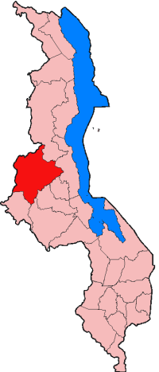
Figure 1: Map of Malawi with the Kasungu district indicated in red, and lake Malawi indicated in blue (Wikipedia, 2022)

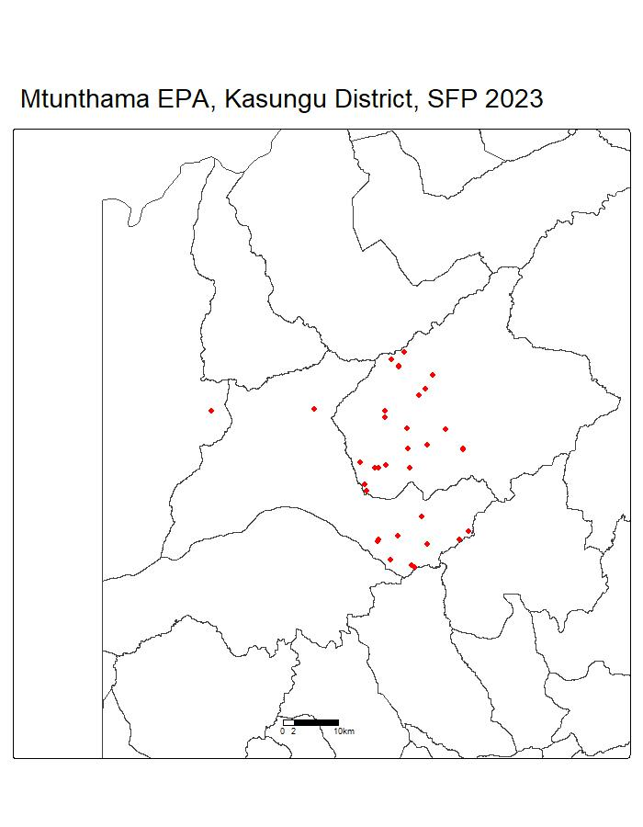
Figure 2: Map of Mtunthama EPA showing farm locations marked in red dots

2.2 Experimental Design and Treatment Setup
An on-farm experimental design was employed to evaluate sustainable intensification (SI) options for maize production under real field conditions across two consecutive agricultural seasons (2023/24 and 2024/25). Full treatment sets were established on 44 farms in Mtunthama EPA, with each farm containing all six treatments to ensure direct comparability within sites while capturing environmental variability across the landscape. Plot sizes were standardised at 25 m × 15 m for maize-based plots and 12.5 m × 7.5 m for legume plots, with consistent treatment allocation across both seasons.
The trial was designed to assess progressively complex SI strategies. In the first season, treatments focused on comparing conventional maize with Conservation Agriculture (CA)-based systems incorporating legume intercropping and residue retention. In the second season, the design was expanded to include maize grown in rotation with the legume species tested in the first season, allowing comparison of intercropping versus rotation effects within a CA framework.
The six agronomic treatments, with their corresponding plot identifiers and core features, are summarised in Table 1, followed by Table 2, which presents the field layout.
Table i: Description of agronomic treatments and plot layout implemented in the on-farm trials, Mtunthama EPA, Malawi.
Treatment Type | Crops | Plot Number | Description
Conventional Maize | Maize | Plot 1 | Maize planted with ridges (traditional practice).
CA Maize | Mazie | Plot 2 | Maize planted without ridges.  - Includes mulching  (20 plots out of 44 received mulch)
CA Maize intercropping | Cowpea  Maize | Plot 3 | Maize intercropped with inoculated cowpea (double-row strip cropping).  - Includes mulching  (25 plots out of 44 received mulch)  - Crop diversification
CA Maize intercropping | Lablab  Maize | Plot 4 | Maize intercropped with inoculated lablab (double-row strip cropping).  - Includes mulching  (19 plots out of 44 received mulch)  - Crop diversification
CA Maize rotation | Cowpea  Maize | Plot 5a  Plot 5b | Rotation between maize and inoculated cowpea. In Year 1, regarded as sole maize and sole cowpea due to lack of prior rotation data.  - Includes mulching  (15 plots out of 44 received mulch)
CA Maize rotation | Lablab  Maize | Plot 6a  Plot 6b | Rotation between maize and inoculated lablab. In Year 1, regarded as sole maize and sole lablab due to lack of prior rotation data.  - Includes mulching  (13 plots out of 44 received mulch)

Table ii: Field layout
15 m
15 m
15 m
25 m
25 m
25 m
25 m
Plot 1. Conventional ridging with continuous sole maize | Plot 3. CA with maize/inoculated cowpea double-row strip cropping | Plot 5a. CA with inoculated cowpea-maize rotation | Plot 5b. CA with maize-inoculated cowpea rotation
Plot 2. CA with continuous sole maize | Plot 4. CA with maize/inoculated lablab double-row strip cropping | Plot 6a. CA with inoculated lablab-maize rotation | Plot 6b. CA with maize-inoculated lablab rotation

Data collection focused on plot-level agronomic parameters. In both seasons, core measurements included plant stand counts, cob counts, and grain yield determined from a standardised net harvest area (5 m × two central rows), shelled, weighed, and corrected to 12.5% moisture content. In the 2024/25 season, additional variables were incorporated, including total fresh biomass weight, subsample collection for dry matter calibration, and counts of the parasitic weed Striga asiatica.

2.3 Farmer Selection Trial Management and Agronomic Practices
Farmers were selected in collaboration with local extension officers based on interest and land availability to host the full experimental layout. From an initial list of 50 randomly chosen farmers, five withdrew due to labour constraints or changes in cropping intentions, resulting in 45 participating farms. Selected farmers received standardised inputs (maize, cowpea, and lablab seeds; fertilisers; pesticides) and participated in group training on plot layout, planting procedures, and treatment-specific protocols, including residue retention and the required 75 cm row spacing for maize-legume systems.
All crops were planted following the first effective rains after 15 December in both seasons. Maize (variety MH43), cowpea (variety Sudan), and lablab (variety Hayworth) were used. For sole crops, row spacing was standardised at 75 cm for maize and 60 cm for legumes, with in-row spacing of 25 cm and 20 cm, respectively. In intercrop treatments (Plots 3 & 4), the maize population was maintained by planting two rows of maize 50 cm apart, alternating with two rows of legumes spaced at 45 cm. A uniform fertiliser regime was applied to all maize plots: a basal application of 100 kg ha⁻¹ of NPK fertiliser at planting, followed by a top-dressing of 100 kg ha⁻¹ of urea. Pre-emergence weed control was achieved with a blanket application of glyphosate at a rate of 2.5 L ha⁻¹. Mulch coverage, defined as the percentage of ground covered by retained crop residues, was quantified in each plot and recorded as a continuous variable for use as a covariate in statistical models to account for within-treatment variability.
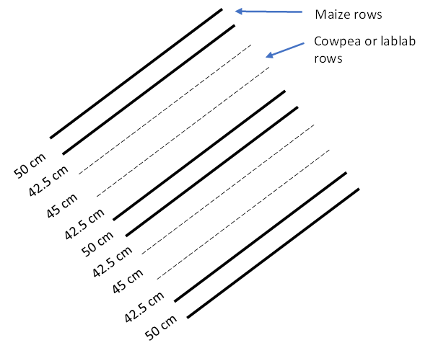
Figure 3: A schematic illustration of planting configuration for double-row strip cropping for maize and cowpea or lablab in Treatments 3 and 4.

2.4 Harvesting, Yield Measurement, and Yield Components
The primary agronomic response variable was maize grain yield (kg ha⁻¹). Yield was determined from a standardized net harvest area of 5 m length encompassing two central crop rows. All cobs within this area were harvested, sun-dried, shelled, and weighed using a calibrated digital scale (±5 g precision). Grain weight was adjusted to a standard moisture content of 12.5%. For legume intercrops and rotation plots, all mature pods within an equivalent net plot area were harvested sequentially at maturity, air-dried, threshed, weighed, and adjusted to 12% moisture.

Seed moisture content (SMC) at harvest was determined on a wet weight basis using six randomly selected ears per plot, calculated as:
$$SMC=\frac{M1-M2}{M1}×100$$
where M1 is the fresh mass (g) and M2 is the dry mass (g) of seeds. Thousand-seed weight (TSW) was determined by counting 100 seeds and multiplying by 10.
Additional yield components recorded at plot level included plant population per hectare, extrapolated from plant counts within the harvest area, number of cobs per plant, shelling percentage, calculated as the ratio of grain weight to total cob weight, and above-ground biomass yield, estimated from dry stover weight and converted to per-hectare basis
In the 2024/25 season, protocol enhancements included recording total fresh biomass weight and collecting subsamples (nine representative maize cobs per plot; approximately 3 kg of legume pods) for precise dry matter calibration. Dry matter content for grain and biomass fractions was used to adjust total plot weights. Striga asiaticacounts were also conducted within the net harvest area as an indicator of parasitic weed pressure.

2.5 Soil sampling and baseline characterization
Prior to trial establishment, composite soil samples were collected from each experimental plot at a depth of 0–20 cm to establish baseline soil fertility conditions. Samples were air-dried, ground, and sieved through a 2 mm mesh before laboratory analysis. The analytical procedures included soil pH (water method), organic carbon (Walkley–Black method), total nitrogen (Kjeldahl method), available phosphorus (Bray-1 method), and exchangeable bases (K, Ca, Mg). These measurements provided baseline soil property data for each plot.

2.6 Statistical Analysis
Statistical analysis was performed using R software and emphasised direct, plot-level comparisons of agronomic performance. Descriptive statistics (mean, median, standard deviation, range) were calculated for maize grain yield and key covariates (mulch cover %, baseline soil properties) by treatment.

2.7 Farmer Perception and Innovation Scoring
To contextualise the agronomic results, participatory field days were held at two trial sites following the seasonal harvests. These events facilitated direct observation of the treatments. A structured voting exercise was conducted where attending farmers selected their top three preferred management practices based on in-field observation. Ballots were collected separately from men and women to allow for gender-disaggregated analysis of preferences. Different treatments were qualitatively evaluated by the farmers present and other invited stakeholders. To quantify these perceptions, farmers were also asked to individually score each treatment on a numeric scale based on criteria such as perceived yield benefit and labour demand. These scores were compiled to provide a supplementary perspective to the agronomic data.

2.8 Ethical Considerations
Consent was obtained from relevant authorities, including the Mtunthama Extension Planning Area office, Kasungu District Agriculture Office, village heads, and participating farmers, before commencing the study. Farmers were fully informed of the study objectives, their voluntary participation, and the potential benefits and risks. Data confidentiality and respectful engagement were maintained throughout the research process.

Results

3.1 Weather Data During the Study Seasons
Weather data indicated moderate differences in both rainfall distribution and temperature conditions between the 2023/24 and 2024/25 maize growing seasons (November–April) in Kasungu District. Overall, both seasons followed the district’s typical unimodal rainfall regime, but variations were evident in onset timing, cumulative rainfall totals, and mid-season precipitation intensity. Statistical analysis confirmed that the inter-annual temperature differences were not significant (F = 0.32, p = 0.73).
Table iii: Monthly rainfall totals for the 2023/24 and 2024/25 seasons (Malawi Department of Climate Change and Meteorological Services)
Season | Nov | Dec | Jan | Feb | Mar | Apr | Total
2023/24 | 79.5 | 82.2 | 237.9 | 207.9 | 84.4 | 8.4 | 700.3
2024/25 | 42.3 | 100.3 | 217.7 | 125.9 | 96.6 | 19.2 | 602.0
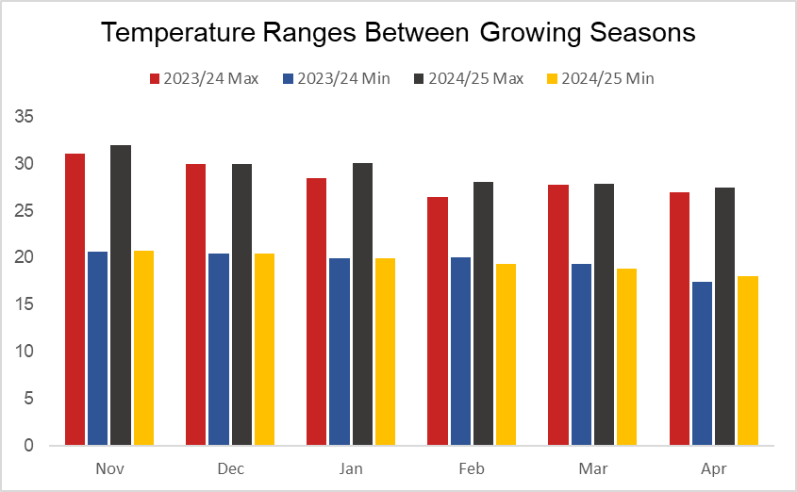
Figure 4:Temperature for growing months of Maize

3.2 Preliminary soil fertility analysis
Baseline soil analysis across all experimental plots indicated moderately acidic to near-neutral conditions, with mean pH of 6.05 (Figure 5). Soil organic carbon averaged 1.11%, corresponding to organic matter content of 1.92%. Mean total nitrogen was 0.10%, reflecting limited inherent nitrogen reserves typical of continuously cultivated smallholder systems. Available phosphorus averaged 30.50 µg g⁻¹, while exchangeable potassium, calcium, and magnesium averaged 0.31 cmol kg⁻¹, 3.71 cmol kg⁻¹, and 0.39 cmol kg⁻¹, respectively. These baseline characteristics provide context for interpreting plot-level yield responses to the different sustainable intensification options.
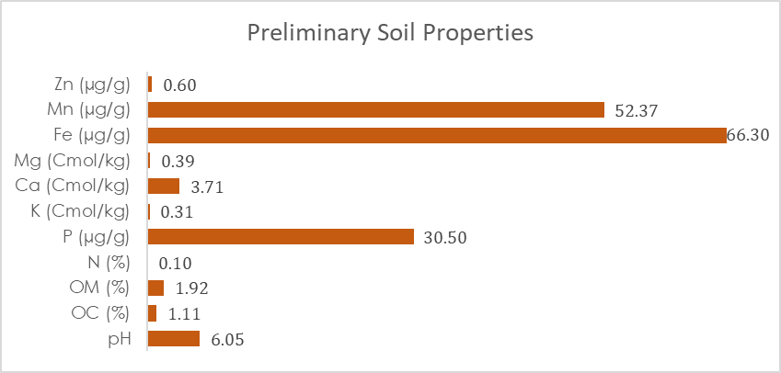
Figure 5: Soil properties for Mtunthama EPA

3.3 Number of Maize cobs per net plot
The number of maize cobs per net plot is one of the key yield-determining components. As shown in Figure 7, cob numbers varied across treatments and between seasons, with clear differences in central tendency and distribution.
In 2024, higher cob numbers were generally observed under the strip-cropping systems compared to other treatments. Both CA maize–cowpea strip cropping and CA maize–lablab strip cropping exhibited relatively higher median values (around 40 cobs per net plot), with upper quartiles extending beyond 45 cobs, indicating comparatively stronger performance. Rotation systems showed intermediate cob numbers, with CA maize–lablab rotation slightly outperforming CA maize–cowpea rotation, although both remained below the strip systems in terms of median values. Lower cob numbers were recorded under CA sole maize and conventional maize, with conventional maize showing one of the lowest medians.
In 2025, an overall increase in cob numbers was observed across most treatments. The CA maize–cowpea strip system showed a noticeable rise in median cob count to the mid-40s, with the upper range exceeding 50 cobs per net plot. Similar improvements were observed for CA maize–lablab strip and CA maize–lablab rotation treatments, which displayed relatively higher medians compared to other treatments. Rotation systems continued to exhibit intermediate performance, while CA sole maize and conventional maize maintained comparatively lower median cob numbers, although slight increases were evident relative to 2024.
Across both seasons, substantial variability within treatments was observed, as indicated by the wide interquartile ranges and the presence of numerous outliers. In some cases, cob numbers extended beyond 50 cobs per net plot, particularly in 2025. Generally, there was general increase in cob number in 2025 relative to 2024 across most treatments. However, considerable variability was observed within treatments, as indicated by the spread of the boxplots and the presence of outliers, suggesting variability in field conditions and management practices.

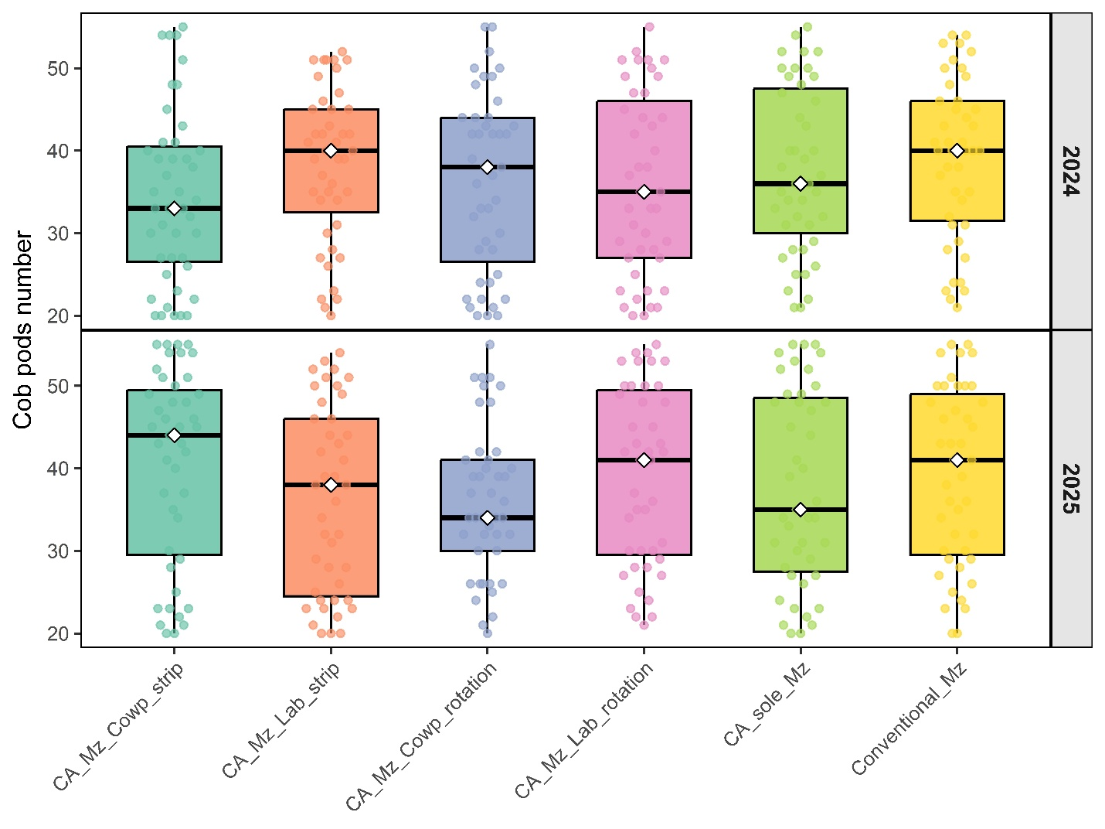
Figure 6: Number of maize cobs per net plot under six management treatments: conservation agriculture maize–cowpea strip cropping, conservation agriculture maize–lablab strip cropping, conservation agriculture maize–cowpea rotation, conservation agriculture maize–lablab rotation, conservation agriculture sole maize, and conventional sole maize, across the 2024 and 2025 growing seasons in Mtunthama Extension Planning Area. Boxplots represent the median, interquartile range, and variability across plots.

3.4 Maize yield distribution by treatment
Maize grain yield, the primary agronomic response variable, varied across the six treatments and between the two growing seasons (Figure 7; Appendix 1). The boxplots illustrate clear differences in yield distribution, central tendency, and variability among treatments.
In 2024, the highest grain yields were observed under the maize–legume strip-cropping systems. Both CA maize–cowpea strip and CA maize–lablab strip treatments exhibited relatively higher median yields (approximately 1,500–1,600 kg ha⁻¹), with upper ranges extending beyond 2,500 kg ha⁻¹ in some plots. Rotation systems showed intermediate performance, with CA maize–lablab rotation having slightly higher median yields than CA maize–cowpea rotation. Lower median yields were recorded under CA sole maize and conventional maize, with conventional maize generally among the lowest-performing treatments.
In 2025, yield distributions shifted upward for several treatments. The CA maize–cowpea strip and CA maize–lablab strip systems maintained relatively higher median yields (around 1,700–1,800 kg ha⁻¹), with some observations exceeding 3,000 kg ha⁻¹. Rotation systems continued to show intermediate yields, while CA sole maize and conventional maize remained comparatively lower, although slight improvements were evident relative to 2024.
Across both seasons, strip-cropping systems consistently showed higher median yields compared to rotations and sole maize systems. Rotation treatments maintained moderate performance, while sole maize systems, particularly conventional maize, tended to record lower yields. Variability within treatments was substantial, as indicated by wide interquartile ranges and the presence of numerous outliers, reflecting heterogeneity in field conditions and management practices.

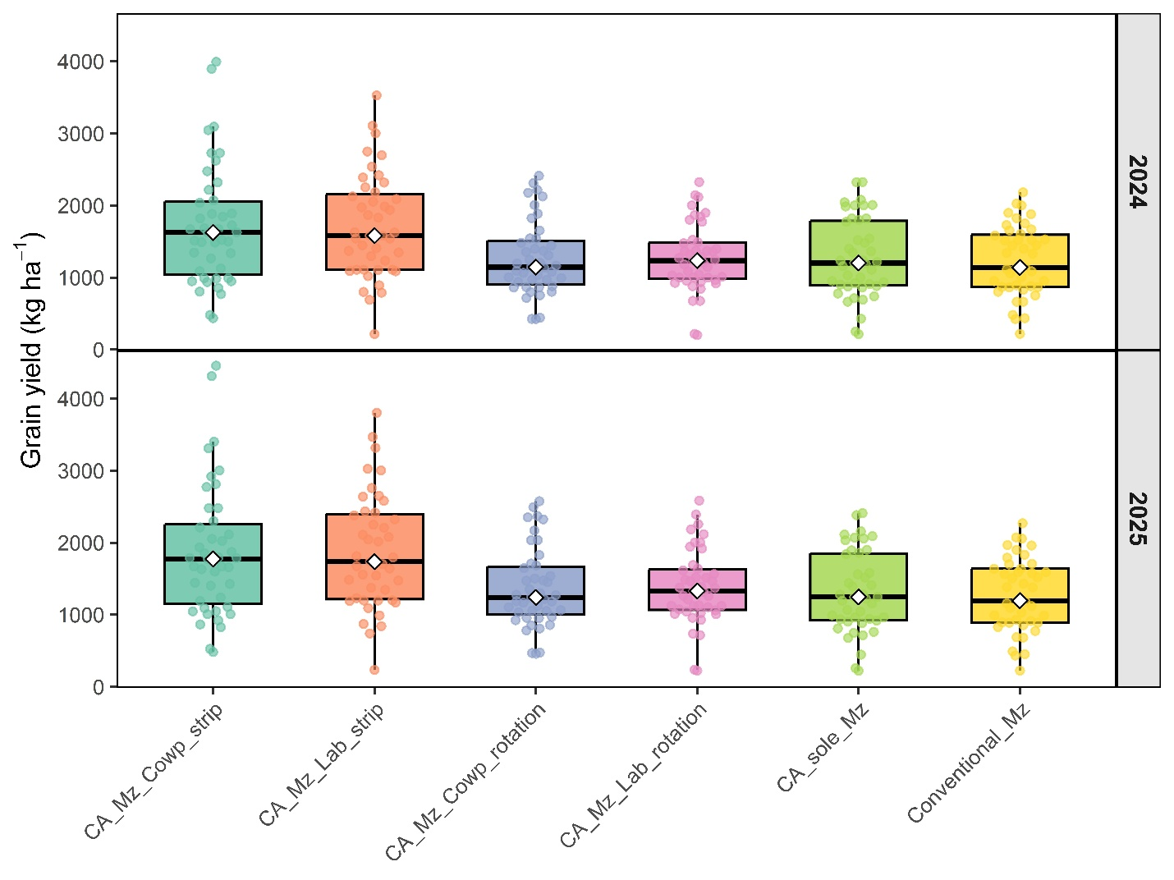
Figure 7: Boxplot of maize grain yield (kg/ha) across six treatment types: conservation agriculture maize–cowpea strip cropping, conservation agriculture maize–lablab strip cropping, conservation agriculture maize–cowpea rotation, conservation agriculture maize–lablab rotation, conservation agriculture sole maize, and conventional sole maize, across the 2024 and 2025 seasons in Mtunthama Extension Planning Area. Boxplots represent median, interquartile range, and variability across plots.

3.5 Biomass performance across treatments
Maize biomass yield, an important indicator of both crop productivity and residue availability, varied across treatments and between seasons (Figure 8; Appendix 2). The boxplots show clear differences in biomass distribution, central tendency, and variability among treatments.
In 2024, biomass yields were relatively higher under the conservation agriculture (CA)-based systems compared to conventional maize. The strip-cropping treatments (CA maize–cowpea strip and CA maize–lablab strip) exhibited comparatively high median biomass values (approximately 3,500–3,700 kg ha⁻¹), with upper ranges extending beyond 4,000 kg ha⁻¹. Rotation systems (CA maize–cowpea rotation and CA maize–lablab rotation) also showed relatively strong performance, with median values comparable to, and in some cases slightly exceeding, those of the strip systems. In contrast, lower biomass yields were observed under CA sole maize and conventional maize, both showing medians around 3,100–3,300 kg ha⁻¹.
In 2025, biomass yields increased across most treatments. The CA maize–lablab rotation and CA maize–lablab strip systems showed relatively higher median biomass values (approaching or exceeding 4,800–5,000 kg ha⁻¹), followed closely by CA maize–cowpea strip and CA maize–cowpea rotation. The strip and rotation systems generally exhibited higher upper ranges, with several observations exceeding 5,500 kg ha⁻¹. CA sole maize and conventional maize continued to record comparatively lower biomass yields, with medians around 3,300–3,600 kg ha⁻¹, although slight improvements were evident compared to 2024.
Across both seasons, CA-based systems (strip-cropping and rotations) consistently showed higher biomass yields relative to sole maize systems, while conventional maize remained among the lowest-performing treatments. Substantial variability within treatments was evident, as indicated by wide interquartile ranges and the presence of outliers, reflecting heterogeneity in field conditions and management practices.

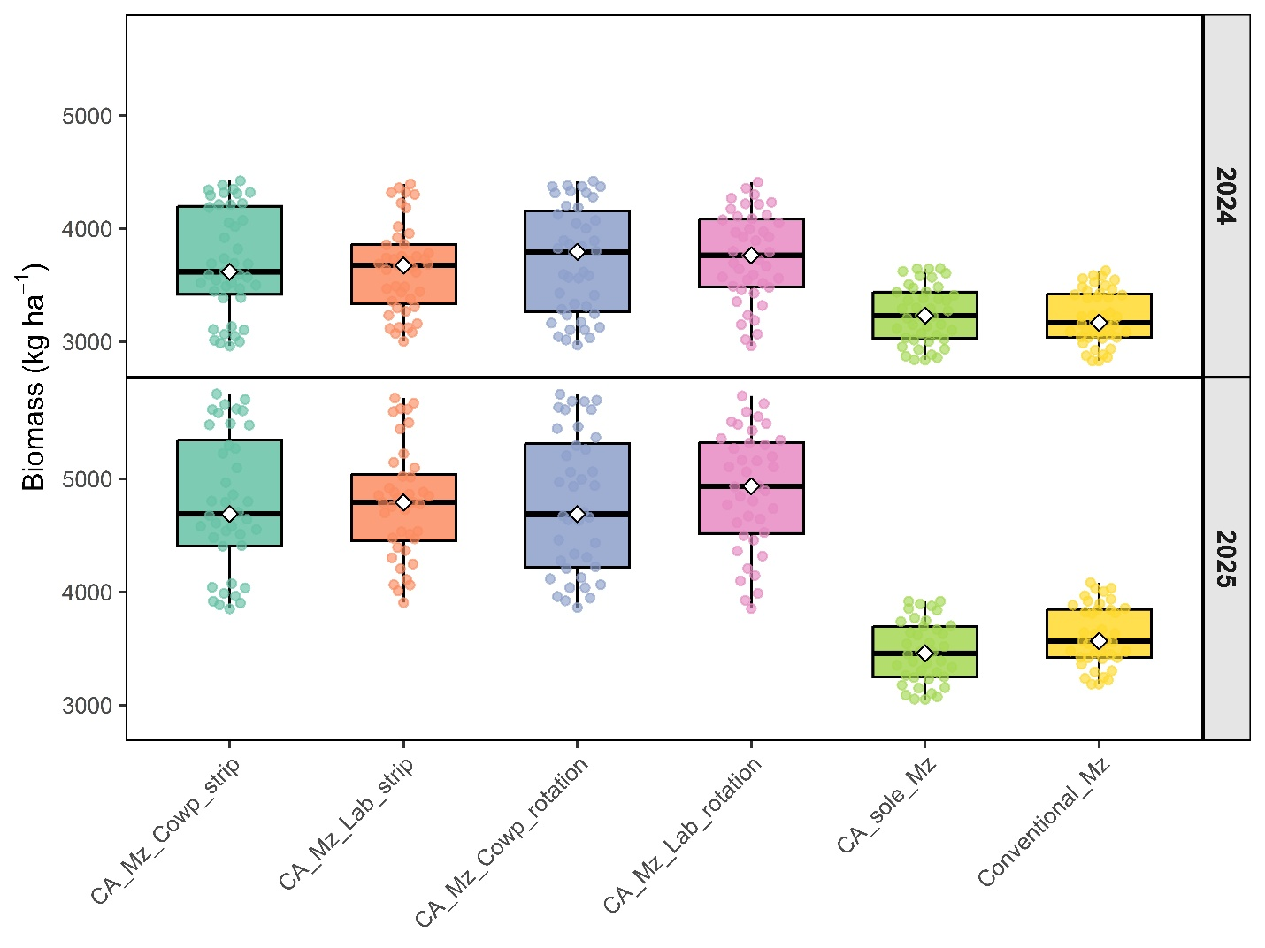
Figure 8: Biomass yield (kg ha⁻¹) of maize under six management treatments: conservation agriculture maize–cowpea strip cropping, conservation agriculture maize–lablab strip cropping, conservation agriculture maize–cowpea rotation, conservation agriculture maize–lablab rotation, conservation agriculture sole maize, and conventional sole maize, across the 2024 and 2025 seasons in Mtunthama Extension Planning Area. Boxplots represent median, interquartile range, and variability across plots.

3.6 Farmer Perceptions and Innovation Preferences
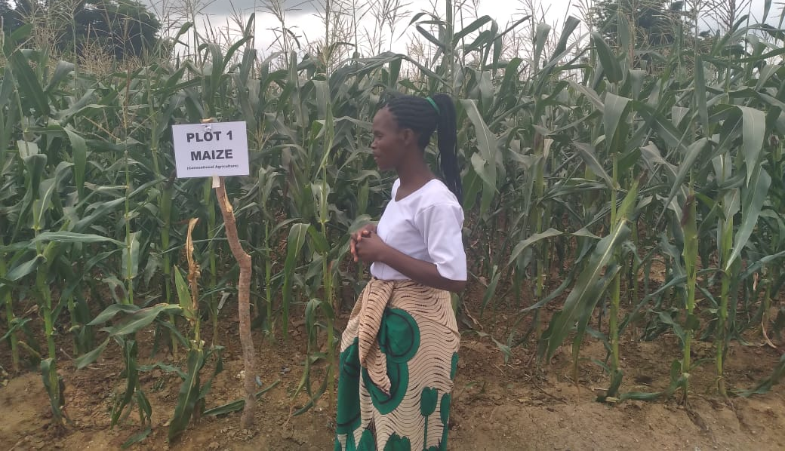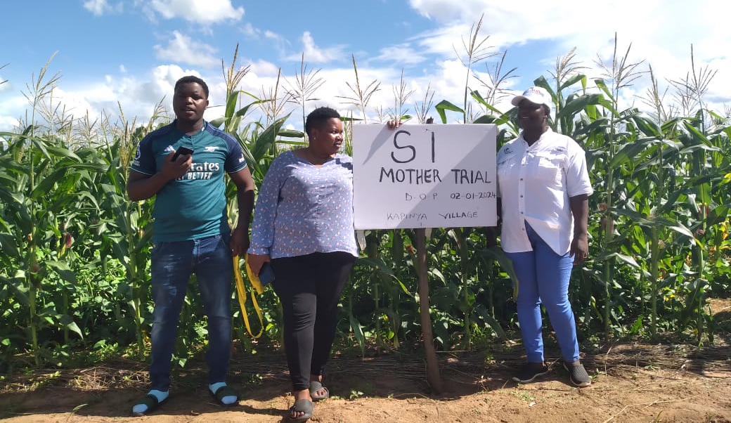
A total of 758 farmers participated in field day evaluations across two sites (398 at Sarai Mkanase's farm; 360 at Charles Kanyenda's farm), with balanced gender representation (358 male, 400 female voters). Farmers selected their top three preferred innovations from the trial plots through a structured voting exercise, with results disaggregated by gender and site (Table 6).
The maize-cowpea strip intercrop (Plot 3) emerged as the most preferred innovation, receiving 91 votes across both sites and gender. This was followed by soybean grown with organic inputs and inoculant (Plot 8A) with 62 votes. Two rotation systems, maize-cowpea rotation with maize first (Plot 5B) and maize-lablab rotation with maize first (Plot 6B), each received 58 votes, ranking third.
Gender-disaggregated results showed that both men and women strongly favoured intercrops and rotations, though some site-specific differences were observed. Women at Sarai tended to cast more votes for intercrops, while men at Charles expressed greater interest in soybean under improved management.
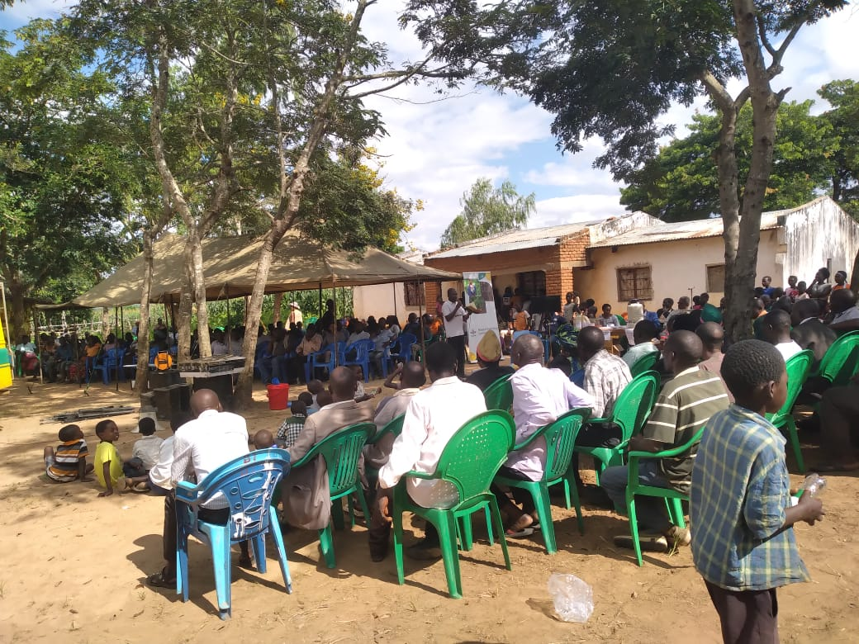
Host farmer explaining the overview of the trial to participants during the field day exercise, highlighting the objectives, management practices, and key observations from the trials

Table iv: Field Day Voting Results – Summary of Farmer Preferences by Site and Gender

Plot | Innovation | Sarai – Male | Sarai – Female | Charles – Male | Charles – Female | Combined Total
Plot 1 | Conventional maize (sole) | 12 | 27 | 15 | 2 | 56
Plot 2 | CA sole maize | 30 | 15 | 12 | 20 | 77
Plot 3 | Maize–Cowpea intercrop (strip) | 48 | 103 | 29 | 54 | 234
Plot 4 | Maize–Lablab intercrop (strip) | 40 | 29 | 24 | 58 | 151
Plot 5A | Cowpea–Maize rotation (cowpea first) | 14 | 17 | 19 | 11 | 61
Plot 5B | Maize–Cowpea rotation (maize first) | 11 | 16 | 21 | 20 | 68
Plot 6A | Lablab–Maize rotation (lablab first) | 19 | 18 | 4 | 12 | 53
Plot 6B | Maize–Lablab rotation (maize first) | 10 | 8 | 25 | 15 | 58

4.0 Discussion
The results of this study demonstrate that sustainable intensification options integrating legumes within conservation agriculture (CA) systems significantly enhance maize productivity under smallholder conditions in Mtunthama Extension Planning Area. In particular, maize–legume strip intercropping systems consistently outperformed sole maize and rotation systems in terms of grain yield, biomass production, and cob number per net plot. These findings align with a growing body of evidence indicating that cereal–legume intercropping systems improve productivity through enhanced resource-use efficiency and ecological complementarities (Snapp et al., 2010; Iqbal et al., 2019), with broader system-level evidence supporting these gains across diverse agroecosystems (Abdul Rahman et al., 2021).
The superior performance of strip intercropping systems can be attributed to complementary interactions between maize and legumes in the use of key growth-limiting resources, including light, water, and nutrients. In such systems, maize, as the dominant crop, captures a greater proportion of incident radiation, while legumes occupy lower canopy layers, improving canopy stratification and photosynthetically active radiation (PAR) use efficiency (Iqbal et al., 2019). This spatial and temporal complementarity enhances total system photosynthesis and biomass accumulation. Moreover, intercropping modifies the field microclimate, particularly temperature, humidity, and light distribution, which has been shown to improve crop physiological performance and growth (Iqbal et al., 2019). These mechanisms collectively explain the observed increases in biomass and grain yield under strip intercropping systems.
Nitrogen dynamics also play a central role in driving productivity gains in legume-integrated systems. Legumes contribute to biological nitrogen fixation, increasing nitrogen availability within the system while reducing losses associated with leaching and volatilization. This enhanced nitrogen supply supports improved maize growth, as nitrogen is a critical determinant of key physiological processes such as leaf area development, chlorophyll content, and photosynthetic capacity. Experimental evidence shows that enhanced nitrogen availability supports key physiological processes such as leaf development and grain formation (Ashraf et al., 2016), which are widely associated with improved yield components in maize-based systems. The higher cob number observed in this study under strip intercropping systems is therefore indicative of improved reproductive development driven by enhanced nutrient availability and overall plant vigor.
Biomass production followed trends similar to grain yield, with intercropping systems producing substantially higher biomass than sole cropping systems. This is particularly important in smallholder farming systems, where crop residues serve multiple functions, including soil cover, organic matter inputs, and livestock feed. Increased biomass under CA-based intercropping systems suggests improved photosynthetic efficiency and resource capture. However, the role of biomass extends beyond productivity gains; it is central to broader system sustainability. In mixed crop–livestock systems, crop residues are often preferentially allocated to livestock feed, potentially limiting their contribution to soil fertility. Evidence from Eastern Africa indicates that as productivity increases, farmers may reallocate biomass between soil cover and livestock feed depending on system priorities (Duncan et al., 2016). This highlights the importance of considering biomass not only as an output but also as a critical component of system-level trade-offs and decision-making.
The moderate performance of maize–legume rotation systems observed in this study suggests that while rotations contribute to soil fertility improvement, their benefits may not be immediately realized. Unlike intercropping, which allows simultaneous resource sharing and complementarity, rotational systems rely on residual effects that accumulate over time. This finding is consistent with previous studies indicating that the benefits often accrue gradually and are strongly influenced by residue management and baseline soil fertility conditions (Franke et al., 2018). In contrast, intercropping provides more immediate productivity gains due to concurrent interactions between component crops.
Seasonal variation also influenced treatment performance, with slightly higher yields, biomass, and cob numbers recorded in the second season. This pattern suggests cumulative benefits associated with CA practices, particularly improvements in soil structure, moisture retention, and nutrient cycling over time. Conservation agriculture systems are known to exhibit progressive improvements in soil structure, moisture retention, and yield stability over time (Thierfelder et al., 2015). Furthermore, the observed seasonal differences may reflect variability in rainfall distribution, which plays a critical role in determining crop performance. Intercropping systems are particularly advantageous under such conditions, as they enhance resilience by spreading production risk across multiple crops. Studies have shown that in seasons with lower maize yields, legume yields may compensate, thereby stabilizing overall system productivity (Abdul Rahman et al., 2021).
An important dimension of intercropping systems is their efficiency in land use. Although Land Equivalent Ratio (LER) was not explicitly calculated in this study, the observed yield advantages are consistent with findings from similar systems where LER values greater than one indicate superior land productivity compared to monocropping. In some cases, LER values greater than one are commonly reported, indicating higher land-use efficiency relative to monocropping systems (Iqbal et al., 2019; Abdul Rahman et al., 2021). This underscores the potential of strip intercropping as a viable strategy for intensifying production in land-constrained smallholder systems.
In addition to productivity gains, this study observed that legume-integrated systems contributed to the suppression of Striga asiatica, a major biotic constraint to maize production in sub-Saharan Africa. The reduction in Striga infestation under intercropping systems can be attributed to multiple interacting factors, including improved soil fertility, enhanced crop vigor, shading effects, and the presence of mulch under CA practices. Improved soil fertility and crop vigor reduce the production of germination stimulants required for Striga emergence, while increased canopy shading further suppresses its development. These findings are consistent with previous studies demonstrating that integrated soil fertility management and organic matter inputs can significantly reduce Striga incidence (Carsky et al., 2000).
The performance of legumes within intercropping systems further highlights the multifunctional benefits of diversification. Both cowpea and lablab produced higher yields under strip intercropping compared to other treatments, indicating that these systems enhance not only maize productivity but also legume performance. This is particularly important for smallholder farmers, as legumes provide early maturing grain for household consumption and income generation, thereby improving food security and livelihood resilience. Moreover, diversified systems have been shown to increase economic returns and reduce income variability, making them more attractive to risk-averse farmers (Pretty et al., 2018; Abdul Rahman et al., 2021).
Farmer perceptions strongly reinforced the agronomic findings of this study. The preference for maize–cowpea strip intercropping reflects its ability to meet multiple farmer objectives, including improved moisture availability, early food supply, and income generation. The introduction of new legume varieties further suggests potential for adoption and scaling, particularly when technologies deliver immediate and tangible benefits. This observation is consistent with evidence that smallholder adoption is driven by technologies that provide immediate, low-risk benefits aligned with household needs (Smale & Jayne, 2010).
Overall, this study demonstrates that the integration of legumes within CA systems creates synergistic effects that enhance productivity, resource-use efficiency, and system resilience. While conservation agriculture alone may provide limited short-term benefits, its combination with legumes addresses key soil fertility constraints and improves system performance. Beyond confirming existing knowledge, these findings contribute to a deeper understanding of sustainable intensification by highlighting the role of intercropping as a mechanism for optimizing resource complementarities, reducing production risks, and enhancing multifunctionality in smallholder farming systems. This supports the argument that sustainable intensification strategies must move beyond single interventions and instead adopt integrated approaches that simultaneously address productivity, resilience, and sustainability objectives (Vanlauwe et al., 2014).

5.0 Conclusion
This study demonstrates that maize–legume strip intercropping within conservation agriculture (CA) systems is a highly effective pathway for sustainable intensification in smallholder farming systems of central Malawi. The consistent increases in grain yield, biomass, and cob number observed under intercropping systems reflect improved resource-use efficiency driven by complementary interactions in light capture, water use, and nitrogen dynamics. Legume integration enhanced biological nitrogen fixation and soil fertility, which in turn supported better crop growth, photosynthetic performance, and reproductive development. These findings indicate that the productivity gains were not only a result of improved soil conditions but also of underlying physiological and ecological mechanisms that optimize system performance.
Beyond yield improvements, the integration of legumes contributed to the suppression of Striga asiatica, increased system resilience to seasonal variability, and enhanced overall productivity, including higher legume yields. The multifunctional benefits of intercropping, ranging from soil fertility improvement to risk reduction and diversified outputs, were further reinforced by strong farmer preference, particularly for maize–cowpea systems that provide early food and income. Overall, the study confirms that sustainable intensification in maize-based systems is best achieved through integrated, systems-based approaches that combine CA with legume diversification, enabling simultaneous gains in productivity, resilience, and livelihood outcomes.

Declaration of Competing Interest
This manuscript is original unpublished work, read and approved by all authors, and not being considered for publication elsewhere. All those listed as authors have contributed to the development of this paper and have approved the manuscript and this submission. We have no conflicts of interest to declare.

Acknowledgements
We gratefully acknowledge the financial and technical support provided by the One CGIAR Initiative on Sustainable Intensification of Mixed Farming Systems (SI-MFS) under the International Maize and Wheat Improvement Center (CIMMYT). We also extend our appreciation to the Department of Agricultural Research Services (Malawi) for their valuable technical assistance.
Our sincere gratitude goes to the School of Agricultural, Earth and Environmental Sciences, University of KwaZulu-Natal (South Africa), and Wageningen University & Research (The Netherlands) for their academic support and guidance. Additionally, we thank the Department of Agricultural Extension for their collaboration and for facilitating the participation of their extension workers, who played a crucial role in data collection throughout the project.
Finally, we extend our deepest appreciation to the farmers for their time, insights, and willingness to share their experiences and expertise, which were instrumental to the success of this research project.

References
Abdul Rahman, M., Zhang, J., Rahman, M. H., & Wang, X. (2021). Intercropping systems and resource-use efficiency: A global review. Agricultural Systems, 190, 103117.
Ashraf, U., Salim, M. N., Sher, A., Sabir, S. R., Khan, A., Pan, S., & Tang, X. (2016). Maize growth, yield formation, and water–nitrogen usage in response to varied irrigation and nitrogen supply under semi-arid conditions. Agricultural Water Management, 172, 1–10.
Carsky, R. J., Berner, D. K., Oyewole, B. D., Dashiell, K., & Schulz, S. (2000). Reduction of Striga hermonthica parasitism on maize using integrated soil fertility management. Plant and Soil, 219(1–2), 203–211.
Chimonyo, V. G. P., Snapp, S. S., & Chikowo, R. (2019). Grain legume integration and the productivity of maize-based systems in sub-Saharan Africa: A review. Agronomy for Sustainable Development, 39(3), 1–18.
Duncan, A. J., Thorne, P. J., & Valbuena, D. (2016). Trade-offs and synergies in crop–livestock systems in sub-Saharan Africa: A review. Agricultural Systems, 147, 1–10. https://doi.org/10.1016/j.agee.2016.05.011.
Franke, A. C., van den Brand, G. J., Vanlauwe, B., & Giller, K. E. (2018). Sustainable intensification through rotations with grain legumes in sub-Saharan Africa: A review. Agriculture, Ecosystems & Environment, 261, 172–185. https://doi.org/10.1016/j.agee.2017.09.029
Iqbal, N., Hussain, S., Ahmed, Z., Yang, F., Wang, X., Liu, W., Yong, T., Du, J., Shu, K., & Liu, J. (2019). Comparative analysis of maize–soybean strip intercropping systems: A review. Agricultural Systems, 173, 109–119.
Lobell, D. B., Cassman, K. G., & Field, C. B. (2009). Crop yield gaps: Their importance, magnitudes, and causes. Annual Review of Environment and Resources, 34, 179–204. https://doi.org/10.1146/annurev.environ.041008.093740
Pretty, J., Benton, T. G., Bharucha, Z. P., Dicks, L. V., Flora, C. B., Godfray, H. C. J., Goulson, D., Hartley, S., Lampkin, N., Morris, C., Pierzynski, G., Prasad, P. V. V., Reganold, J., Rockström, J., Smith, P., Thorne, P., & Wratten, S. (2018). Global assessment of agricultural system redesign for sustainable intensification. Nature Sustainability, 1(8), 441–446. https://doi.org/10.1038/s41893-018-0114-0
Smale, M., & Jayne, T. S. (2010). Maize in eastern and southern Africa: “Seeds” of success in retrospect (Working Paper No. 97). Michigan State University.
Snapp, S. S., Blackie, M. J., Gilbert, R. A., Bezner-Kerr, R., & Kanyama-Phiri, G. Y. (2010). Biodiversity can support a greener revolution in Africa. Proceedings of the National Academy of Sciences, 107(48), 20840–20845. https://doi.org/10.1073/pnas.1007199107
Snapp, S. S., Jayne, T. S., Mhango, W., Benson, T., & Ricker-Gilbert, J. (2014). Maize yield response to nitrogen in Malawi’s smallholder production systems.
Steward, P. R., Dougill, A. J., Thierfelder, C., Pittelkow, C. M., Stringer, L. C., Kudzala, M., & Shackelford, G. E. (2018). The adaptive capacity of maize-based conservation agriculture systems to climate stress in tropical and subtropical environments: A meta-regression of yields. Agriculture, Ecosystems & Environment, 251, 194-202.
Thierfelder, C., & Wall, P. C. (2010). Rotation in conservation agriculture systems of Zambia: effects on soil quality and water relations. Experimental agriculture, 46(3), 309-325.
Thierfelder, C., Rusinamhodzi, L., Ngwira, A. R., Mupangwa, W., Nyagumbo, I., Kassie, G. T., & Cairns, J. E. (2015). Conservation agriculture in Southern Africa: Advances in knowledge. Renewable Agriculture and Food Systems, 30(4), 328-348.
Vanlauwe, B., Wendt, J., & Giller, K. E. (2014). A fourth principle is required to define conservation agriculture in sub-Saharan Africa: The appropriate use of fertilizer. Field Crops Research, 155, 10–13. https://doi.org/10.1016/j.fcr.2013.10.002
Vanlauwe, B., Descheemaeker, K., Giller, K. E., Huising, J., Merckx, R., Nziguheba, G., Wendt, J., & Zingore, S. (2015). Integrated soil fertility management in sub-Saharan Africa: Unravelling local adaptation. SOIL, 1(1), 491–508. https://doi.org/10.5194/soil-1-491-2015

Appendix

Table 1: Seasonal maize grain yields, biomass, mulch cover, and percentage changes between the 2023/24 and 2024/25 seasons.
Treatment | n | 2023 Yield (kg ha⁻¹) | 2023 Biomass (kg ha⁻¹) | 2023 Mulch (%) | 2024 Yield (kg ha⁻¹) | 2024 Biomass (kg ha⁻¹) | 2024 Mulch (%) | Yield Change (%) | Biomass Change (%)
Conventional | 43 | 1,550 | 2,815 | 0 | 1,520 | 2,980 | 0 | –1.9 | +5.9
CA Sole Maize | 43 | 1,750 | 2,950 | 35 | 1,780 | 3,420 | 35 | +1.7 | +15.9
CA Intercrop (Cowpea) | 43 | 3,250 | 4,250 | 40 | 3,267 | 5,480 | 45 | +0.5 | +28.9
CA Intercrop (Lablab) | 42 | 3,150 | 4,120 | 28 | 3,180 | 5,290 | 32 | +1.0 | +28.4
CA Rotation (Cowpea) | 43 | 2,150 | 3,120 | 21 | 2,150 | 3,850 | 25 | 0.0 | +23.4
CA Rotation (Lablab) | 43 | 2,050 | 3,050 | 18 | 2,090 | 3,720 | 22 | +2.0 | +21.9

Table 2: Biomass production under different cropping systems
Cropping system / treatment | n | Maize Biomass  (kg ha⁻¹, mean ± SD)
Conventional ridge tillage | 43 | 3,420 ± 1,510
CA sole maize | 43 | 3,850 ± 1,420
CA intercrop (maize–cowpea) | 43 | 5,120 ± 2,240
CA intercrop (maize–lablab) | 42 | 5,450 ± 2,510
CA rotation (maize–cowpea) | 43 | 4,210 ± 1,980
CA rotation (maize–lablab) | 43 | 4,180 ± 1,650

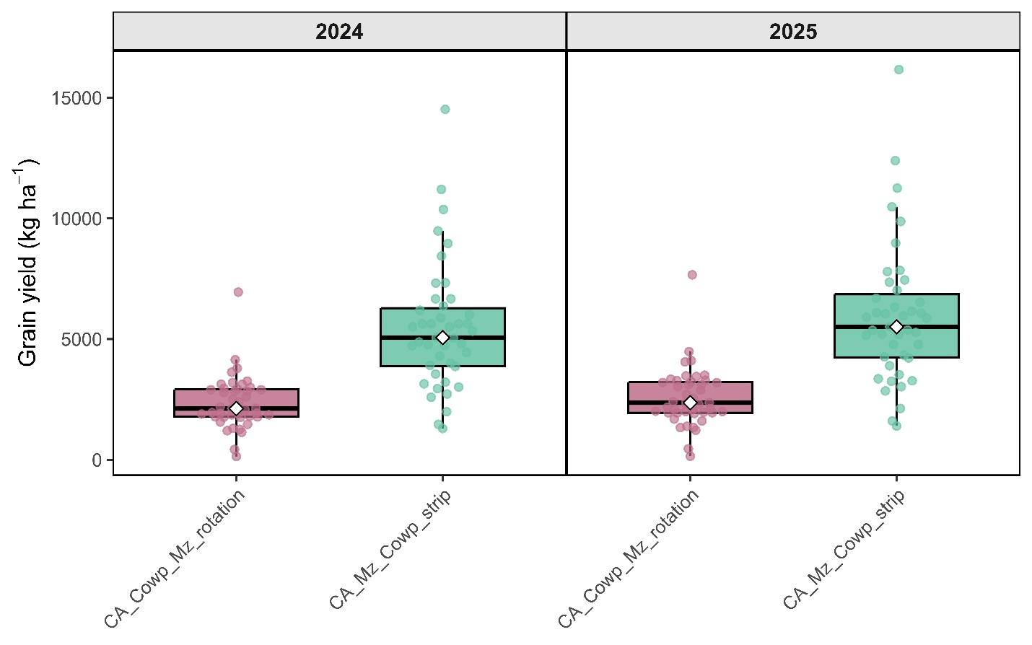

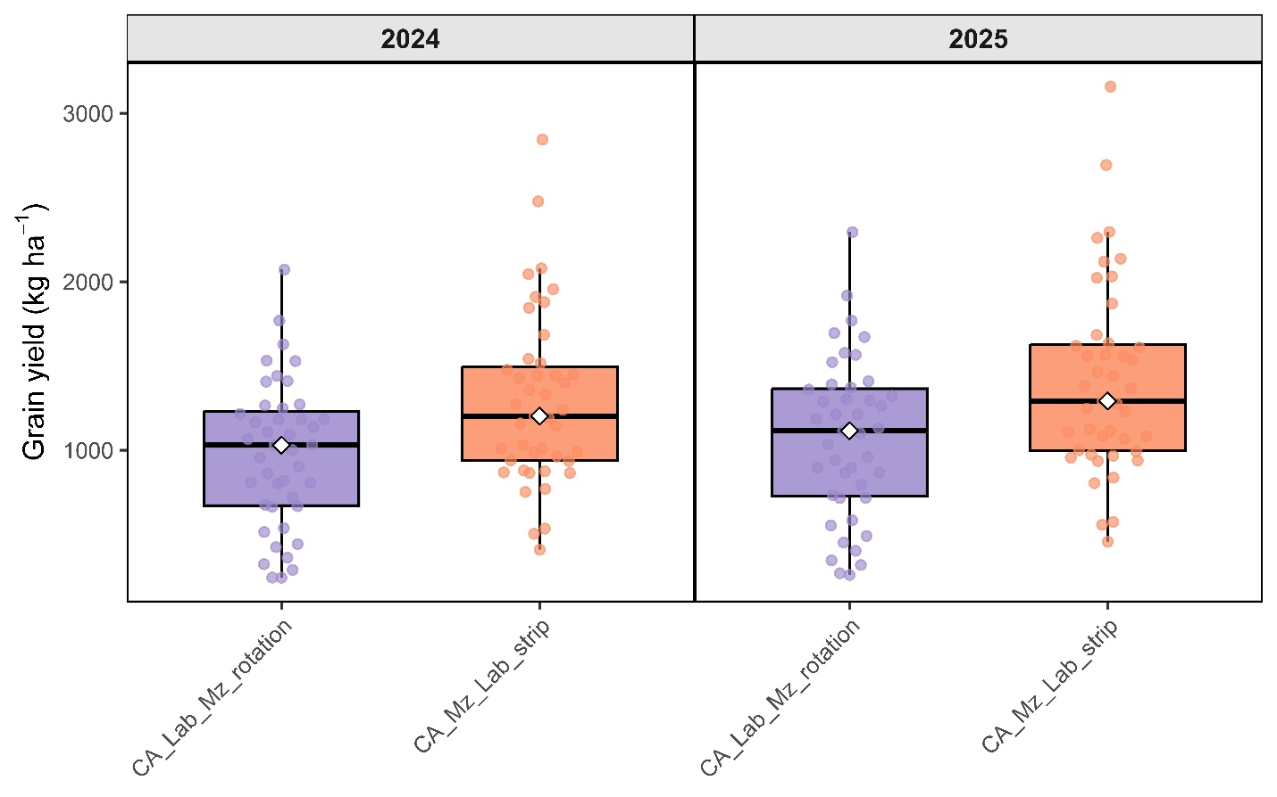

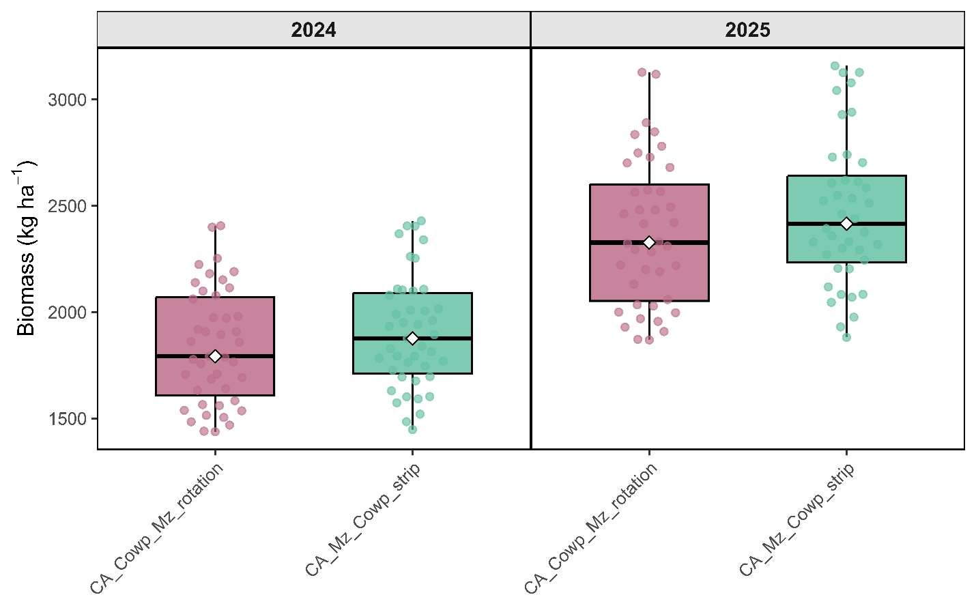

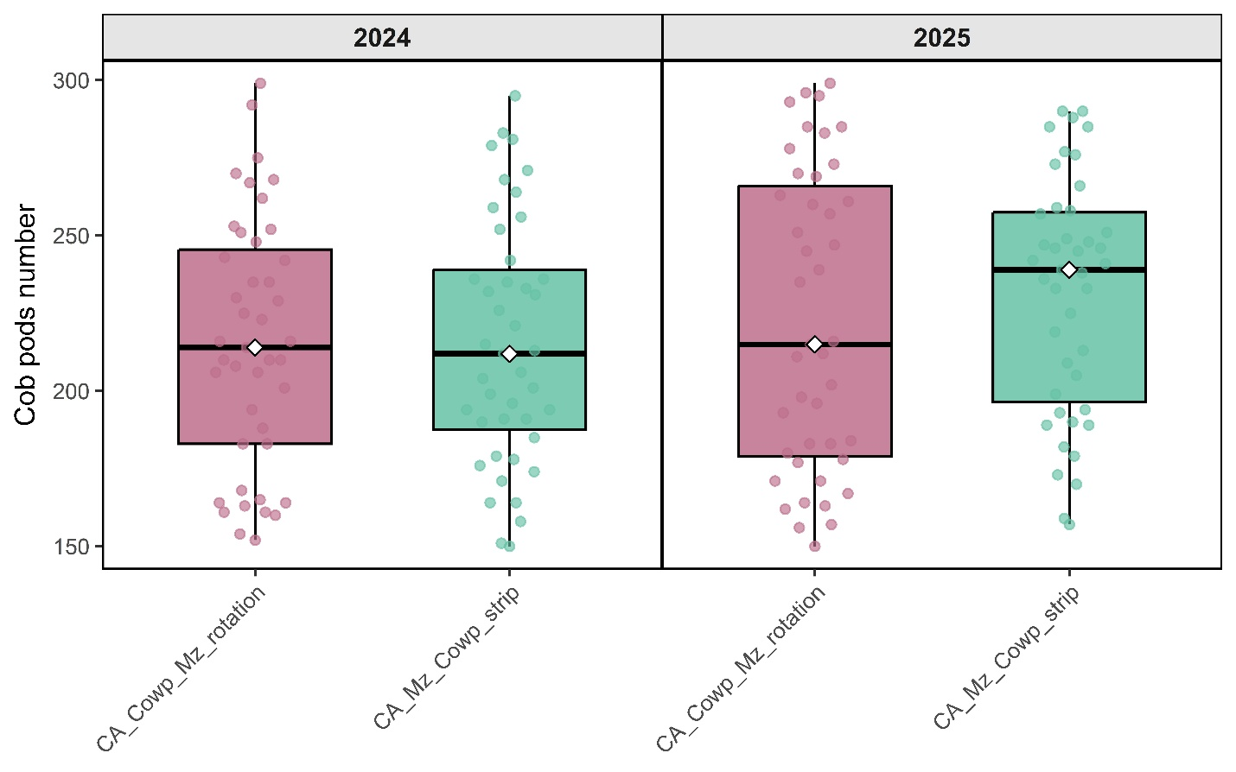

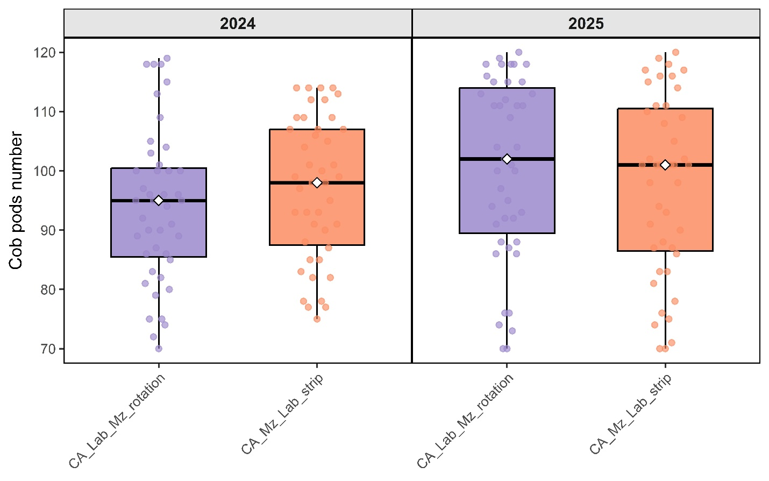

Chapter 3
Assessing Sustainable Intensification Options for Maize Across Diverse Farm Types in central Malawi

Kamwana-Ngwira Florence^{1,2,3}, Chiduwa Mazvita^{2,} Mabhaudhi Tafadzwanashe³ Groot Jeroen⁴ Santiago Lopez-Ridaura⁴
Kamwana-Ngwira Florence^{1,2,3}, Chiduwa Mazvita^{2,} Mabhaudhi Tafadzwanashe³ Groot Jeroen⁴
¹Department of agriculture research services, Malawi ²International Maize and Wheat Improvement Center (CIMMYT), Malawi, ³School of Agricultural, Earth and Environmental Sciences, University of KwaZulu Natal, Private Bag X01, Scottsville 3209, South Africa, ⁴Wageningen University & Research (WUR), The Netherlands
*Corresponding author: kamwanaflorence@yahoo.co.uk
Abstract
Smallholder farming systems are highly heterogeneous in terms of resource endowment, production strategies, and livelihood objectives, posing challenges for the design of effective and scalable agricultural interventions. This study characterises farm system diversity in Mtunthama Extension Planning Area (EPA), Kasungu District, Malawi, and evaluates the suitability of sustainable intensification (SI) innovations across different farm types. Data were collected through focus group discussions and household surveys involving 43 farming households. Principal Component Analysis (PCA) was used to construct a farm typology based on structural, socioeconomic, and production variables, while farm performance and innovation suitability were assessed using a multi-criteria framework.
The analysis identified four distinct farm typologies reflecting differences in resource endowment and production orientation: High Resource-Endowed farms with larger landholdings and greater livestock ownership (HRE), Moderately resource-endowed farms with either Mixed crop-livestock orientation (MMX) or with Diversified Cropping systems (MDC), and Resource-Constrained Maize-dominated farms with limited productive assets (RCM).
The multi-criteria assessment of SI innovations revealed substantial variation in suitability across farm types. Conservation agriculture recorded the highest overall score (0.68), followed by intercropping (0.54), while strip cropping showed the lowest adoption (0.25). Farm Type III achieved the highest overall innovation score (0.66), reflecting consistent adoption across multiple practices, whereas Farm Types II and IV showed limited uptake. Innovation performance varied by resource context, with more resource-endowed and intermediate farms better positioned to adopt integrated and management-intensive practices, while resource-constrained farms exhibited lower adoption levels.
These findings move beyond the conventional recommendation of typology-based targeting by demonstrating that the effectiveness of sustainable intensification is shaped not only by resource endowment, but by distinct trade-offs between productivity, income, and sustainability across farm types. In particular, the decoupling of maize yield and household income, alongside uneven adoption of sustainable practices, suggests that intensification pathways are not linear but context-specific and multidimensional. By integrating farm typology with a multi-criteria evaluation of innovation performance, this study provides a more nuanced framework for identifying which combinations of practices are most appropriate under different structural conditions, rather than prescribing single technologies. This approach offers a practical basis for designing adaptive, portfolio-based intervention strategies that better reflect the complex realities of smallholder farming systems.

Keywords: context-specific interventions, farm diversity, Malawi, climate resilience

- Introduction

The global population is projected to reach approximately 9.7 billion by 2050, creating an urgent challenge for food security (United Nations, 2022). To meet the growing demands of this expanding population, agricultural production must increase at a rate that keeps pace with population growth. However, agricultural productivity is constrained by several global factors, including land scarcity due to population pressures and the adverse effects of climate change (Rahman, S and Rahman, M. S., 2014). These challenges are particularly pronounced in Sub-Saharan Africa (SSA), where rapid population growth coincides with a heavy reliance on subsistence farming (United Nations, 2015). In SSA, the majority of farmers are smallholder farmers who primarily rely on subsistence agriculture for food and income (FAO, 2013). However, these farmers face numerous challenges in producing adequate cereal and legume crops to meet their families’ nutritional needs (Verschelde et al., 2013). These challenges are exacerbated by limited access to resources (Chen et al., 2018; Rahman et al., 2014), raising serious concerns about food security in Eastern and Southern Africa, where agriculture is predominantly rain-fed (Rockström et al., 2009; Ngwira et al., 2013). In response to these challenges, global policy initiatives have emphasised the need for sustainable agricultural development. In 2015, United Nations member states jointly pledged their support for 17 Sustainable Development Goals (SDGs), with SDG2 aiming to “end hunger, achieve food security and improved nutrition, and promote sustainable agriculture” by 2030 (UN, 2015). However, achieving SDG2 in SSA remains a significant challenge, as rapid population growth is projected to triple the demand for major cereals and double the demand for animal-sourced food by 2050 (Thornton, 2010; van Ittersum et al., 2016). Additionally, climate change is expected to alter rainfall and temperature patterns, potentially creating climate conditions with no present-day analogues. Given these challenges, farmers must adopt adaptive farming systems that align with their environmental conditions while addressing the ongoing need for soil fertility management to sustain agricultural productivity.

While many challenges faced by smallholder farmers are common across regions, the interaction of biophysical and socio-economic factors results in farm diversity within and across landscapes. In most regions of SSA, soil types and fertility management practices have led to variations in soil health across farms (e.g., Zingore et al., 2022; Corbeels et al., 2020). Additionally, differences in resource endowment, land ownership, production orientation, and farm objectives further contribute to complex and dynamic farm typologies (Alvarez et al., 2018; López-Ridaura et al., 2021; Kuivanen et al., 2021). Recent advances in farm typology frameworks integrate ex-ante assessments and trade-off analyses to evaluate intervention impacts across heterogeneous systems (Komarek et al., 2019; Marinus et al., 2023). The failure of agricultural technologies to account for this complexity has historically limited their adoption (Emtage & Suh, 2005), but participatory and data-driven approaches now enable tailored interventions (van Wijk et al., 2020; Descheemaeker et al., 2022). Understanding farm diversity through these lenses is critical to move beyond one-size-fits-all recommendations (Tittonell et al., 2021; Giller et al., 2021). This approach improves the relevance, applicability, and adoption of agricultural innovations.

The concept of farm typologies helps identify farm groups based on similar attributes, including social, structural, and operational characteristics (Huber et al., 2024). Participatory approaches have been used to categorise farms accordingly (Mtambanengwe & Mapfumo, 2005; Carelsen et al., 2021). While community-based classifications offer advantages in farmer engagement, they may overlook individual farm-level variations. Since decision-making and production orientation are largely household-driven, farm classifications should reflect household characteristics rather than broad community traits. Increasingly, multivariate statistical techniques such as Principal Component Analysis (PCA), Multiple Correspondence Analysis (MCA), and Cluster Analysis have been used to identify farm typologies across diverse farming systems (Lopez-Ridaura et al., 2019; Kuivanen et al., 2016; Rusinamhodzi et al., 2012; Tittonell et al., 2010). Agricultural production and productivity are central to achieving livelihood sustainability and food security, particularly in smallholder systems (Alvarez et al., 2018). One promising approach to addressing the challenges faced by smallholder farmers is through farm clustering or typology identification, which groups farms with similar structural and functional characteristics. This approach enables the development of tailored farm designs and interventions that are more closely aligned with the specific needs, resources, and goals of different farm types (Timler et al., 2017; Tittonell et al., 2010). Beyond its role in improving farm-level decision-making, farm typology analysis supports broader development goals by facilitating the scaling of innovations, targeting of extension services, and formulation of policies that reflect on-the-ground realities (Kuivanen et al., 2016; Hammond et al., 2020).

In Malawi, as in much of Sub-Saharan Africa, smallholder farmers form the backbone of agricultural production. Legume integration is a cornerstone of sustainable intensification strategies due to its multifunctional roles: it can enhance soil fertility through biological nitrogen fixation, provide protein-rich food for improved nutrition, and offer marketable products for income diversification. Crucially, legumes present a diverse array of integration options, such as rotation, intercropping, and strip cropping, that can, in principle, be tailored to fit varying resource endowments and labour availability. Yet, the persistent mismatch between uniform technology recommendations and diverse farmer realities means this potential remains underutilised.

Our study addresses this gap by applying a farm typology approach to better understand and classify the diversity of smallholder farming systems in Mtunthama Extension Planning Area (EPA), a representative smallholder farming region in central Malawi. By integrating multivariate statistical methods with participatory insights, the study identifies distinct farm types and their associated constraints. These types serve as a basis for designing more context-appropriate legume-based interventions—such as improved varieties, rotations, and resource-conserving practices—tailored to the specific capacities and challenges of each farm type. Ultimately, this research aims to contribute to more effective, equitable, and scalable agricultural innovations that enhance food security, soil fertility, and resilience in Malawi’s smallholder sector.

The objective of this study was to characterize the diversity of farming systems in Mtunthama Extension Planning Area (EPA) in Kasungu District, central Malawi, with a particular focus on resource endowment and legume cultivation practices, and to generate actionable insights that could inform the design and targeting of sustainable intensification (SI) interventions at the farm level. Data from farm interviews and focus group discussions were analyzed to identify constraints and opportunities across different farm categories, thus providing a nuanced understanding of the farming landscape.

- Materials and methods
  - Site description
The climate in Kasungu district (Figure 1) is characterised by distinct seasonal variations. A cool and dry winter season occurs from May to August, with mean daily temperatures ranging from 17 to 27°C. This is followed by a hot and dry season from September to October, with average daily temperatures between 25 and 37°C. The warm, wet season extends from November to April, bringing the majority of annual rainfall (800–1,000 mm) through convective storms, with mean daily temperatures of 20–30°C. Peak rainfall typically occurs between December and March, coinciding with the cropping season. However, local variations in temperature and precipitation patterns are influenced by the area’s complex topography (Chimonyo et al., 2023).

The district's soils are predominantly medium-textured sandy loam, which are prone to erosion and fertility depletion. Patches of clay loam soils, which are more suitable for crop cultivation, are also found in the area (Mvula, 2017). Poor agricultural practices, such as monocropping without soil conservation measures, contribute to soil degradation and fertility loss (Mvula, 2017). Maize is the staple food crop, grown by 95% of households but primarily for subsistence, covering 50-60% of cropland (Gondwe 2021). Kasungu is Malawi’s leading tobacco-producing district, accounting for 25% of national production (NASFAM, 2022). Tobacco dominates as the primary cash crop, cultivated by 78% of farmers on 35-40% of arable land (Chimonyo et al., 2023; Gondwe, 2021). Legumes, which are grown by 65% of farmers, rank third in economic importance, with soybean and groundnuts occupying 15-20% of cultivated area, often intercropped with maize (Ngwira et al., 2013; Njira et al., 2012). Both soybean and groundnut are grown for cash, while groundnut is also utilised at home for dietary purposes. Secondary cash crops like cassava and sweet potatoes, adopted by 30% and 25% of farmers, respectively, are expanding as climate-resilient alternatives but collectively account for <10% of agricultural land (Kasungu District Agricultural Report, 2023).

Farmers in Kasungu face significant challenges due to their reliance on rain-fed agriculture, small landholdings, limited access to agricultural inputs, and poor market linkages. As a result, many households struggle to meet their nutritional needs, with one in three households unable to satisfy their daily per capita caloric requirements (Makombe, Lewin, & Fisher, 2010). Farmers rear various livestock species, including cattle, sheep, goats, pigs, poultry, and rabbits. However, livestock production remains low. The Central Region has an average of 0.99 Tropical Livestock Units (TLU) per household, which is substantially lower than the Northern Region (1.59 TLU) and moderately higher than the Southern Region (0.71 TLU) (National Statistical Office, 2017). While there has been a consistent increase in livestock populations, the production and consumption of animal products remain low (Mvula, 2017), exacerbating the food and nutrition issues highlighted previously (Chimonyo et al., 2023).

Figure 1: Map of Malawi showing district boundaries, highlighting the location of Kasungu District and the areas of interest, in red, with Lake Malawi visible on the north-eastern border in blue.

The research was conducted across eight of twelve sections in Mtunthama EPA, where farmers typically manage landholdings larger than 5 acres (Kasungu DAES, 2023), presenting lower land fragmentation constraints compared to southern Malawi, where farmers on average own about 0.5 acres (World Bank, 2009). An Extension Planning Area (EPA), as defined by the Malawi Ministry of Agriculture in 2023, is a sub-district administrative unit that serves as the primary operational hub for delivering decentralised agricultural extension services, bridging the gap between district-level policy and field-level implementation for smallholder farmers.

  - Focus Group Discussions (FGD)
To understand smallholder farmers’ perceptions, practices, challenges, and aspirations within Mtunthama EPA, a qualitative research approach was adopted using two Focus Group Discussions (FGDs). These discussions were part of the initial participatory activities under the Sustainable Intensification of Mixed Farming Systems (SI-MFS) initiative. The FGDs were conducted in August and September 2023 and took place at the Mtunthama EPA office, an accessible and centrally located venue for participants. Prior to the FGDs, introductory meetings were held with key stakeholders at the District Agriculture Office. These included officers from the crop, livestock, irrigation, food and nutrition, and planning departments. These preliminary engagements helped align the SI-MFS initiative with existing local development structures and provided valuable contextual insights into the district’s agricultural systems. Participants for the FGDs were purposively selected to ensure diversity across gender and age groups and to reflect a range of farming experiences. 45 farmers were involved in total, grouped into older men, younger men, and women. Each group comprised 15 participants, who were lead or representative farmers from different villages within the EPA. Local extension officers and the research team facilitated participant mobilisation.

The discussions were conducted using a semi-structured interview guide designed to generate in-depth and context-specific insights into farmers' lived experiences and farming systems. The guide was developed collaboratively by SI-MFS researchers and was structured around three core questions:
- What are your main challenges related to productivity, environment, nutrition, human capital, and profitability?
- What are the most important value chains in your farming system, and what production practices support them?
- What changes or improvements do you aim to implement on your farm in the coming years?
Each focus group session lasted approximately 90 minutes and was facilitated by a trained moderator from the SI-MFS research team with support from local translators where necessary. Sessions were conducted in a neutral and comfortable setting to promote open and inclusive participation. Separate facilitators led each group to ensure tailored engagement and to reduce response bias.

  - Typology construction
A structured household survey was conducted through face-to-face interviews with 44 smallholder farmers in Mtunthama EPA. These farmers were purposively selected as they were participants in the SI-MFS mother-baby trials, serving as key contact points for the co-design and testing of sustainable farming innovations. Data were collected using KoboToolbox, a digital survey tool that enabled efficient and accurate data capture in the field. The survey gathered detailed quantitative information on farm characteristics, resource endowments, management practices, and production constraints, providing a foundation for typology development and guiding targeted interventions. The variables used for typology construction were selected based on literature (Tittonell et al., 2010; Alvarez et al., 2018), insights from the FGDs, and expert judgment. These variables captured differences in farming resources (land, labour), income streams (including off-farm income), integration of legumes (acreage, years of experience in growing legumes), tropical livestock units (TLU), total labour inputs, cost of hiring labour, proportion of labour used for land preparation and weeding, crop and livestock enterprises, and the farmer’s evaluation of legumes.

  - Cluster analysis
Farm typologies were derived using a two-step cluster analysis. First, hierarchical clustering (agglomerative method, Gower's distance) suggested an initial number of groups. Second, k-means clustering was applied to the principal components from the PCA and dimensions from the MCA to finalize the farm groupings and maximize within-cluster homogeneity. The optimal number of clusters was determined by evaluating statistical metrics (fusion coefficients, discrimination measures >0.3) and ensuring alignment with qualitative insights from the FGDs, following established typology development frameworks (Köbrich et al., 2003; Lebart et al., 1995)

  - Multi-criteria analysis for targeting sustainable intensification options
A Multi-Criteria Analysis was used to evaluate and rank Sustainable Intensification (SI) options for suitability across the identified farm typologies. The analysis served as a decision-support framework to use farm typologies to derive tailored recommendations for technology use. It assessed disaggregated SI components (e.g., legume rotations, micro-dosing) against five weighted criteria: productivity potential, feasibility of adoption, economic viability, resource use efficiency, and scalability. This approach aligns with frameworks that emphasize context-specific evaluation of agricultural innovations (Locola et al., 2020).
2.6.1 SI innovation disaggregation
The sustainable intensification (SI) options evaluated in this study were identified from practices currently implemented by farmers in the study area, based on focus group discussions and household survey data. These practices were not assessed as fixed technological packages but were instead operationalised as distinct innovation categories reflecting key management strategies observed in the field. The innovations considered included conservation agriculture, intercropping, small livestock integration, legume–maize rotation (cover cropping), and strip cropping.
Rather than evaluating individual technical components (e.g., minimum tillage or residue retention) in isolation, each innovation was represented using indicators derived from farmer-reported adoption and related management variables. These indicators were subsequently standardised on a 0–1 scale to enable comparison across farm types. The scaled scores were then aggregated to generate farm-type-specific performance values for each innovation, as well as an overall innovation score. This approach allowed for a comparative assessment of the relative performance and adoption of different SI practices across farm typologies, while reflecting the integrated nature of how these innovations are implemented in practice. Similar approaches have been used in multi-criteria assessments of farming systems to capture variation in technology performance across heterogeneous smallholder contexts (Lopez-Ridaura et al., 2019).
2.6.2 Criteria definition and justification of evaluation criteria
Five evaluation criteria were selected to reflect key dimensions of sustainable intensification in smallholder farming systems, while remaining consistent with the variables available in the dataset. These criteria captured both biophysical performance and socio-economic feasibility, and were operationalised using quantitative indicators derived from household and farm-level data. In addition to generating composite innovation scores, each criterion was also retained as a separate indicator to allow for disaggregated analysis across farm types.:
  - Productivity potential: was assessed using observed crop yields, particularly maize and legume yields derived from farmer records and plot-level data. These indicators capture the capacity of each innovation to contribute to crop output under existing management conditions.
  - Feasibility of adoption: was approximated using household resource endowment indicators, including landholding size (acres), livestock ownership (TLU), and labour availability (proxied by household size and labour-to-land ratios). These variables were standardised to a 0–1 scale and combined to reflect the relative capacity of households to implement different innovations.
  - Economic viability: was represented using farm income indicators, particularly income per hectare, as a proxy for the economic performance of farming activities.
  - Resource use efficiency; was assessed using indicators related to management practices, including the adoption of sustainable practices and integration of crop–livestock systems. Variables such as the count of sustainable practices and livestock density (TLU per acre) were used as proxies for the efficient use and recycling of farm resources.
  - Scalability and replicability: were inferred from the observed prevalence and distribution of innovations across farm types. Innovations that were widely adopted across multiple farm types were considered more scalable, while those concentrated within specific groups were interpreted as more context-dependent.
These criteria were selected not only for their relevance to smallholder contexts but also to comprehensively address the five pillars of Sustainable Intensification: productivity, economic viability (Giller et al., 2021; Musumba et al., 2017).

2.6.3 Scoring and Weighting Procedure
Each farm type’s performance under each SI innovation component was scored on a standardised 0–1 scale using min–max normalisation. Scores based on quantitative indicators (e.g., yield, income, land size, livestock units) were computed directly from household survey data and aggregated to farm type means.
For criteria where direct quantitative measurement was not feasible (e.g., residue utilisation and scalability), scores were derived through expert-informed assessment, based on consultations with extension officers and field observations collected during the study. In these cases, scoring reflected the relative suitability of each innovation for different farm types given their resource endowment profiles. For example, farm types with higher land, labour, and livestock resources were assigned higher feasibility scores for labour- and capital-intensive practices.
To ensure consistency, all scoring procedures were guided by predefined criteria and cross-checked across the research team. To avoid bias in aggregation, all criteria were assigned equal weights in the base model, following recommendations by Alvarez et al. (2018). Sensitivity analyses were conducted using alternative weighting schemes to test the robustness of the results.
The final composite score for each SI innovation was calculated using a weighted additive model:
$$Composite score=\sum_{i=1}^{n}{​{w​}_{i}×s_{ij}}​$$
Where:
- w_{i}​ is the weight for criterion i,
- s_{ij}​ is the normalised score of innovation j on criterion i,
- n is the total number of criteria (5 in this case).

Multi-criteria analysis scores were used to rank SI innovations by their suitability for each farm typology. This process allowed for cross-type comparison and informed the most appropriate SI innovations per farm type. The MCA thus complemented the farm typology and yield analysis by providing a structured, context-sensitive framework for matching SI interventions to the real-world constraints and opportunities faced by different smallholder farm households.

3. RESULTS

3.1 Focus Group Discussions
The focus group discussions identified a range of constraints affecting agricultural production and livelihoods in Mtunthama Extension Planning Area (EPA). These constraints were grouped into productivity, environmental, economic, institutional, and nutritional domains (Table 1).
Limited access to inorganic fertilisers and reliance on recycled seeds were frequently reported constraints affecting crop productivity. Farmers reported that high input costs and transport expenses reduced their ability to purchase certified seed and fertiliser. Livestock production was constrained by shortages of feed, limited access to improved breeding stock, and disease outbreaks such as African swine fever and Newcastle disease.
Environmental challenges included unreliable rainfall patterns, soil erosion, and deforestation. Farmers reported late onset and early cessation of rains, which affected crop planning and yields.
Economic constraints included poor market prices, limited access to capital, and weak market linkages. Farmers indicated that crops were often sold to vendors at low prices due to lack of organised markets.
Institutional challenges included limited access to extension services due to a low extension officer-to-farmer ratio. However, some farmers reported accessing agricultural information through radio, television, and mobile phones.
Table 1: Agricultural constraints identified during focus group discussions in Mtunthama EPA.
Domain | Key constraints | Illustrative description
Productivity | Limited fertiliser access; recycled seeds; high input costs; limited improved livestock breeds | Farmers reported difficulty purchasing fertiliser and certified seed, reducing yields
Environment | Unreliable rainfall; soil erosion; deforestation | Erratic rainfall reduced crop productivity
Profitability | Poor market prices; lack of capital | Farmers reported selling crops at low prices
Social/Institutional | Limited extension services; weak group leadership | Extension coverage reported to be limited
Human/Nutrition | Poor dietary diversity; limited consumption of livestock products | Households prioritised crop sales over consumption
Farmers also identified the major crop enterprises cultivated in the area and their relative importance for food security and income generation.
Table 2: Relative importance of crop enterprises identified during focus group discussions
Enterprise | Importance score  (1 – 10) | Primary role
Maize | 10 | Staple food crop
Tobacco | 8 | Main cash crop
Livestock | 7 | Income diversification
Vegetables | 7 | Household food and income
Groundnuts | 5 | Secondary food and cash crop
Soybean | 4 | Secondary cash crop
Cassava | 3 | Food supplement
Sweet potatoes | 3 | Food supplement

3.2 Farm Typology Construction

3.2.1 Principal Component Analysis
Principal Component Analysis (PCA) was conducted to reduce the dimensionality of the dataset and identify key underlying farm system characteristics. Three components with eigenvalues greater than one were retained based on the Kaiser criterion and scree plot inspection, explaining 67.2% of the total variance.

The first component primarily reflected structural differences in land access and labour allocation, with strong but oppositely signed loadings from total land size, labour-to-land ratio, and maize area allocation. This indicates a gradient contrasting land-abundant systems with labour-intensive, land-constrained systems, rather than a single internally consistent construct. The second component represented a productivity–sustainability gradient, driven by maize yield and the adoption of sustainable practices. The third component captured variation in wealth and livestock integration, with high loadings from farm income and tropical livestock units (TLU). Only variables with loadings exceeding |0.5| were retained for interpretation, and component scores were used for subsequent cluster analysis. Given the multidimensional nature of farming systems, PCA components were interpreted as latent gradients rather than internally consistent scales.

3.2.2 Cluster Analysis and Identification of Farm Types
Cluster analysis identified four distinct farm types among the 43 surveyed households (Figure 2 and Table 3), reflecting differences in resource endowment, productivity, and management strategies. The typology is further supported by the multi-criteria assessment and principal component analysis, which revealed underlying trade-offs between land, labour, sustainability, and wealth.
Cluster 1 (7% of sample) represents high resource-endowed and economically dominant farms. These households operate the largest landholdings (average ≈ 16.3 acres) and exhibit the highest farm income per hectare, coupled with relatively high livestock density. They also perform strongly in cowpea productivity. However, they show lower labour intensity per unit land and only moderate adoption of sustainable practices, indicating a more extensive production system where scale and assets drive performance rather than intensive management.
Cluster 3 (14% of sample) comprises medium-high resource-endowed farms with integrated and sustainability-oriented systems. These farms combine moderate landholdings and livestock ownership with the highest levels of sustainable practice adoption. Crop yields are moderate across maize and legumes, suggesting a balanced strategy that integrates productivity with long-term soil and system management. This group aligns closely with the “sustainability–productivity trade-off” identified in the PCA.
Cluster 2 (47% of sample) represents labour-intensive but resource-constrained farms. These households operate relatively small landholdings and have low livestock ownership, but exhibit the highest labour-to-land ratios. Despite limited asset endowment, they achieve moderate income per hectare, indicating reliance on labour-driven intensification. However, their crop yields remain relatively low, suggesting constraints in accessing productivity-enhancing inputs or technologies.
Cluster 4 (32% of sample) reflects low resource-endowed but productivity-oriented farms. These households operate small landholdings with limited livestock and lower overall income levels. Despite this, they achieve the highest maize and lablab yields among all farm types. However, this productivity advantage is not matched by higher income or sustainability outcomes, as these farms exhibit low adoption of sustainable practices. This suggests a focus on short-term yield maximization, potentially at the expense of long-term system resilience.
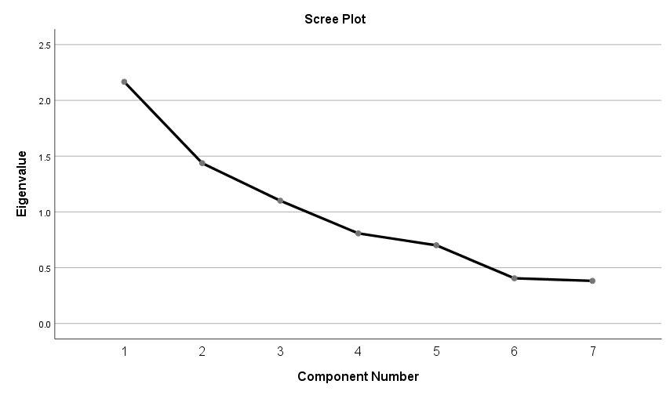
Figure 2: Scree plot of eigenvalues from principal component analysis showing the retention of three components based on the point of inflection and eigenvalues greater than one.

3.3 Socio-Economic and Production Characteristics of Farm Types
Significant differences in key farm characteristics across the four farm types were further examined using one-way ANOVA followed by Tukey post-hoc comparisons (Table 3). The results confirm that landholding size, maize productivity, and adoption of sustainable practices vary systematically across farm types, although the nature of these differences differs by variable.
For total landholding size, Tukey post-hoc results indicate that Farm Type 1 is significantly different from all other farm types (p < 0.001), operating substantially larger land areas. No statistically significant differences were observed among Farm Types 2, 3, and 4, suggesting that these groups are relatively similar in terms of land access despite differences in other characteristics.
In terms of maize yield, post-hoc comparisons show that Farm Type 4 achieves significantly higher yields than both Farm Type 2 (p = 0.001) and Farm Type 3 (p = 0.005). Differences between Farm Type 4 and Farm Type 1 were marginal (p = 0.061), while no significant differences were observed among Farm Types 1, 2, and 3. This highlights Farm Type 4 as the most productive group in maize, despite its relatively lower resource endowment.
For sustainable practice adoption, the results reveal that Farm Type 3 adopts significantly more sustainable practices than both Farm Type 2 (p = 0.004) and Farm Type 4 (p = 0.001). No significant differences were observed between Farm Type 3 and Farm Type 1, or among the remaining groups. This reinforces the characterization of Farm Type 3 as the most sustainability-oriented system.
Maize productivity varied significantly across farm types (p < 0.01), although the pattern differs from earlier expectations. Farm Type IV recorded the highest maize yields (1872.00 kg/ha), significantly outperforming Farm Types II and III, while differences with Farm Type I were marginal. Despite these yield differences, household income remained highest in Farm Type I (USD 2717.39) and declined progressively across Farm Types III, II, and IV (p < 0.01). This divergence indicates that higher maize productivity does not necessarily translate into higher overall income across farm types. Rather, income differences appear to reflect broader resource endowment factors, including landholding size and livestock ownership, as well as engagement in higher-value enterprises. These findings suggest that productivity and income are associated with farm typology, but not directly aligned at the individual variable level.
Farm resource endowment also differed significantly. Farm Type I operated substantially larger landholdings (16.33 acres) compared to the other farm types (p < 0.01), while livestock ownership was highest in Farm Type I (1.92 TLU), followed by Farm Type III (0.92 TLU), with Farm Types II and IV showing significantly lower levels. Input use patterns were similarly differentiated, with fertiliser application and hired labour use highest in Farm Type I and lowest in Farm Type IV (p < 0.01).
Land use patterns further highlight structural differences, with Farm Type IV allocating the largest share of land to legumes, while Farm Types I and III maintained relatively higher tobacco area shares. Age of household heads did not differ significantly across farm types (p = 0.111).
The distribution of education levels (Table 4) shows that primary education dominates across all farm types, particularly in Farm Types III and IV, while secondary education is more prevalent in Farm Type II. Tertiary education is rare and observed only in Farm Type I. Overall, these results indicate that farm types differ significantly in terms of resource endowment, production outcomes, and input use, while demographic characteristics such as age and education show relatively limited variation.
Table 3: Socio-economic and production characteristics of farm types
Variable | Farm Type I | Farm Type III | Farm Type II | Farm Type IV | p-value
Age (years) | 45.7ᵃ | 44.2ᵃ | 41ᵃ | 50.9ᵃ | 0.111
Household income (USD) | 2717.39ᵃ | 766.76ᵇ | 666.79ᶜ | 426.63ᵈ | <0.01
Livestock ownership (TLU) | 1.92ᵃ | 0.92ᵇ | 0.20ᶜ | 0.53ᶜ | <0.01
Farm area (acres) | 16.33ᵃ | 7.67ᵇ | 4.75ᶜ | 4.52ᶜ | <0.01
Mean Maize yield (kg/ha) | 1217.95ᵃ | 1178.23ᵇ | 1296.32ᶜ | 1872.00ᶜ | <0.01
Mean Legume area share (%) | 16ᶜ | 37ᵃᵇ | 39.35ᵇ | 51ᵃ | <0.01
Tobacco area share (%) | 7.5ᵃ | 7.0ᵃ | 5.0ᵇ | 0.0ᶜ | <0.01
Fertiliser use (kg/acre) | 166.6ᵃ | 133.4ᵇ | 131.0ᵇ | 82.2ᶜ | <0.01
Hired labour (%) | 100ᵃ | 33ᵇ | 24ᵇ | 0ᶜ | <0.01
Means sharing the same superscript letter are not significantly different at p < 0.05.
Table 4: Education level of household heads across farm types (%).
Education level | Farm Type I | Farm Type II | Farm Type III | Farm Type IV | Total
None | 0.00% | 5.00% | 0.00% | 0.00% | 2.30%
Primary | 33.30% | 35.00% | 66.70% | 71.40% | 51.20%
Secondary | 33.30% | 60.00% | 33.30% | 28.60% | 44.20%
Tertiary | 33.30% | 0.00% | 0.00% | 0.00% | 2.30%

To facilitate a visual comparison of farm characteristics, key variables related to productivity and resource use were standardized (scaled from 0 to 1) and presented using a radar plot (Figure 3). The variables included yields of major crops (lablab, maize, and cowpea), livestock density (TLU), total landholding, farm income per hectare, adoption of sustainable practices, and labour availability per unit land.
Farm Type 1 emerged as the best performing group exhibiting a resource-endowed and economically strong profile, characterized by the highest values in total land, farm income per hectare, and livestock density, as well as relatively strong performance in cowpea yield. However, it showed comparatively lower labour intensity and moderate adoption of sustainable practices, suggesting a more extensive production system.
Farm Type 3 displayed a balanced and sustainability-oriented profile, achieving the highest level of sustainable practice adoption while maintaining moderate levels across most other indicators, including livestock density, land size, and crop yields. This suggests a more integrated and management-intensive farming system.
Farm Type 2 reflected a labour-intensive but resource-constrained system, with the highest labour-to-land ratio and relatively strong income per hectare, but generally low performance across crop yields, landholding, and livestock ownership. This indicates reliance on labour rather than asset-based intensification.
Farm Type 4 demonstrated a productivity-oriented profile, with the highest maize and lablab yields among all groups. However, this came alongside relatively lower farm income per hectare, limited landholding, and low adoption of sustainable practices, suggesting a focus on yield maximization that may not yet translate into broader economic or sustainability gains.
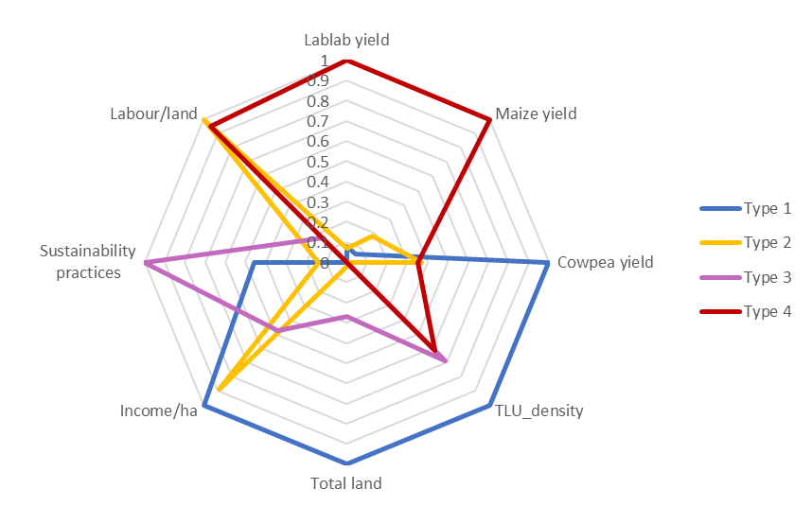
Figure 3: Radar plot showing standardized resource and production characteristics across farm types.

3.4 Multi-Criteria Analysis of Sustainable Intensification Innovations
Sustainable intensification innovations were evaluated across the four farm types using multi-criteria analysis. scores were calculated based on productivity potential, feasibility, economic viability, resource efficiency, and scalability.
The scaled innovation scores show clear variation across farm types. Conservation agriculture recorded the highest overall score (0.68), indicating the widest adoption across farm types, followed by intercropping (0.54). Strip cropping had the lowest overall score (0.25), with adoption concentrated in Farm Type II.
Farm Type III achieved the highest overall innovation score (0.66), followed by Farm Type I (0.60), while Farm Types II and IV recorded lower scores of 0.29 and 0.23, respectively. Farm Type I showed maximum adoption in intercropping, livestock integration, and conservation agriculture, whereas Farm Type III demonstrated consistently high scores across multiple innovations, including rotation and conservation agriculture. In contrast, Farm Type II relied primarily on strip cropping, while Farm Type IV showed generally low adoption across most innovations.
Table 5: MCA scores for sustainable intensification innovations.
Innovation | Type 1 | Type 2 | Type 3 | Type 4 | Average
Conservation Agriculture (Intensification) | 1 | 0 | 0.87 | 0.84 | 0.68
Intercropping | 1 | 0.17 | 1 | 0 | 0.54
Small Livestock Integration | 1 | 0 | 0.42 | 0.19 | 0.40
Legume–Maize Rotation (Cover Crop) | 0 | 0.3 | 1 | 0.11 | 0.35
Strip Cropping | 0 | 1 | 0 | 0 | 0.25
Overall Score | 0.6 | 0.29 | 0.66 | 0.23 | 0.45

4. Discussion
Integrating legumes into cropping systems through practices such as crop rotation, intercropping, and conservation agriculture is widely recognized as a pathway toward sustainable intensification. These practices can improve soil fertility, enhance land-use efficiency, and contribute to more resilient farming systems when appropriately matched to local conditions (Giller et al., 2009; Baudron et al., 2012; Rusinamhodzi et al., 2012). However, the results of this study highlight that the benefits and adoption of such practices are not uniform across farm households, but instead vary systematically with underlying differences in resource endowment, production strategies, and management capacity. This reinforces the broader understanding that smallholder farming systems are highly heterogeneous, and that uniform agricultural interventions often fail to capture this complexity (Tittonell et al., 2010; Kuivanen et al., 2016).

Farm diversity and its implications for agricultural development
The findings emphasise that farm diversity in Mtunthama EPA is not merely descriptive but has important implications for agricultural development planning. While the results clearly show variation in resource endowment and production strategies, the key insight is that such diversity fundamentally shapes how farmers respond to interventions and opportunities. This reinforces the argument that agricultural development approaches must move beyond aggregate recommendations and instead account for differences in capacity, incentives, and constraints across farm types (Alvarez et al., 2018; Giller et al., 2021).
An important implication emerging from this study is that similar external constraints such as input access limitations or climate variability do not translate into uniform outcomes across households. Rather, farm-level responses are mediated by underlying structural characteristics, particularly access to land, livestock, and labour. This highlights the risk of overgeneralising smallholder systems and supports growing evidence that heterogeneity is a defining feature of African farming systems, requiring differentiated analytical and policy approaches (Tittonell et al., 2010).
Furthermore, the observed distribution of farm types suggests that development strategies targeting only high-performing or highly resource-endowed farms may have limited impact at the population level. Instead, greater emphasis is needed on designing interventions that are inclusive of resource-constrained households, which constitute a substantial proportion of the farming population. This strengthens the case for typology-based targeting as a practical framework for improving the relevance, equity, and effectiveness of sustainable intensification efforts.

Resource endowment and farm performance patterns
The differences observed across farm types highlight the important, but not uniform, role of resource endowment in shaping farm performance. Consistent with the typology results, Farm Type I is characterised by substantially larger landholdings and higher livestock ownership, while Farm Types II and IV operate under more constrained resource conditions. These structural differences align with broader evidence that access to land and livestock assets remains a key determinant of production opportunities in smallholder systems (Giller et al., 2021).
However, the findings also demonstrate that resource endowment does not translate linearly into productivity outcomes. While Farm Type I exhibits the highest income levels and asset ownership, it does not achieve the highest maize yields. Instead, Farm Type IV records the highest maize productivity despite having relatively limited land and lower income levels. This suggests that farm performance reflects multiple interacting factors beyond resource access alone, including management strategies, crop choices, and possibly differential allocation of labour and inputs. Similar patterns have been reported in smallholder systems where yield outcomes are shaped by both resource availability and management intensity (Tittonell et al., 2010).
Livestock ownership remains an important distinguishing feature across farm types, particularly in differentiating wealthier households. Its contribution in this context appears to be more closely associated with income diversification and asset accumulation rather than directly observable yield differences. While integrated crop–livestock systems are widely recognised for their role in enhancing soil fertility and resource cycling (Tittonell et al., 2010), the results of this study do not show a direct statistical relationship between livestock density and maize productivity. This reinforces the need to interpret livestock integration as part of a broader livelihood and system resilience strategy rather than a direct driver of crop yield in isolation.
The role of labour and input use also appears more complex than a simple intensification gradient. Although labour-to-land ratios differ across farm types, correlation analysis indicates a negative relationship between labour intensity and land size, suggesting that smaller farms rely more heavily on family labour. However, this does not consistently translate into higher productivity. Similarly, while fertiliser use and hired labour are higher among resource-endowed farms, their effects are not directly reflected in maize yield differences across all groups. These findings highlight that constraints in input access and labour allocation interact with other structural and management factors, reinforcing the need for context-specific interpretations of farm performance.

Implications for targeting sustainable intensification innovations
The multi-criteria analysis demonstrates that the suitability of sustainable intensification innovations as perceived by farmers varied
considerably across farm types. Rather than identifying a single dominant innovation, the results suggest that innovation outcomes are strongly conditioned by farm-specific resource endowments and management strategies. This supports the argument that typology-based targeting is essential for designing effective interventions in heterogeneous smallholder systems (Kuivanen et al., 2016).
Among the evaluated innovations, conservation agriculture and intercropping emerged as the most consistently adopted practices across farm types, indicating their relative adaptability within the study context. Conservation agriculture recorded the highest overall score, suggesting broad relevance, while intercropping also performed strongly, particularly among certain farm types. In contrast, practices such as strip cropping and legume–maize rotation showed more limited or uneven adoption, reflecting possible constraints related to labour, knowledge, or resource requirements.
The variation in innovation scores across farm types further illustrates differentiated adoption pathways. Farm Types I and III achieved higher overall innovation scores, with Farm Type III demonstrating particularly strong performance across multiple practices, consistent with its characterization as a sustainability-oriented system. In contrast, Farm Types II and IV recorded lower scores, indicating more limited uptake of sustainable intensification practices. This pattern suggests that while some innovations are broadly applicable, their effective adoption is closely linked to household capacity and system characteristics.
Importantly, the results do not indicate a single innovation that performs optimally across all farm types. Instead, they highlight the need to consider trade-offs between feasibility, productivity, and resource requirements when promoting sustainable intensification practices. Similar findings have been reported in sub-Saharan Africa, where adoption of agricultural innovations is often uneven and shaped by local constraints and opportunities (Rusinamhodzi et al., 2012).

The role of typology-based targeting in sustainable intensification
The differentiated patterns observed across farm types underscore the importance of tailoring agricultural interventions to specific farm contexts. Typology-based approaches provide a structured framework for linking farm characteristics with appropriate development strategies, allowing for more precise targeting compared to uniform recommendations.
For resource-endowed farms, such as Farm Type I, interventions may focus on improving efficiency and sustainability within existing production systems. Given their greater access to land and assets, these households may be better positioned to adopt practices that enhance long-term soil health and system resilience, including conservation agriculture and improved crop–livestock integration.
Farm Type III represents a group with strong potential for sustainable intensification, given its relatively high adoption of sustainable practices and balanced resource base. Supporting this group through improved extension services and access to complementary inputs could further enhance both productivity and sustainability outcomes.
For more resource-constrained farm types, particularly Types II and IV, the results suggest that interventions should prioritise feasibility and risk reduction rather than complexity. Lower adoption of innovations among these groups indicates that constraints related to labour, capital, or knowledge may limit the uptake of more demanding practices. In such contexts, simpler and more flexible approaches, such as intercropping or incremental improvements in input use,may offer more realistic pathways for enhancing productivity and resilience.
Overall, these findings reinforce the value of typology-based targeting as a means of aligning agricultural interventions with the diverse realities of smallholder farmers. By accounting for differences in resource endowment, production strategies, and innovation capacity, such approaches can improve both the relevance and effectiveness of sustainable intensification efforts.

Enabling conditions for sustainable intensification
While farm-level innovations are important, broader institutional and policy environments play a critical role in enabling sustainable intensification. Collective action mechanisms, such as farmer cooperatives and producer groups, have been shown to improve market access, reduce transaction costs, and strengthen bargaining power for smallholder farmers (Kraaijvanger et al., 2016). In the context of Mtunthama EPA, strengthening farmer organisations could facilitate collective marketing of crops and livestock products while improving access to agricultural inputs.
Digital technologies also offer promising opportunities for enhancing agricultural advisory services. Mobile-based extension platforms can deliver timely information on weather conditions, pest management, and market prices, helping farmers make better-informed management decisions. Studies have shown that mobile-based advisory services can significantly improve productivity and resilience among smallholder farmers, particularly in areas where traditional extension services are limited (Aker, 2011; Masuka et al., 2016).
Supportive policy frameworks are equally essential for promoting sustainable intensification. Agricultural policies that provide targeted input support, expand access to credit, and strengthen extension systems can help address the structural barriers faced by many smallholder farmers. Integrating typology-based approaches into policy design may also improve the effectiveness of agricultural development programs by ensuring that interventions are tailored to different categories of farmers.

Study limitations and future research
Although this study provides valuable insights into farm diversity and innovation targeting in Mtunthama EPA, some limitations should be acknowledged. First, the typology analysis is based on a relatively small sample of households, which may limit the generalizability of the findings beyond the study area. Second, the analysis relies partly on self-reported production data, which may introduce measurement errors or recall bias.

In addition, the typology represents a static snapshot of farm characteristics at a single point in time. Farming systems are dynamic, and households may transition between typologies as their resource endowments, livelihood strategies, and environmental conditions change. Understanding these transitions is important for designing development interventions that support long-term improvements in agricultural productivity and resilience.
Future research could build on this work by incorporating longitudinal data to examine how farm households evolve over time and how different interventions influence these trajectories. Expanding the sample size and geographic scope of similar studies would also help strengthen the evidence base for typology-based approaches to sustainable intensification across Malawi and other smallholder farming regions in sub-Saharan Africa.

5. Conclusions
This study applied principal component analysis, cluster analysis, and a multi-criteria assessment to characterise farm diversity in Mtunthama Extension Planning Area (EPA), identifying four distinct farm types that differ in resource endowment, production strategies, and livelihood outcomes. The findings confirm substantial heterogeneity among smallholder households, particularly in terms of landholding size, livestock ownership, income levels, and adoption of sustainable practices. Importantly, the results show that resource endowment does not translate directly into productivity outcomes, as higher maize yields were observed among relatively resource-constrained farms, while higher income levels were concentrated among more resource-endowed households. The multi-criteria analysis further revealed that the performance and adoption of sustainable intensification innovations vary across farm types, with conservation agriculture and intercropping emerging as the most widely applicable practices. These findings reinforce the need to move beyond uniform agricultural recommendations and instead recognise the complex and context-specific nature of smallholder farming systems (Tittonell et al., 2010; Kuivanen et al., 2016; Komarek et al., 2019).
The study demonstrates that typology-based approaches provide a practical framework for designing targeted sustainable intensification strategies that reflect the diverse realities of farming households. Resource-endowed farms are better positioned to adopt integrated and asset-intensive practices, while moderately resourced farms show potential for incremental improvements through enhanced access to inputs and extension support. In contrast, resource-constrained farms require low-cost, risk-reducing innovations that prioritise feasibility and resilience. While the analysis offers important insights, it is based on a relatively small, cross-sectional dataset and relies partly on self-reported information, which may limit generalisability. Future research could build on these findings by incorporating larger samples, longitudinal data to capture transitions between farm types, and more detailed biophysical indicators. Overall, the results highlight the importance of aligning sustainable intensification interventions with farm-specific conditions to improve adoption, productivity, and livelihood outcomes in smallholder systems.

Declaration of Competing Interest
This manuscript is original unpublished work, read and approved by all authors, and not being considered for publication elsewhere. All those listed as authors have contributed to the development of this paper and have approved the manuscript and this submission. We have no conflicts of interest to declare.

Acknowledgements
We gratefully acknowledge the financial and technical support provided by the One CGIAR Initiative on Sustainable Intensification of Mixed Farming Systems (SI-MFS) under the International Maize and Wheat Improvement Center (CIMMYT). We also extend our appreciation to the Department of Agricultural Research Services (Malawi) for their valuable technical assistance.
Our sincere gratitude goes to the School of Agricultural, Earth and Environmental Sciences, University of KwaZulu-Natal (South Africa), and Wageningen University & Research (The Netherlands) for their academic support and guidance. Additionally, we thank the Department of Agricultural Extension for their collaboration and for facilitating the participation of their extension workers, who played a crucial role in data collection throughout the project.
Finally, we extend our deepest appreciation to the farmers for their time, insights, and willingness to share their experiences and expertise, which were instrumental to the success of this research project.

References

Aker, J. C. (2011). Dial "A" for agriculture: A review of information and communication technologies for agricultural extension in developing countries. Agricultural Economics, 42(6), 631–647. https://doi.org/10.1111/j.1574-0862.2011.00545.x
Alvarez, S., Timler, C. J., Michalscheck, M., Paas, W., Descheemaeker, K., Tittonell, P., ... & Groot, J. C. (2018). Capturing farm diversity with hypothesis-based typologies: An innovative methodological framework for farming system typology development. PloS one, 13(5), e0194757.
Baudron, F., Tittonell, P., Corbeels, M., Letourmy, P., & Giller, K. E. (2012). Comparative performance of conservation agriculture and conventional tillage systems in maize-based farming systems of Malawi and Zimbabwe. Field Crops Research, 132, 122–138.
Carelsen, C. P. R., Ncube, B., & Fanadzo, M. (2021). Classification and characterisation of smallholder farmers in South Africa: a brief review. South African Journal of Agricultural Extension, 49(2), 97-106.
Chimonyo, V. G. P., Mabhaudhi, T., Muthoni, F. K., & Chavula, G. (2023). Context assessment for mixed farming systems in Malawi.
Corbeels, M., Naudin, K., Whitbread, A. M., Kühne, R., & Letourmy, P. (2020). Limits of conservation agriculture to overcome low crop yields in sub-Saharan Africa. Nature Food, 1(7), 447–454. https://doi.org/10.1038/s43016-020-0114-x
Descheemaeker, K., Oosting, S. J., Homann-Kee Tui, S., Masikati, P., Falconnier, G. N., & Giller, K. E. (2022). Climate change adaptation and mitigation in smallholder crop–livestock systems in sub-Saharan Africa: A call for integrated impact assessments. Regional Environmental Change, 16(8), 2331–2343. https://doi.org/10.1007/s10113-016-0957-8
Emtage, N. F., & Suh, J. (2005). Socio-economic factors affecting regional adoption of new agricultural technologies. Journal of Agricultural Education and Extension.
Food and Agriculture Organization of the United Nations (FAO). (2013). The state of food and agriculture: Food systems for better nutrition. FAO.
Giller, K. E., Delaune, T., Silva, J. V., van Wijk, M., Hammond, J., Descheemaeker, K., van de Ven, G., Schut, A. G. T., Taulya, G., Chikowo, R., & Andersson, J. A. (2021). Small farms and development in sub-Saharan Africa: Farming for food, for income or for lack of better options? Food Security, 13(6), 1431–1454. https://doi.org/10.1007/s12571-021-01209-0
Giller, K. E., Witter, E., Corbeels, M., & Tittonell, P. (2009). Conservation agriculture and smallholder farming in Africa: The heretics’ view. Field Crops Research, 114(1), 23-34.
Gondwe, S. (2021). Assessment of maize and tobacco production trends in Kasungu District.
Greenacre, M. (2017). Correspondence Analysis in Practice. CRC Press.
Hair, J. F., Black, W. C., Babin, B. J., & Anderson, R. E. (2010). Multivariate data analysis (7th ed.). Pearson.
Hammond, J., van Wijk, M. T., Teufel, N., Isaacs, K., & Pagliaro, G. (2020). The Rural Household Multi-Indicator Survey (RHoMIS) for rapid characterisation of household-level livelihoods, food security and environmental impacts. Agricultural Systems, 180, 102804.
Huber, R., Bartkowski, B., Brown, C., El Benni, N., Feil, J. H., Grohmann, P., ... & Müller, B. (2024). Farm typologies for understanding farm systems and improving agricultural policy. Agricultural Systems, 213, 103800.
International Food Policy Research Institute (IFPRI). (2007). Malawi's legume revolution: Soybean diversification and income growth. IFPRI.
Iocola, I., Angevin, F., Bockstaller, C., Catarino, R., Curran, M., Messéan, A., ... & Canali, S. (2020). An actor-oriented multi-criteria assessment framework to support a transition towards sustainable agricultural systems based on crop diversification. Sustainability, 12(13), 5434.
Kasungu District Agricultural Extension Services (DAES). (2023). Annual Agricultural Report: Mtunthama Extension Planning Area. Ministry of Agriculture, Malawi.
Köbrich, C., Rehman, T., & Khan, A. S. (2003). Land use entities in the Fourth Region of Chile: An application of modern farm typology development techniques. Agricultural Systems, 76(1), 313–332.
Komarek, A. M., Kwon, H., Haile, B., Thierfelder, C., Mutenje, M. J., & Azzarri, C. (2019). From plot to scale: ex-ante assessment of conservation agriculture in Zambia. Agricultural Systems, 173, 504-518.
Kraaijvanger, R., Veldkamp, T., & Almekinders, C. (2016). Strengthening market access and collective action: A review of cooperative models in sub-Saharan Africa. Agricultural Economics, 47(4), 1–12. https://doi.org/10.1111/agec.12345
Kuivanen, K. S., et al. (2016). Characterising the diversity of smallholder farming systems: From species to farm types and socio-ecological interactions. Agricultural Systems, 145, 1–11.
Kuivanen, K. S., et al. (2021). A comparison of statistical and participatory clustering of smallholder farming systems: A case study in Northern Ghana. Journal of Rural Studies, 81, 27–37. https://doi.org/10.1016/j.jrurstud.2020.12.008
Lebart, L., Morineau, A., & Piron, M. (1995). Statistique exploratoire multidimensionnelle. Dunod.
Lopez-Ridaura, S., Barba-Escoto, L., Reyna, C. et al. Food security and agriculture in the Western Highlands of Guatemala. Food Sec. 11, 817–833 (2019). https://doi.org/10.1007/s12571-019-00940-z
López-Ridaura, S., Barba-Escoto, L., Reyna-Ramirez, C. A., Sum, C., Palacios-Rojas, N., & Gerard, B. (2021). Food security and agriculture in the Western Highlands of Guatemala. Food Security, 13(3), 595–614. https://doi.org/10.1007/s12571-021-01141-3
Marenya, P. P., & Barrett, C. B. (2009). State-conditional fertilizer yield response on Western Kenyan farms. American Journal of Agricultural Economics, 91(4), 991–1006. https://doi.org/10.1111/j.1467-8276.2009.01320.x
Masuka, B., Matenda, T., Chipomho, J., Mapope, N., Mupangwa, W., & Nyagumbo, I. (2016). Mobile technology adoption and its impact on smallholder farmer productivity in sub-Saharan Africa. Agricultural Systems, 146, 137–146. https://doi.org/10.1016/j.agsy.2016.05.009
Mtambanengwe, F., & Mapfumo, P. (2005). Organic matter management as a volatile resource in smallholder farming systems. Nutrient Cycling in Agroecosystems.
Musumba, M., Grabowski, P., Palm, C. A., & Snapp, S. S. (2017). Guide for the sustainable intensification assessment framework.
Mvula, S. (2017, September). Kasungu District Council socio economic profile 2017–2022. Kasungu District Council. https://globaluploads.webflow.com/6061a9d807f5368139d1c52c/610b26ade478c94f0e0c6cc4_ClearedKasungu-SEP-02-June-2018.pdf
NASFAM. (2022). Tobacco production and national economic impact report. National Smallholder Farmers' Association of Malawi.
National Statistical Office (NSO). (2017). Fourth Integrated Household Survey (IHS4) 2016-2017: Household Socio-Economic Characteristics Report. Zomba, Malawi.
Ngwira, A. R., Thierfelder, C., Eash, N., & Lambert, D. M. (2013). Risk and maize-based cropping systems for smallholder Malawi farmers using conservation agriculture technologies. Experimental Agriculture, 50(4), 1–15. https://doi.org/10.1017/S0014479713000306
Nunnally, J. C., & Bernstein, I. H. (1994). Psychometric theory (3rd ed.). McGraw-Hill.
Rahman, S., & Rahman, M. S. (2014). Exploring the potential and performance of maize production in Bangladesh. International Journal of Agricultural Management, 3(2), 99-107.
Rockström, J., Kaumbutho, P., Mwalley, J., Nzabi, A. W., Temesgen, M., Mawenya, L., ... & Damgaard-Larsen, S. (2009). Conservation farming strategies in East and Southern Africa: Yields and rain water productivity from on-farm action research. Soil and tillage research, 103(1), 23-32.
Rusinamhodzi, L., Corbeels, M., Nyamangara, J., & Giller, K. E. (2012). Maize–grain legume intercropping is an attractive option for ecological intensification that reduces risk for smallholder farmers in central Mozambique. Field Crops Research, 136, 12-22.
Snapp, S. S., Mafongoya, P. L., & Waddington, S. (2002). Organic matter technologies for integrated nutrient management in smallholder cropping systems of southern Africa. Agriculture, Ecosystems & Environment, 89(3), 217–229. https://doi.org/10.1016/S0167-8809(01)00167-8
Thornton, P. K. (2010). Livestock production: Recent trends, future prospects. Philosophical Transactions of the Royal Society B: Biological Sciences, 365(1554), 2853-2867.
Timler, C., Michalscheck, M., Alvarez, S., Descheemaeker, K., & Groot, J. C. (2017). Exploring options for sustainable intensification through legume integration in different farm types in Eastern Zambia. In Sustainable Intensification in Smallholder Agriculture (pp. 196-209). Routledge.
Tittonell, P., Klerkx, L., Baudron, F., Félix, G. F., Ruggia, A., van Apeldoorn, D., & Rossing, W. A. H. (2021). Ecological intensification: Local innovation to address global challenges. Agronomy for Sustainable Development, 41(1), 1–17. https://doi.org/10.1007/s13593-020-00658-9
Tittonell, P., Muriuki, A., Shepherd, K. D., Mugendi, D., Kaizzi, K. C., Okeyo, J., Verchot, L., Coe, R., & Vanlauwe, B. (2010). The diversity of rural livelihoods and their influence on soil fertility in agricultural systems of East Africa—A typology of smallholder farms. Agricultural Systems, 103(2), 83–97. https://doi.org/10.1016/j.agsy.2009.10.001
United Nations (UN). (2015). Transforming our world: The 2030 Agenda for Sustainable Development. UN General Assembly.
United Nations (UN). (2022). World population prospects 2022: Summary of results. UN Department of Economic and Social Affairs.
van Ittersum, M. K., van Bussel, L. G. J., Wolf, J., Grassini, P., van Wart, J., Guilpart, N., & Cassman, K. G. (2016). Can sub-Saharan Africa feed itself? Proceedings of the National Academy of Sciences, 113(52), 14964–14969. https://doi.org/10.1073/pnas.1610359113
van Wijk, M. T., Merbold, L., Hammond, J., & Butterbach-Bahl, K. (2020). Improving assessments of the three pillars of climate smart agriculture: Current achievements and ideas for the future. Frontiers in Sustainable Food Systems, 4, 558483. https://doi.org/10.3389/fsufs.2020.558483
Verschelde, M., D’Haese, M., Rayp, G., & Vandamme, E. (2013). Challenging small‐scale farming: A non‐parametric analysis of the (Inverse) relationship between farm productivity and farm size in Burundi. Journal of Agricultural Economics, 64(2), 319-342.
World Bank. (2009). Malawi: Community based rural land development project - Project information document (PID). ReliefWeb.
Zingore, S., Mutegi, J., Agesa, B., Tamene, L., & Kihara, J. (2022). Soil degradation in sub-Saharan Africa and crop production options for soil rehabilitation. Agriculture, Ecosystems & Environment, 326, 107824. https://doi.org/10.1016/j.agee.2021.107824

Chapter 4
Farmers’ Perceptions of the Advantages, Risks and Farmer-Centred Targeting of Sustainable Intensification Innovations in Mtunthama EPA, Central Malawi
Kamwana-Ngwira Florence^{1,2,3}, Chiduwa Mazvita^{2,} Mabhaudhi Tafadzwanashe³ Groot Jeroen⁴ Santiago Lopez-Ridaura⁴
¹Department of agriculture research services, Malawi ²International Maize and Wheat Improvement Center (CIMMYT), Malawi, ³School of Agricultural, Earth and Environmental Sciences, University of KwaZulu Natal, Private Bag X01, Scottsville 3209, South Africa, ⁴Wageningen University & Research (WUR), The Netherlands
*Corresponding author: kamwanaflorence@yahoo.co.uk
Abstract
Smallholder farming systems in sub-Saharan Africa are highly heterogeneous, resulting in differences in farmers’ capacities, priorities, and responses to sustainable intensification (SI) innovations. This study assessed farmers’ perceptions of selected SI innovations and evaluated their suitability across different farm typologies in Mtunthama Extension Planning Area, Central Malawi. A mixed-methods participatory approach involving focus group discussions, key informant interviews, and farmer-led innovation ranking was used to evaluate six SI innovations across four farm typologies. Qualitative data were analysed using thematic content analysis, while preference rankings were converted into weighted and standardised scores for comparison across farm types. Farmers generally perceived SI innovations positively, identifying improved yields, soil fertility, food security, dietary diversity, and climate resilience as major benefits. However, labour requirements, input constraints, management complexity, and limited training were identified as key barriers to adoption. Innovation preferences differed considerably across farm typologies, reflecting variations in household resource endowment and livelihood strategies. Although conventional ridging with continuous sole maize received the highest proportion of first-choice rankings, conservation agriculture systems incorporating legumes, particularly maize–cowpea double-row strip cropping, achieved the highest overall preference scores because they were consistently favoured across farm types. The findings demonstrate that farmer evaluations extend beyond agronomic performance to include livelihood needs and resource constraints. Integrating farm typology analysis with participatory innovation assessment can improve the targeting of SI interventions and support the design of context-specific innovation packages that are more likely to achieve sustained adoption than blanket technology recommendations.
Keywords: Conservation agriculture, legume integration, participatory evaluation, innovation adoption, food security, climate resilience, mixed farming systems.

Introduction
Smallholder farming systems in sub-Saharan Africa are inherently heterogeneous, differing substantially in landholding size, livestock ownership, labour availability, access to capital, market participation, and livelihood objectives (Tittonell et al., 2009; Alvarez et al., 2018). This diversity shapes how farming households allocate resources, respond to production constraints, and evaluate agricultural innovations. Rather than representing a single farming population, smallholder agriculture consists of multiple farm types with distinct capacities, priorities, and production strategies, requiring interventions that recognise this variability (Garrity et al., 2012; Franke et al., 2014).

Agriculture remains the foundation of rural livelihoods in Malawi, where the majority of households depend on rain-fed maize-based mixed farming systems for food security and income generation. However, agricultural productivity remains constrained by declining soil fertility, small landholdings, climate variability, and limited access to productive resources (Mango et al., 2018; Bhatti et al., 2021). Climate projections further suggest that increasing temperatures and uncertain rainfall patterns will continue to threaten maize production and increase production risk unless farming systems become more resilient and adaptive (Warnatzsch & Reay, 2020). These challenges have intensified interest in production systems capable of increasing productivity while simultaneously strengthening resilience and maintaining natural resource quality.

Sustainable Intensification (SI) has emerged as one of the leading frameworks for addressing these challenges by increasing agricultural productivity without causing unacceptable environmental degradation while improving the resilience of farming systems (Pretty et al., 2011; Pretty, 2018; Vanlauwe et al., 2014). Rather than relying on a single technology, sustainable intensification promotes complementary practices that improve resource-use efficiency and strengthen interactions between crops, livestock, soils, and natural resources. Within smallholder farming systems these practices commonly include conservation agriculture, legume integration, crop diversification, crop rotation, integrated crop–livestock systems, and improved soil fertility management.

In Malawi, sustainable intensification has increasingly been promoted through initiatives such as Africa RISING and the Sustainable Intensification of Mixed Farming Systems (SI-MFS) programme to improve productivity, restore soil fertility, and strengthen resilience among smallholder farmers (TerAvest, 2012; Homann-Kee Tui et al., 2025). Evidence from long-term experiments and participatory on-farm research demonstrates that integrating legumes into maize-based systems can improve soil fertility, maintain maize productivity, increase dietary diversity, and reduce production risks (Snapp et al., 2002; Smith et al., 2017; Franke et al., 2014). Similarly, conservation agriculture and integrated crop–livestock systems have been shown to improve soil moisture conservation, nutrient cycling, and long-term system sustainability when appropriately adapted to local farming conditions (Giller et al., 2021; Valbuena et al., 2012).

Despite these documented benefits, adoption and sustained implementation of sustainable intensification practices remain uneven across smallholder farming systems (Ngoma et al., 2021; Takahashi et al., 2019). Research increasingly shows that adoption decisions are influenced not only by the agronomic performance of technologies but also by farmers' perceptions of labour requirements, input availability, profitability, risk, compatibility with existing farming systems, and expected livelihood benefits (Rogers, 2003; Alomia-Hinojosa et al., 2018; Zeweld et al., 2017). Farmers therefore evaluate innovations within the broader context of household objectives and resource constraints rather than solely on their technical performance.

Participatory research has demonstrated that direct farmer involvement in technology evaluation can substantially improve understanding of adoption behaviour. For example, Alomia-Hinojosa et al. (2018) found that participatory evaluation of maize–legume innovations in Nepal improved farmers' perceptions of new technologies, yet final adoption decisions continued to depend on labour availability, access to inputs, and compatibility with existing farming systems. Similar findings have been reported across sub-Saharan Africa, where labour scarcity, seasonal cash shortages, and competing household priorities frequently limit adoption even when technologies are perceived positively (White et al., 2005; Leonardo et al., 2015; Takahashi et al., 2019).

An increasing body of literature also recognises that differences among farming households strongly influence which innovations are technically suitable and economically feasible. Farm typology approaches have therefore become important tools for understanding farming system diversity and for designing interventions that better match technologies to household characteristics (Alvarez et al., 2018; Franke et al., 2014). Rather than recommending identical technology packages to all farmers, typologies provide a basis for identifying innovations that align with differences in resource endowment, labour availability, market orientation, and production objectives.

The farming system typology developed in the previous chapter identified substantial diversity among households in Mtunthama Extension Planning Area, including differences in crop–livestock integration, landholding size, labour availability, asset ownership, and market participation. Four distinct farm types were identified, ranging from resource-endowed households with relatively diversified enterprises to resource-constrained households facing greater labour and capital limitations. These differences suggest that the suitability of sustainable intensification innovations is unlikely to be uniform across households and that farmer-centred targeting may improve both adoption and long-term sustainability.

Understanding farmers' perceptions of sustainable intensification innovations is therefore important for several reasons. First, perceptions influence both the initial acceptance and the sustained implementation of agricultural innovations (Rogers, 2003). Second, farmers' evaluations provide valuable insight into the practical trade-offs they consider when balancing productivity, labour, food security, and livelihood objectives (Alomia-Hinojosa et al., 2018; Pannell et al., 2006). Third, identifying how these perceptions vary across farm typologies can support the development of more targeted extension strategies and context-specific innovation packages that better reflect the diversity of smallholder farming systems.

This study therefore aimed to assess farmers' perceptions of selected sustainable intensification innovations and evaluate their suitability across different farm typologies in Mtunthama Extension Planning Area, Central Malawi. Specifically, the study sought to (i) identify and describe major sustainable intensification innovations promoted within mixed farming systems; (ii) assess farmers' perceptions of the advantages and risks associated with the selected innovations; (iii) evaluate sustainable intensification innovations using farmer-defined criteria; and (iv) examine farmer-centred targeting of sustainable intensification innovations across different household typologies.

Methodology

Study Area
The study was conducted in Mtunthama Extension Planning Area, located in Kasungu District in the Central Region of Malawi (Figure 1). The area is characterised by mixed crop–livestock farming systems in which maize-based production is integrated with legumes, tobacco, and small livestock enterprises. Agriculture in the area is rain-fed and forms the primary livelihood source for rural households (Nyamayevu et al., 2024). Sustainable intensification (SI) innovations have increasingly been promoted within the area by government extension services, research institutions, and development organisations to address declining productivity, soil degradation, and climate-related production risks among smallholder farmers.
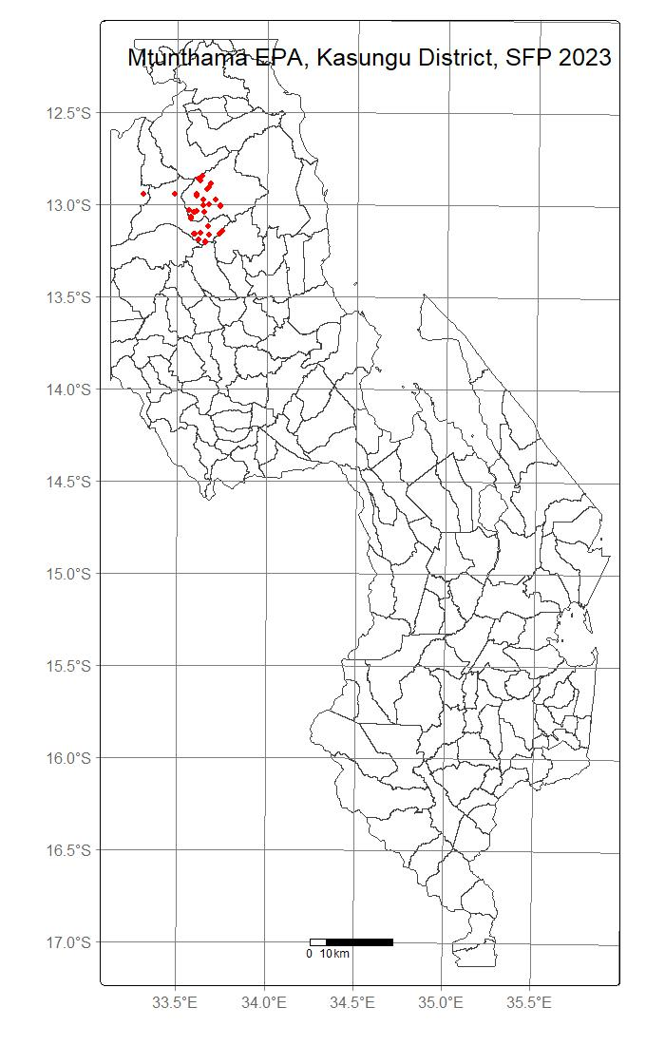
Figure 1: Map of Malawi showing Kasungu district, Mtunthama EPA, and farms of the study marked with red dots

Kasungu District experiences a tropical sub-humid climate with distinct seasonal variations. The cool dry season extends from May to August, with mean daily temperatures ranging from 17 to 27°C, followed by a hot dry season from September to October, during which temperatures range from 25 to 37°C. The rainy season occurs from November to April and contributes the majority of annual precipitation, averaging between 800 and 1,000 mm annually. Rainfall is concentrated between December and March and supports the main cropping season. However, increasing temperatures and growing uncertainty in rainfall distribution have heightened production risks for rain-fed maize systems in Central Malawi, with projected climate change expected to increase yield variability and the risk of maladaptation if appropriate adaptation strategies are not implemented (Warnatzsch & Reay, 2020).
The district is dominated by medium-textured sandy loam soils that are susceptible to erosion and nutrient depletion, although patches of relatively fertile clay loam soils are also present. Continuous cultivation, monocropping, and limited use of soil conservation practices have contributed to declining soil fertility and land degradation in many farming areas (Thierfelder et al., 2013). These production constraints have contributed to the promotion of sustainable intensification approaches such as conservation agriculture, legume integration, intercropping, fertiliser micro-dosing, and crop–livestock integration within the district.
Cropping systems in the study area are dominated by maize, which serves as the primary staple crop and occupies the largest proportion of cultivated land. Tobacco is the major cash crop and represents an important income source for many households in Kasungu District (Thabbie, 2004; Mwasikakata, 2003). Legumes, particularly soybean, groundnut and pigeonpea, are widely promoted because they improve biological nitrogen fixation, diversify household food production and enhance long-term soil fertility within maize-based systems (Franke et al., 2014; Smith et al., 2017). Cassava and sweet potatoes are also cultivated as supplementary food and climate-resilient crops, although they occupy relatively smaller land areas.
Livestock production forms an important component of rural livelihood systems in the area. Farmers commonly rear cattle, goats, pigs, sheep, poultry, and rabbits for income generation, manure production, asset accumulation, and household nutrition (Homann-Kee Tui et al., 2025). Although livestock are important for nutrient cycling, income generation and household resilience, many resource-constrained households own relatively small herds, creating competition between crop residues used as livestock feed and those retained as soil mulch (Valbuena et al., 2012). The farming systems in the area therefore exhibit considerable diversity in terms of landholding size, livestock ownership, labour allocation, market orientation, and enterprise combinations.
Smallholder farmers in Kasungu, Malawi, particularly in the Mtunthama EPA, face interconnected agricultural challenges including severe soil nutrient depletion, high input costs, labour shortages, and poor market access (Phiri et al., 2012). These factors, combined with increasing climate variability, severely restrict livelihood stability and technology adoption (Bhatti et al., 2021). Most households rely on smallholder rain-fed agriculture and operate under resource-constrained conditions, which influence their production decisions and ability to adopt agricultural innovations. These conditions make the area particularly relevant for examining how farmers perceive different sustainable intensification options within diverse livelihood systems.
The research was conducted across eight sections within Mtunthama EPA. Previous farm typology analysis conducted in the area revealed substantial heterogeneity among households in terms of resource endowment, productivity orientation, labour use, and sustainable practice adoption, providing an appropriate context for assessing farmer perceptions and farmer-centred targeting of SI innovations.

Selection of Sustainable Intensification Innovations
Six sustainable intensification (SI) innovations commonly promoted within mixed farming systems in Mtunthama Extension Planning Area were selected for evaluation. The innovations were identified through a combination of literature review, consultations with agricultural extension personnel, and preliminary discussions with farmers during field reconnaissance activities. Selection was guided by the relevance of the innovations to key production challenges in the study area, including declining soil fertility, low agricultural productivity, climate variability, limited resource availability, and livelihood diversification needs.
The selected innovations represented a range of agronomic, ecological, and livelihood-oriented intensification strategies that are widely promoted within Malawi and across sub-Saharan Africa as complementary strategies for improving productivity, soil fertility and resource-use efficiency (Pretty et al., 2011; Vanlauwe et al., 2014; Takahashi et al., 2019). In addition, the innovations differed in terms of labour requirements, input intensity, management complexity, and expected livelihood benefits, making them appropriate for evaluating farmer perceptions across heterogeneous farm types. Table 1 presents the sustainable intensification innovations evaluated in this study.
Table 1: Sustainable Intensification Innovations Evaluated
Innovation | Description
Conservation Agriculture | Farming approach based on minimum soil disturbance, permanent soil cover, and crop diversification
Legume–Maize Rotation | Sequential cultivation of legumes and maize to improve soil fertility and nitrogen cycling
Strip Cropping (Maize–Cowpea) | Cultivation of maize and cowpea in alternating strips to improve land productivity and reduce risk
Small Livestock Integration | Integration of goats, poultry, or pigs into cropping systems for nutrient cycling and livelihood diversification
Fertilizer Micro-Dosing | Application of small, targeted quantities of fertilizer to improve nutrient use efficiency
Intercropping | Simultaneous cultivation of two or more crops on the same plot to enhance productivity and resilience

Research Design and Data Collection
The study adopted a participatory research design consistent with farmer-centred innovation evaluation approaches that actively engage farmers in assessing technologies under their own production conditions (Alomia-Hinojosa et al., 2018). The approach also recognises farm heterogeneity through the use of farm typologies to support context-specific evaluation of agricultural innovations (Alvarez et al., 2018).
Data collection involved focus group discussions (FGDs), key informant interviews (KIIs), and participatory innovation evaluation exercises conducted four times for each, among the forty-four farming households within the previously identified farm typologies. The integration of multiple methods allowed triangulation of farmer perspectives and enhanced understanding of how perceptions differed across heterogeneous farming systems.
Participants were purposively selected from households previously classified into the four farm typologies developed in Chapter 3. The typologies represented contrasting resource endowment levels, livelihood strategies, labour allocation patterns, and production orientations. This enabled an assessment of how perceptions of SI innovations varied according to household characteristics and farming system context.

Focus Group Discussions
A total of four focus group discussions were conducted with farmers representing different farm typologies to explore perceptions of the advantages, risks, constraints, and suitability of selected SI innovations. Separate discussions were organised to encourage open interaction among households with relatively similar production conditions and resource endowments. Discussions focused on perceived productivity benefits, labour requirements, profitability, implementation challenges, risk exposure, compatibility with existing livelihood systems, and long-term sustainability considerations.
The FGDs also explored how household resource availability, livestock ownership, labour access, and market participation influenced farmer preferences for different SI options.

Key Informant Interviews
For four times key informant interviews (KIIs) were conducted with agricultural extension officers, lead farmers, and representatives of agricultural development organisations operating within Mtunthama EPA. The interviews provided contextual information regarding the promotion history of SI innovations, observed adoption patterns, extension challenges, and perceived suitability of innovations under different farming conditions.
The KIIs also helped validate farmer-reported constraints and targeting considerations identified during focus group discussions.

Participatory Innovation Evaluation
Participatory innovation evaluation exercises were conducted to assess farmers’ perceptions of the selected SI innovations using farmer-defined evaluation criteria. The criteria reflected both technical and livelihood-oriented dimensions influencing innovation suitability within smallholder farming systems.
Farmers collectively discussed and scored each innovation against the selected criteria using a participatory ranking approach. The evaluation process encouraged farmers to compare innovations based on practical experiences, perceived trade-offs, and expected livelihood outcomes under real farming conditions. Table 2 presents the criteria used for evaluating sustainable intensification innovations.

Table 2: Farmer Evaluation Criteria for Sustainable Intensification Innovations
Criterion | Description
Productivity Potential | Perceived ability of the innovation to improve crop or livestock productivity
Feasibility of Adoption | Ease of implementation considering labour, skills, and resource requirements
Economic Viability | Potential to increase income or reduce production costs
Resource Use Efficiency | Efficient utilisation of land, labour, nutrients, and water resources
Scalability and Replicability | Potential for wider adoption and applicability among farming households
The evaluation criteria were selected because previous research has shown that farmers evaluate agricultural innovations not only according to expected productivity gains but also according to labour requirements, compatibility with existing farming systems, profitability, implementation feasibility and perceived usefulness (Alomia-Hinojosa et al., 2018; Zeweld et al., 2017; Arsil et al., 2022).

Ethical Consideration
All participants were informed about the objectives of the study, the nature of their participation, and the intended use of the information collected. Participation was entirely voluntary, and informed consent was obtained from all respondents before focus group discussions, key informant interviews, and participatory evaluation exercises commenced. Participants were assured that they could decline to answer any question or withdraw from the study at any stage without any negative consequences. To ensure confidentiality and privacy, no personal identifiers were included in the analysis or reporting of results, and all information collected was used solely for academic research purposes.

Data Analysis
Qualitative data obtained from focus group discussions (FGDs) and key informant interviews (KIIs) were analysed using thematic content analysis. An inductive coding approach was applied, whereby farmer responses were systematically coded and grouped into major themes related to perceived benefits, production risks, labour demands, profitability, resource constraints, climate resilience, compatibility with livelihood systems, and adoption feasibility. Thematic comparisons were subsequently conducted across farm typologies to identify differences and similarities in farmer perceptions and innovation experiences.
In addition, farmers' participatory ranking data were analysed using a structured ordinal-to-interval transformation approach. Farmers were asked to rank the six sustainable intensification (SI) innovations from 1 (most preferred) to 6 (least preferred). These ordinal rankings were converted into weighted preference scores using an inverse weighting system, where higher-ranked innovations received higher scores (1st choice = 6, 2nd = 5, 3rd = 4, 4th = 3, 5th = 2, and 6th = 1). The weighted preference score for each innovation was calculated as:
${WPS}_{i} = \sum_{j=1}^{6}{(w_{j} × f_{ij})}$
where WPS_{i} is the weighted preference score for innovation i, w_{j} is the weight assigned to ranking position j (6, 5, 4, 3, 2, and 1 for first to sixth choice, respectively), and f_{ij} is the number of farmers who assigned innovation i to ranking position j. The resulting scores were aggregated by innovation and disaggregated by farm typology to assess variation in preferences across household groups.
To facilitate comparison across farm types with different sample sizes, weighted preference scores were subsequently standardised by dividing the observed weighted score by the maximum possible score for each farm type:
$${SPS}_{i}=\frac{{WPS}_{i}}{6 ×n}$$
where SPS_{i} is the standardised preference score for innovation i, WPS_{i} is the observed weighted preference score, n is the number of respondents within the respective farm typology, and 6 represents the maximum possible weight a single respondent can assign. The standardised scores ranged from 0 to 1, with values closer to 1 indicating stronger overall farmer preference for a particular innovation.
To enable cross-innovation comparison and visual representation, composite preference scores were normalised as a proportion of the maximum achievable score. This standardisation facilitated the construction of comparative visual outputs, including radar plots, to illustrate multidimensional preference patterns across farm types.
Participatory innovation evaluation responses were further summarised using descriptive statistics, and mean scores were computed for each innovation across the evaluation criteria (productivity potential, feasibility of adoption, economic viability, resource use efficiency, and scalability). These composite indices were used to compare perceived suitability of SI options across heterogeneous farming systems.
Finally, quantitative and qualitative findings were triangulated to strengthen interpretation of results. The analysis emphasised understanding how farm heterogeneity shapes farmer perceptions, innovation preferences, and targeting pathways rather than identifying universally superior technologies. This analytical approach aligns with contemporary sustainable intensification research that recognises the importance of farm heterogeneity, participatory evaluation and context-specific targeting of innovations rather than assuming universal suitability across farming households (Alvarez et al., 2018; Franke et al., 2014; Alomia-Hinojosa et al., 2018).

Results

Farmers' Perceptions of Sustainable Intensification Innovations Across Farm Typologies
Farmers across all farm typologies expressed generally positive perceptions towards the sustainable intensification (SI) innovations evaluated in the study (Table 3). All respondents in the study expressed willingness to participate in future research trials. At the same time, most reported that participation in the innovation trials had improved their ability to make farm management decisions.
Perceptions regarding the primary benefits of the innovations were broadly similar across typologies. Yield improvement was most frequently identified as the principal benefit, followed by improvements in soil fertility. Furthermore, all respondents from the low- and medium-resource groups and the majority of respondents from the high-resource group reported that intercropping resulted in higher yields compared with sole cropping.
Most respondents perceived the innovations as contributing to improved resilience against climatic variability. Nearly all farmers agreed that the innovations helped them cope with unpredictable weather conditions and contributed to more stable household incomes. Similarly, positive perceptions were observed regarding crop–livestock integration, with respondents across all typologies indicating that integrating livestock into farming systems improved overall farm productivity and reduced dependence on external inputs such as inorganic fertilisers.
Despite these positive perceptions, several implementation challenges were reported. Across all typologies, most respondents indicated that successful implementation of the innovations required additional inputs and resources. Perceptions regarding labour requirements differed among farm types. All low-resource and high-resource farmers reported that the innovations required additional labour, whereas most medium-resource farmers perceived the innovations as requiring less labour. Likewise, perceptions of management complexity varied across typologies, with low-resource farmers generally reporting that innovation plots were easier to maintain, while a larger proportion of high-resource farmers considered them more difficult to manage throughout the growing season.
Responses regarding the adequacy of training were mixed. Only half of the low-resource farmers reported receiving sufficient training to implement the innovations independently, whereas most medium- and high-resource farmers either disagreed or were neutral. Interest in participating in future research trials without external input support was lower than overall willingness to participate in trials, particularly among high-resource households.
Regarding residue management, clear differences were observed among farm typologies. Most low-resource households preferred using crop residues for mulching, whereas livestock feeding was more frequently preferred among medium- and high-resource households. Nevertheless, the majority of respondents across all typologies agreed that retaining crop residues in the field was an effective management practice.
Overall, the results indicate widespread positive perceptions of sustainable intensification innovations across farm typologies, although differences were observed in perceived labour requirements, management complexity, training adequacy, and residue use preferences.
Table 3: Percentage of farmers reporting selected perceptions, benefits, and challenges of sustainable intensification (SI) innovations across farm resource typologies.
Perception domain | Indicator | Low-resource (%) (n = 6) | Medium-resource (%) (n = 8) | High-resource (%) (n = 8)
Research participation and learning | Willing to participate in future research trials | 100.0 | 100.0 | 100.0
 | Reported improved farm decision-making after participation | 100.0 | 75.0 | 100.0
 | Received sufficient training to independently implement innovations | 50.0 | 25.0 | 25.0
 | Willing to participate without externally provided inputs | 66.7 | 50.0 | 37.5
Perceived productivity benefits | Identified yield improvement as the main benefit | 66.7 | 50.0 | 50.0
 | Identified soil improvement as the main benefit | 0.0 | 12.5 | 25.0
 | Believed intercropping produces higher yields than sole cropping | 100.0 | 100.0 | 87.5
Perceived resilience and livelihood benefits | Innovations help cope with unpredictable weather | 100.0 | 87.5 | 100.0
 | Innovations contribute to more stable income | 100.0 | 100.0 | 100.0
 | Crop–livestock integration improves farm productivity | 100.0 | 100.0 | 100.0
 | Livestock integration reduces dependence on external inputs | 100.0 | 100.0 | 100.0
Perceived implementation challenges | Innovations require additional inputs and resources | 100.0 | 100.0 | 87.5
 | Innovations require more labour | 100.0 | 12.5 | 100.0
 | Innovations are easier to maintain | 100.0 | 12.5 | 12.5
 | Innovations are harder to maintain | 0.0 | 0.0 | 50.0
Pest and disease perceptions | Observed lower pest and disease pressure on innovation plots | 50.0 | 62.5 | 50.0
 | Observed higher pest and disease pressure on innovation plots | 50.0 | 37.5 | 25.0
Crop residue management preferences | Prefer residues for mulching | 100.0 | 25.0 | 12.5
 | Prefer residues for livestock feeding | 0.0 | 12.5 | 12.5
Crop diversification preferences | Prefer growing diverse crop enterprises | 100.0 | 100.0 | 100.0
Mixed farming system challenges | Reported challenges balancing crop and livestock enterprises | 0.0 | 0.0 | 0.0

Farmer Preference Ranking of Sustainable Intensification Innovations Across Farm Typologies
Farmers from the four farm typologies ranked six sustainable intensification (SI) innovation options according to their overall preference. The ranking exercise revealed substantial variation in preferences both within and across farm types, indicating that innovation attractiveness was strongly influenced by household characteristics and farming contexts.

First-Choice Preferences Across Farm Typologies
The distribution of first-choice rankings revealed distinct preference patterns among farm types (Table 4). Among Farm Type I households, preferences were evenly distributed among CA with cowpea–maize rotation, CA with lablab–maize rotation, and CA with continuous sole maize, each selected by 33.3% of respondents as their most preferred innovation. Although the sample size was small (n=3), these results suggest the absence of a dominant innovation preference within this farm type.
Farm Type II households showed the strongest preference for diversified conservation agriculture systems. CA with maize–lablab double-row strip cropping was the most frequently selected first-choice innovation (30.0%), followed by CA with maize–cowpea double-row strip cropping (25.0%). Conventional ridging with continuous sole maize accounted for 20.0% of first-choice rankings, while rotational CA systems received comparatively lower support.
A contrasting pattern was observed among Farm Type III households, where conventional ridging with continuous sole maize emerged as the dominant first-choice innovation, selected by 50.0% of respondents. The remaining first-choice rankings were equally distributed among CA with lablab–maize rotation, CA with maize–cowpea double-row strip cropping, and CA with maize–lablab double-row strip cropping (16.7% each).
Similarly, Farm Type IV households exhibited a relatively strong preference for conventional ridging with continuous sole maize (35.7%), followed by CA with maize–cowpea double-row strip cropping (28.6%). Other innovations received considerably lower levels of first-choice support.
Across all farm types combined, conventional ridging with continuous sole maize was the most frequently selected first-choice innovation (27.9%), followed by CA with maize–cowpea double-row strip cropping (23.3%) and CA with maize–lablab double-row strip cropping (18.6%).
Table 4: Distribution of first-choice rankings (%) for sustainable intensification innovations across farm typologies.
Innovation | Farm Type I (n = 3) | Farm Type II (n = 20) | Farm Type III (n = 6) | Farm Type IV (n = 14) | Overall (n = 43)
CA with cowpea–maize rotation | 33.3 | 10.0 | 0.0 | 14.3 | 11.6
CA with lablab–maize rotation | 33.3 | 5.0 | 16.7 | 0.0 | 7.0
CA with maize/cowpea double-row strip cropping | 0.0 | 25.0 | 16.7 | 28.6 | 23.3
CA with maize/lablab double-row strip cropping | 0.0 | 30.0 | 16.7 | 7.1 | 18.6
Conservation Agriculture with continuous sole maize | 33.3 | 10.0 | 0.0 | 14.3 | 11.6
Conventional ridging with continuous sole maize | 0.0 | 20.0 | 50.0 | 35.7 | 27.9

Preference Distribution Across Ranking Positions
Analysis of rankings across all six preference positions revealed notable differences in the consistency of farmer preferences. Conventional ridging with continuous sole maize received the largest proportion of first-choice rankings (27.9%), but it was also the innovation most frequently ranked last (32.6%). This indicates substantial variation in farmer perceptions of the practice across farm types.
In contrast, CA with maize–cowpea double-row strip cropping consistently appeared among the highest-ranked innovations while rarely appearing in the lowest preference category. Similarly, CA with cowpea–maize rotation generally received favourable rankings across multiple preference positions. Innovations involving lablab, particularly CA with lablab–maize rotation, appeared more frequently in lower-ranking categories and were less commonly selected as first-choice options.
These findings suggest that while some innovations generated broad support across farm types, others elicited more polarised responses, reflecting differences in household priorities, production objectives, and resource endowments.

Standardised Preference Scores Across Farm Typologies
To facilitate comparison across farm types with different sample sizes, ranking responses were converted into weighted preference scores and standardised. The resulting scores revealed broadly similar patterns to those observed in the first-choice rankings (Table 5; Figure 2).
CA with maize–cowpea double-row strip cropping recorded the highest preference scores among Farm Types II, III, and IV, with standardised scores of 0.717, 0.722, and 0.643, respectively. Farm Type I showed relatively similar preference scores for CA with lablab–maize rotation, CA with maize–cowpea strip cropping, and CA with continuous sole maize (0.667 each).
Farm Type II generally favoured diversified conservation agriculture systems, particularly strip-cropping arrangements involving legumes. Farm Type III displayed strong preferences for maize–cowpea strip cropping and legume rotations, despite the relatively high proportion of respondents selecting conventional ridging as their first-choice innovation. Farm Type IV recorded the highest score for CA with continuous sole maize (0.690), although maize–cowpea strip cropping remained highly preferred (0.643).
Table 5: Standardised weighted preference scores for sustainable intensification innovations across farm typologies.
Innovation | Farm Type I (n=3) | Farm Type II (n=20) | Farm Type III (n=6) | Farm Type IV (n=14)
CA with cowpea–maize rotation | 0.556 | 0.583 | 0.611 | 0.583
CA with lablab–maize rotation | 0.667 | 0.408 | 0.611 | 0.476
CA with maize/cowpea double-row strip cropping | 0.667 | 0.717 | 0.722 | 0.643
CA with maize/lablab double-row strip cropping | 0.333 | 0.608 | 0.583 | 0.524
Conservation Agriculture with continuous sole maize | 0.667 | 0.642 | 0.361 | 0.69
Conventional ridging with continuous sole maize | 0.611 | 0.542 | 0.611 | 0.583
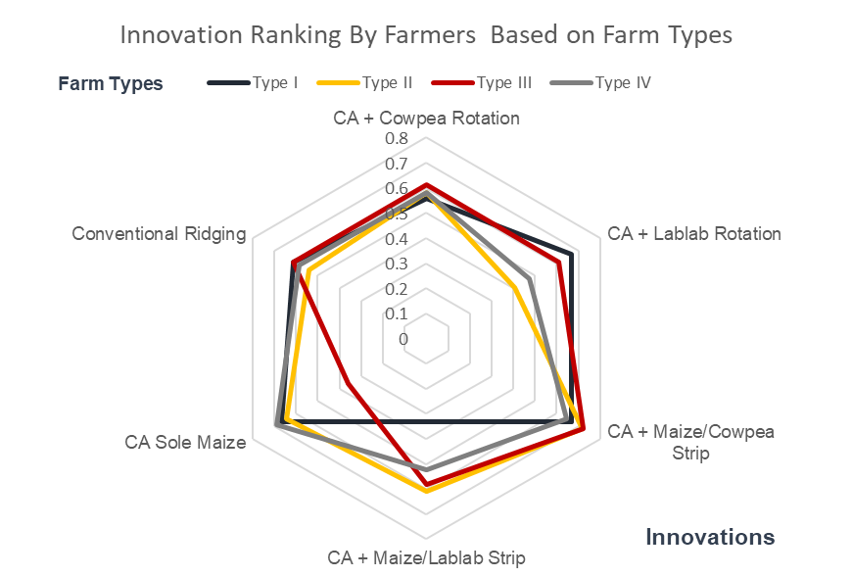
Figure 3: Radar plot showing standardised weighted preference scores for sustainable intensification innovations across farm typologies. Scores were standardised on a 0–1 scale, where values closer to 1 indicate stronger farmer preference for an innovation and values closer to 0 indicate weaker preference. Standardised scores were obtained by dividing the weighted preference score by the maximum possible score within each farm typology.

Overall Ranking of Sustainable Intensification Innovations
When rankings from all farm types were aggregated, CA with maize–cowpea double-row strip cropping emerged as the most preferred innovation overall, followed by conservation agriculture with continuous sole maize and CA with cowpea–maize rotation (Table 6). The least preferred innovations were CA with maize–lablab double-row strip cropping and CA with lablab–maize rotation.
Notably, although conventional ridging with continuous sole maize received the highest proportion of first-choice rankings, its overall ranking was reduced because many farmers also ranked it among their least preferred options. This suggests that the innovation generated highly divergent responses among farmers compared with the more consistently favoured maize–cowpea strip-cropping system.

Table 6: Overall ranking of sustainable intensification innovations based on weighted farmer preference scores.
Innovation | Overall Preference Score | Rank
CA with maize/cowpea double-row strip cropping | 31.99 | 1
Conservation Agriculture with continuous sole maize | 28.98 | 2
CA with cowpea-maize rotation | 26.99 | 3
Conventional ridging with continuous sole maize | 25.99 | 4
CA with maize/lablab double-row strip cropping | 24.99 | 5
CA with lablab-maize rotation | 22.99 | 6

Overall, the results indicate that farmers generally favoured conservation agriculture systems incorporating legumes, particularly cowpea-based strip-cropping arrangements. However, the substantial variation in rankings across farm typologies demonstrates that innovation preferences are context-specific, reinforcing the importance of targeted rather than uniform sustainable intensification recommendations. Below is Figure 3 showing combined graphs of all the rankings of the choices from one to six.
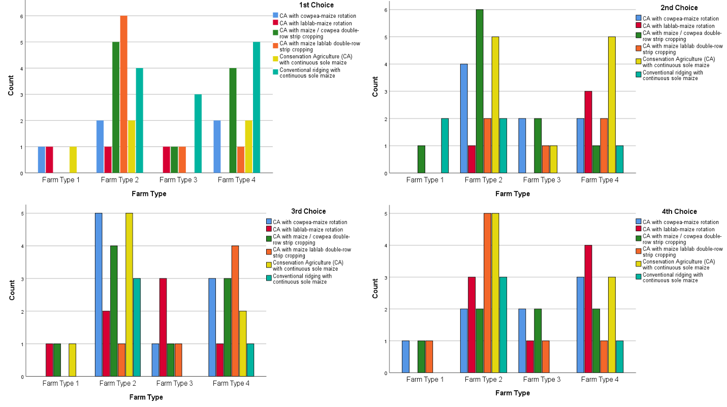
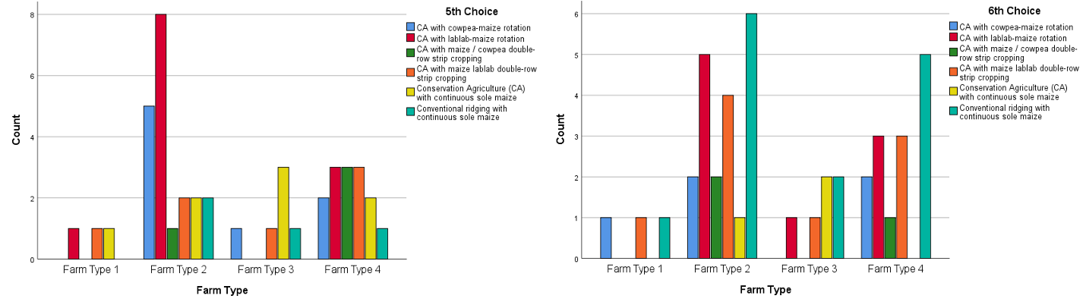
Figure 3: Bar graphs showing the distribution of farmer rankings (1-6th) of SI innovations across all farm typologies.
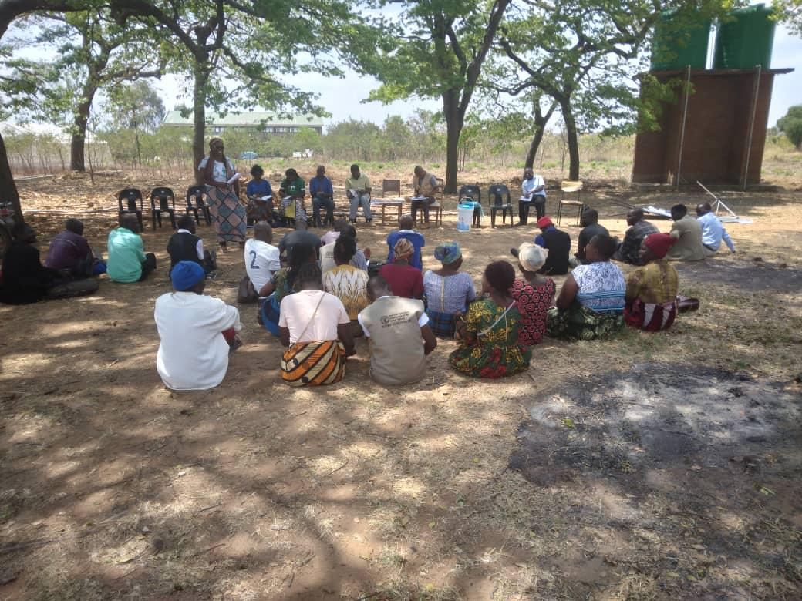
Figure 4: Farmers in Mtunthama EPA conducting a participatory ranking exercise to evaluate and score sustainable intensification innovations during a focus group discussion. Photo used with farmers’ consent.

Farmers’ Reasons for Ranking SI Innovations
Farmers provided detailed explanations for their ranking of sustainable intensification (SI) innovations across farm typologies. The responses revealed interrelated agronomic, socio-economic, and institutional factors shaping preferences. Five dominant themes emerged: (i) perceived productivity and food security benefits, (ii) climate and soil moisture effects, (iii) labour requirements, (iv) input and implementation constraints, and (v) knowledge, training, and institutional support needs.

Perceived Productivity and Food Security Benefits
Across all farm typologies, the strongest driver of innovation preference was expected or observed increases in yield and household food availability. Farmers frequently associated higher-ranked innovations with: increased maize yields per unit area, ability to harvest multiple crops from the same plot, improved household food diversity (maize + legumes), and potential surplus for income generation.
Typical responses included references to “high yield on small piece of land,” “more harvest per acre,” and “variety of food items for household consumption and sale.” Intercropping and conservation agriculture systems were often preferred for their perceived productivity advantages over sole maize or conventional ridging systems.

Climate Resilience and Soil Moisture Conservation
A second dominant theme was the ability of SI innovations to buffer climate variability, particularly dry spells and erratic rainfall. Farmers across all farm types highlighted improved soil moisture retention under mulching and cover crops, reduced crop stress during drought periods, protection against rainfall variability and improved soil fertility over time as some of their reasons for their ranking.
Intercropping systems (especially maize-legume combinations) and conservation agriculture practices were consistently described as “good during dry spells” or “helpful when rains are insufficient.” Farmers linked legume cover and mulch to soil protection and moisture conservation, reinforcing the perceived ecological benefits of SI systems.

Labour Requirements and Workload Trade-offs
Labour demand emerged as a major determinant of ranking, particularly for lower-ranked innovations or initial adoption stages. While some farmers acknowledged long-term labour savings (e.g., reduced weeding under mulch), most emphasised high labour demand during land preparation and planting, ridge modification or flat-planting requirements, increased weeding and management complexity in intercrops, and the need for hired labour in some cases.
Many respondents explicitly described SI innovations as “labour demanding,” particularly in early implementation stages. However, some also noted that labour requirements may decline over time once systems are established.

Input Constraints and Implementation Challenges
Across all farm types, farmers consistently reported input-related and operational constraints that influenced their ranking decisions. Key issues included late delivery of seed and inputs, insufficient quantities of fertilizer and herbicides, lack of sprayers and farm tools, pest and disease pressure and drought and erratic rainfall during trial periods
These constraints were often cited as reasons for lower ranking of certain innovations or reduced performance of trial plots. Farmers frequently attributed challenges to poor timing of project implementation and limited logistical coordination.

Knowledge Gaps, Training, and Institutional Support
A final major theme was the role of capacity building and extension support in shaping farmer perceptions. Farmers repeatedly emphasized the need for more training on application rates and field management, lack of initial orientation before implementation, desire for continuous extension support and supervision, need for knowledge on manure production and soil fertility management and importance of farmer groups and peer learning
Farmers indicated that better training would improve both understanding and performance of SI innovations, and several linked adoption willingness directly to skills acquisition and confidence building.

Integrated Interpretation Across Themes
Overall, farmers’ ranking decisions were not based on a single factor but on a combined evaluation of yield potential, risk exposure, labour burden, and resource availability. Innovations that simultaneously offered higher productivity, improved moisture retention, and food security benefits were ranked higher, while those requiring higher labour inputs or constrained by input shortages tended to be ranked lower.

Perceived Contribution of Sustainable Intensification Innovations to Food Security, Dietary Diversity, Income, and Climate Resilience
Farmers across all resource endowment groups and farm typologies consistently reported that the Sustainable Intensification (SI) innovations positively contributed to household food security, dietary diversity, income generation, and resilience to climate variability. Responses were highly convergent across farm types, with only minor variation in emphasis.

Contribution to Household Food Security
Across all farm types, farmers indicated that the SI innovations improved household food security primarily through increased yields per unit area. The most frequently cited explanation was that innovations such as intercropping, strip cropping, and conservation agriculture enabled farmers to obtain “more harvest from a small piece of land.” Farmers also highlighted that reduced planting spacing and improved crop performance contributed to higher productivity compared to conventional practices.
A second dominant theme was reduced risk of food shortages, with farmers noting that higher and more stable yields reduced reliance on food purchases and improved year-round availability of staple foods.

Contribution to Dietary Diversity
Respondents from all farm types reported that the innovations improved dietary diversity through crop diversification. Farmers consistently noted that mixed cropping systems (maize combined with cowpea, lablab, soybean, and pigeon pea) enabled households to access a wider range of foods.
The main explanatory pattern was that the same plot produced multiple food types simultaneously, allowing households to consume different crops within the same season. Several farmers also highlighted that legumes provided both food and relish, improving meal variety at household level.

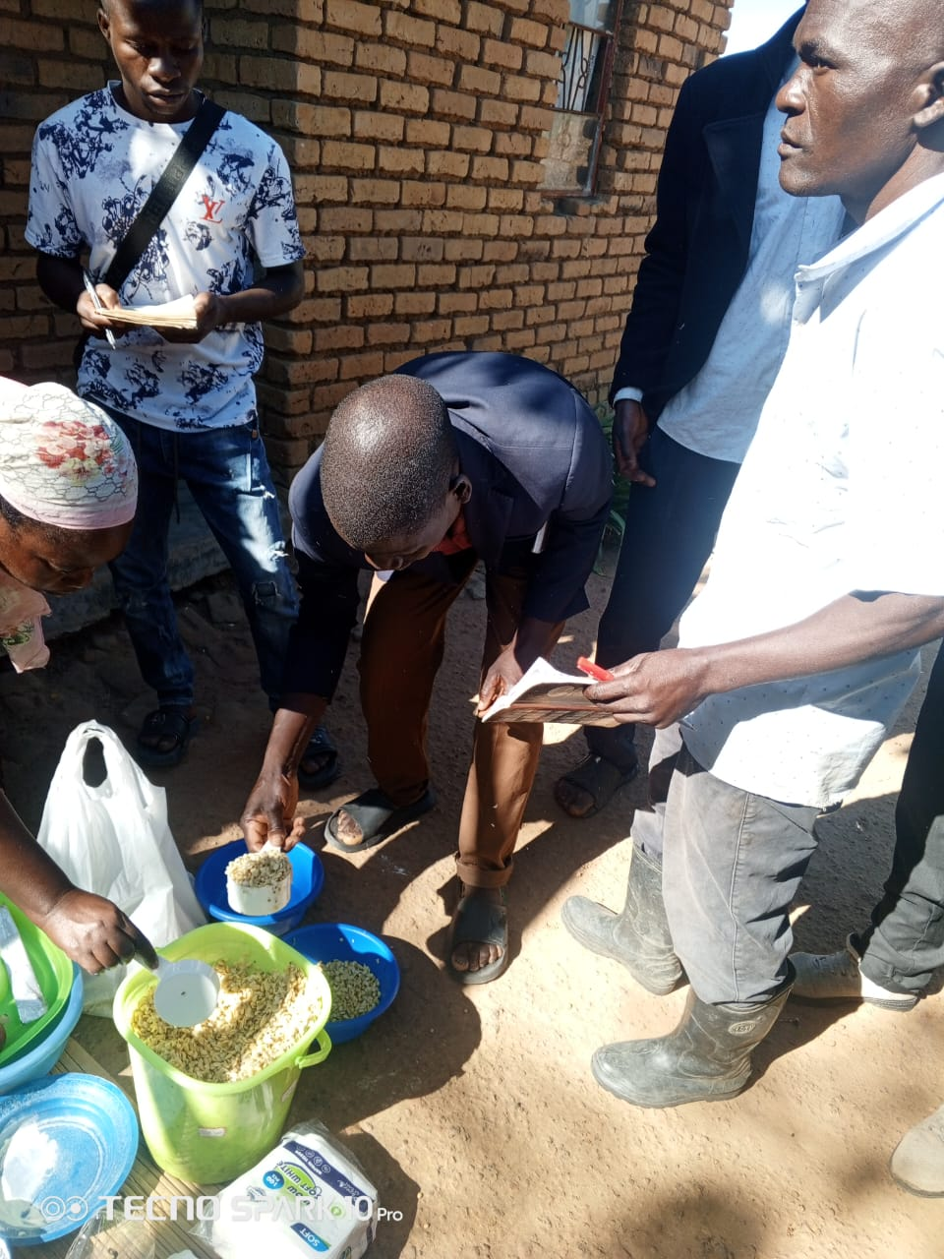
Figure 5: Preparation of composite flour using maize and legume crops by farmers in Mtunthama EPA to demonstrate the potential of legume integration to enhance household dietary diversity, nutritional quality, and utilisation of SI outputs during our value addition activity. Photo used with farmers’ consent.

Contribution to Income Generation
Across all farm categories, farmers reported that the innovations enhanced income generation through the sale of surplus produce. The dominant explanation was that increased yields led to “more food than needed for household consumption,” with the excess being sold.
Farmers also identified inclusion of cash-generating legumes (especially cowpea and lablab) as an important income pathway. In addition, reduced labour demands in some cases (particularly where mulching suppressed weeds) were reported to free time for other income-generating activities.

Contribution to Climate Resilience
Farmers consistently reported that the innovations improved resilience to drought and rainfall variability. The most prominent explanation was moisture retention, particularly through mulching, cover crops, and intercropping systems.
Across all farm types, farmers stated that these practices helped crops “withstand dry spells” and maintain growth during periods of rainfall scarcity. Additional explanations included improved soil structure and fertility from manure and crop residues, early maturing crop varieties escaping drought periods and reduced crop failure compared to sole cropping systems.
These factors were collectively associated with improved ability of crops to cope with both drought and erratic rainfall.

Willingness to Adopt Innovations
A near-universal trend across all farm types was a strong willingness to adopt the innovations after the experiment. Farmers justified this primarily by observed benefits during the trial period, particularly higher yields, improved food availability, income from surplus sales and improved soil moisture and soil health.
However, farmers also noted that continued adoption would depend on addressing constraints such as:
- Labour demands, especially during land preparation and planting
- Timely access to inputs (seed, fertilizer, herbicides)
- Need for training and technical support
- Access to equipment and livestock manure for scaling practices
Despite these constraints, most respondents indicated willingness to continue adopting at least parts of the innovations, particularly mulching, intercropping, and legume integration.
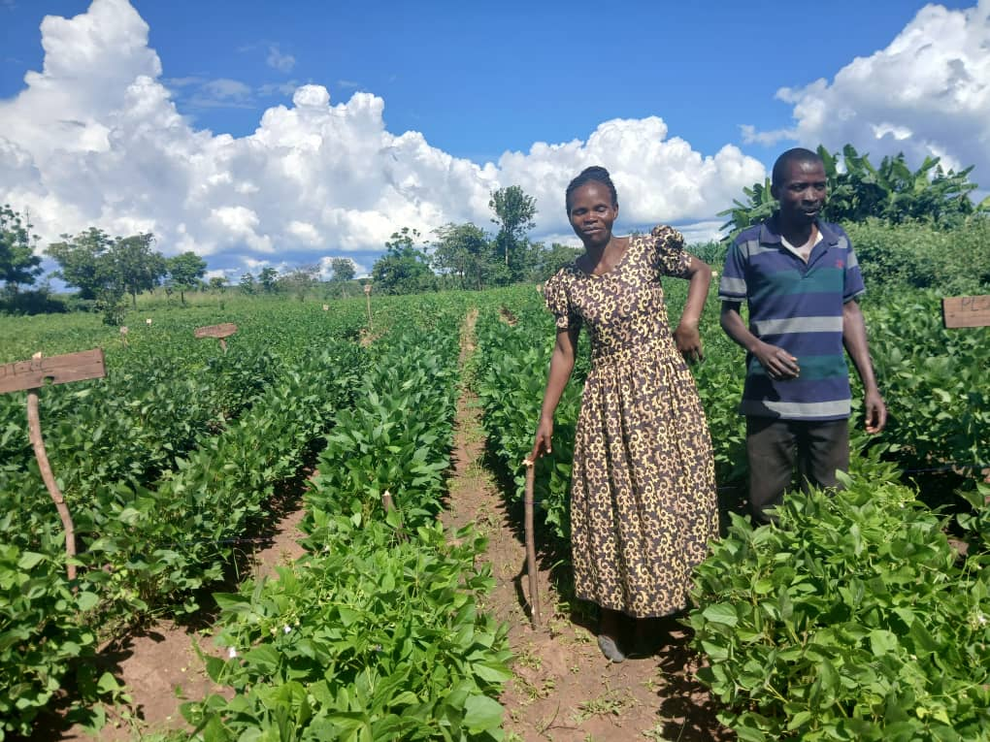
Lead farmer Sarah Mkanase with her husband adopted Chitedze 4 soybean and conservation agriculture practice after the project phased out. Photo used with farmers’ consent.

Discussion

Overview of key findings and novelty of the study
The study demonstrates that farmers across heterogeneous farm typologies generally hold strongly positive perceptions of sustainable intensification (SI) innovations, particularly conservation agriculture (CA) systems that integrate legumes and crop diversification. Across all farm types, innovations were primarily valued for their ability to increase yields, enhance dietary diversity, generate surplus income, and improve resilience to climate variability. This finding agrees with Alomia-Hinojosa et al. (2018), who showed that farmers participating in innovation trials valued technologies that combined productivity gains with compatibility to local farming conditions, while Garrity et al. (2012) emphasise that African farming systems are inherently heterogeneous and therefore require context-specific intensification strategies.
A key finding is that while positive perceptions are widespread, farmer preferences are not uniform. Instead, they are strongly shaped by farm typology, with distinct differences in preferred innovation packages across resource-constrained and better-endowed households. Maize–cowpea strip cropping consistently emerged as the most broadly preferred innovation, while conventional ridging and lablab-based systems elicited more polarised responses.
Importantly, the study contributes novel evidence that farmer decision-making is not driven solely by agronomic performance, but by an integrated assessment of labour requirements, risk exposure, input availability, and livelihood compatibility. This reinforces the argument that SI technologies must be understood as socio-technical systems rather than standalone agronomic interventions (Vanlauwe et al., 2014).

Farm typology and targeting of sustainable intensification innovations
The variation in innovation preferences across farm typologies demonstrates that farmers do not evaluate sustainable intensification technologies using a common set of criteria. Instead, each household appears to assess innovations according to its own resource availability, labour capacity, production objectives, and tolerance for risk. This explains why no single innovation was consistently preferred across all farm types despite farmers generally recognising the benefits of sustainable intensification. The findings therefore suggest that technology suitability is determined less by its agronomic potential alone than by its compatibility with the realities of individual farming systems.

The preference shown by Farm Type II households for diversified conservation agriculture systems, compared with the greater reliance on conventional systems among Farm Types III and IV, illustrates how differences in household circumstances shape technology choices. Although diversified systems may offer greater long-term productivity and resilience, they also require additional labour, management skills, and timely access to inputs. Households with greater capacity to meet these requirements are therefore more likely to value such innovations, whereas those facing labour or resource constraints may favour familiar practices that involve lower implementation risks. This demonstrates that farmers make pragmatic decisions aimed at balancing expected benefits against the costs and uncertainties associated with adopting new practices.
These findings provide empirical evidence that blanket recommendations are unlikely to achieve widespread adoption because they ignore the diversity that exists within smallholder farming systems. Similar conclusions have been reported by Alvarez et al. (2018), who argue that farm typologies provide an effective basis for matching agricultural interventions to household characteristics. Franke et al. (2014) similarly showed that opportunities to benefit from grain legumes differed markedly among Malawian farm types because labour availability, soil fertility and financial resources varied considerably across households. The recent CGIAR Mixed Farming Systems Initiative in Malawi likewise advocates tailoring socio-technical innovation bundles to different farming system typologies rather than promoting uniform technology packages (Homann-Kee Tui et al., 2025).
From a practical perspective, the results indicate that farm typology should become an integral component of extension planning and technology targeting. Rather than recommending identical innovation packages to all households, extension programmes should prioritise technologies that match the specific labour availability, resource endowment, and production goals of different farmer groups. Such an approach is more likely to improve adoption, enhance farmer satisfaction, and increase the long-term sustainability of sustainable intensification interventions.

Participatory evaluation and farmer-led innovation assessment
A notable contribution of this study is that it evaluates sustainable intensification innovations from the farmers' perspective rather than relying solely on agronomic performance. The ranking exercises revealed that farmers simultaneously considered productivity, labour demand, food security, risk, and implementation feasibility when judging the suitability of innovations. This demonstrates that technologies regarded as technically superior by researchers may not necessarily be perceived as the most appropriate under real farming conditions. Farmer-generated rankings therefore provided a more holistic assessment of innovation performance by capturing practical trade-offs that influence day-to-day management decisions.
The findings also suggest that participatory evaluation can identify potential adoption barriers before technologies are promoted at scale. For example, while several conservation agriculture options were recognised for their agronomic benefits, concerns regarding labour requirements and management complexity reduced their attractiveness for some households. Such insights would have been difficult to obtain from conventional yield assessments alone because they emerge from farmers' lived experiences rather than experimental measurements.
These observations support the argument that farmer participation should be viewed as a source of scientific evidence rather than simply a mechanism for stakeholder engagement. These findings closely resemble those of Alomia-Hinojosa et al. (2018), who found that participatory on-farm evaluation not only improved researchers' understanding of farmer decision-making but also changed farmers' perceptions of agricultural innovations by allowing them to evaluate technologies under realistic farming conditions. Similarly, Lacombe et al. (2018) show that involving farmers in technology assessment improves the relevance of innovations by accounting for the diversity of local farming situations. The present findings reinforce these perspectives by demonstrating that farmer-led evaluations provide valuable information for predicting both technology acceptance and potential scaling challenges.
From a practical standpoint, incorporating participatory evaluation into innovation development could improve the design of technologies before large-scale dissemination. This would enable researchers and extension services to refine innovations in response to farmer priorities, thereby increasing their relevance and likelihood of sustained adoption.

Conservation agriculture adoption dynamics in Malawi
Although farmers generally expressed positive perceptions of conservation agriculture (CA) and related sustainable intensification practices, the findings indicate that favourable attitudes alone are unlikely to ensure long-term adoption. Farmers consistently recognised the benefits of conservation agriculture for improving productivity, soil moisture retention, and resilience to climate variability, yet many also identified labour requirements, input availability, and implementation complexity as major constraints. This suggests that farmers clearly distinguish between recognising the value of an innovation and possessing the resources required to implement it consistently.
The coexistence of enthusiasm and caution observed in this study reflects the realities of decision-making within smallholder farming systems. Rather than accepting or rejecting CA outright, farmers appeared to weigh its expected long-term benefits against immediate household demands on labour, capital, and management capacity. This balancing process was particularly evident for practices involving residue retention and diversified cropping, where the perceived agronomic benefits competed with existing demands for crop residues as livestock feed and for other household uses. Such findings indicate that conservation agriculture is evaluated as part of a broader whole-farm livelihood strategy rather than as an isolated production technology.
This interpretation is supported by Chinseu et al. (2019), who found that conservation agriculture in Malawi is frequently discontinued once external project support ends because institutional and input constraints remain unresolved. Similarly, Ward et al. (2016) demonstrated that farmer preferences for conservation agriculture differ substantially according to household circumstances and available incentives. Beyond Malawi, Valbuena et al. (2012) showed that mixed crop–livestock households often face unavoidable trade-offs between retaining crop residues as mulch and using them for livestock feed, limiting adherence to one of conservation agriculture's core principles. More broadly, Pannell et al. (2006) argue that farmers adopt conservation practices only when they perceive a clear advantage relative to their own objectives and when innovations are sufficiently compatible with existing farming systems and easy to trial. Erenstein (2011) further demonstrated that crop residue retention in conservation agriculture frequently conflicts with farmers' competing needs for livestock feed, illustrating why full implementation of conservation agriculture remains difficult within mixed crop–livestock systems.
Taken together, these findings suggest that conservation agriculture promotion should move beyond demonstrating agronomic benefits towards creating an enabling environment that addresses the practical constraints affecting implementation. Recent reviews further emphasise that sustained adoption in developing countries depends on integrated extension services, complementary input support, and continuous farmer learning rather than technology dissemination alone (Takahashi et al., 2019). Strengthening these institutional and advisory systems is therefore likely to be as important as improving the technical performance of conservation agriculture itself.

Linking farmer preferences to food security, resilience, and livelihoods
Farmers consistently evaluated sustainable intensification (SI) innovations according to their contribution to household well-being rather than agricultural production alone. Innovations receiving the highest preference rankings were those perceived to improve food availability, diversify diets, generate marketable surplus, and reduce vulnerability to climatic shocks. This suggests that farmers assess technologies using multiple livelihood criteria simultaneously, with productivity representing only one component of a broader decision-making process.
The strong preference for maize–cowpea systems illustrates this integrated evaluation. Farmers valued these systems not simply because they increased maize production, but because they combined staple food production with nutritious legumes, opportunities for household income, and improvements in soil fertility within the same production system. The results therefore indicate that innovations offering several complementary benefits are more attractive than those delivering gains in only a single dimension. This finding reinforces the importance of designing SI interventions that respond to the multiple objectives of smallholder households rather than focusing exclusively on yield improvement.
This interpretation is consistent with Kerr et al. (2007), who demonstrated that legume diversification in Malawi simultaneously improves household nutrition and soil fertility through participatory farmer-managed systems. Likewise, Smith et al. (2017) showed that diversified legume rotations can maintain maize productivity while improving soil quality and increasing the likelihood of meeting household calorie and protein requirements under variable climatic conditions. Franke et al. (2014) further demonstrated that grain legumes generate different livelihood benefits across farm typologies, with improvements in food self-sufficiency, profitability, and soil fertility depending on household resource endowment. Together, these studies support the finding that farmers value SI innovations because they contribute to multiple livelihood outcomes rather than productivity alone. These livelihood considerations are particularly important in Malawi, where increasing climatic uncertainty threatens maize productivity and household food security, reinforcing the need for innovations that simultaneously improve resilience and production stability (Warnatzsch & Reay, 2020).
The findings also suggest that resilience is interpreted by farmers as both an ecological and socio-economic concept. While practices such as legume integration and conservation agriculture were recognised for improving soil moisture conservation and reducing climate-related production risks, farmers also considered whether these practices could be maintained with their available labour, capital, and management capacity. Similar conclusions have been reported by Matita et al. (2022), who found that improved legume technologies contribute to dietary resilience in Malawi, and by Giller et al. (2021), who emphasise that regenerative and conservation-oriented farming practices deliver sustainable benefits only when they remain feasible within the realities of smallholder farming systems.

Labour constraints and the limits of SI scalability
Labour emerged as one of the most influential factors shaping farmers' evaluations of sustainable intensification (SI) innovations. Across farm typologies, respondents consistently recognised the long-term benefits of conservation agriculture and diversified cropping systems, yet many expressed concern about the additional labour required during land preparation, planting, residue management, and weeding. These findings suggest that labour availability functions as a critical threshold determining whether technically attractive innovations can be implemented under real smallholder conditions.
The findings further indicate that labour constraints are not experienced uniformly across farm types. Households with limited labour resources generally favoured practices that could be accommodated within existing household capacities, whereas innovations requiring intensive management were often considered less feasible despite their recognised agronomic advantages. This pattern implies that farmers evaluate technologies in relation to seasonal labour availability and competing household responsibilities rather than expected productivity gains alone. Consequently, labour availability appears to influence not only whether innovations are adopted but also which components of an innovation package are considered practical.
This interpretation is supported by Leonardo et al. (2015), who identified labour availability as the principal constraint to agricultural production in maize-based smallholder farming systems in Mozambique, exceeding land limitations in importance. Similarly, White et al. (2005) demonstrated that technologies offering positive economic returns may nevertheless be rejected when they impose high labour demands during peak agricultural periods. In mixed crop–livestock systems, Valbuena et al. (2012) further showed that farmers frequently face trade-offs between competing uses of labour and crop residues, limiting the feasibility of implementing conservation agriculture according to recommended practices. More broadly, Ngoma et al. (2021) conclude that labour bottlenecks remain one of the most persistent barriers to conservation agriculture adoption across Eastern and Southern Africa.
Taken together, these findings suggest that improving the scalability of sustainable intensification will require interventions that address labour constraints alongside agronomic performance. Labour-saving technologies, appropriate mechanisation, improved weed management, and extension approaches that promote gradual or phased implementation of SI practices may therefore enhance adoption more effectively than simply promoting technically superior innovations.

Adoption intentions versus likely behavioural outcomes
One of the most encouraging findings of the study was the strong willingness expressed by farmers to continue using sustainable intensification (SI) innovations after participating in the trials. Direct exposure to the innovations appeared to increase farmers' confidence in their potential to improve crop productivity, household food availability, and resilience to climate variability. Nevertheless, respondents consistently indicated that sustained adoption would depend on overcoming practical constraints, particularly labour shortages, limited access to inputs, and continued technical support. These findings suggest that positive perceptions alone are insufficient to ensure long-term behavioural change.
The results further indicate that adoption is likely to occur incrementally rather than through immediate implementation of complete innovation packages. Many households appeared more willing to adopt individual practices that fit their available resources and existing farming systems than to implement the full suite of recommended SI components. This gradual approach reflects farmers' efforts to minimise production risks while gaining experience with unfamiliar practices, illustrating that adoption is better understood as a progressive learning process than as a single decision.
This interpretation is consistent with Rogers (2003), who describes innovation adoption as a staged process through which individuals move from awareness and persuasion to implementation and confirmation. Likewise, Pannell et al. (2006) argue that favourable attitudes do not necessarily translate into adoption unless innovations provide a clear advantage, are compatible with farmers' circumstances, and can be tested with acceptable levels of risk. The findings also support Zeweld et al. (2017), who showed that positive attitudes increase farmers' behavioural intentions towards sustainable practices but do not necessarily guarantee implementation unless farmers perceive sufficient control over labour and resource requirements. Empirical evidence from Abay et al. (2019) further demonstrates that technology adoption depends on complementary inputs, extension support, and interactions among technologies, while substantial differences exist in adoption behaviour even among households with similar observable characteristics. Similarly, Ward et al. (2016) showed that Malawian farmers exhibit heterogeneous preferences for conservation agriculture, with adoption strongly influenced by household characteristics and incentive structures. Recent reviews by Takahashi et al. (2019) likewise conclude that sustained technology adoption in developing countries depends on integrated extension services and continued institutional support rather than exposure to technologies alone. Recent longitudinal evidence further confirms that an intention–action gap exists among farmers. Byfuglien et al. (2025) found that although almost half of surveyed farmers intended to adopt cover crops, only a small proportion subsequently implemented the practice, illustrating how favourable intentions may fail to translate into behaviour when practical constraints remain.
These findings suggest that successful scaling strategies should focus not only on creating positive perceptions of sustainable intensification but also on strengthening the conditions that enable farmers to convert favourable intentions into sustained practice. Improving access to inputs, providing continuous advisory support, and promoting gradual adoption pathways that match household capacities are therefore likely to produce more durable adoption outcomes than one-off technology promotion campaigns.

Implications for targeting sustainable intensification interventions
The findings demonstrate that improving the effectiveness of sustainable intensification (SI) programmes requires greater emphasis on matching innovations to the diversity of farming households. The clear differences in innovation preferences observed across farm typologies indicate that uniform technology recommendations are unlikely to achieve widespread adoption because farmers differ in labour availability, resource endowment, production objectives, and tolerance for production risk. These findings reinforce the argument by Garrity et al. (2012) that successful agricultural development in Africa depends on designing interventions around the diversity of farming systems rather than assuming that technologies perform equally well across all households.
The consistently high preference for maize–cowpea systems across several farm types suggests that such innovations could serve as effective entry points for broader SI interventions. However, the variation observed for other innovations indicates that extension programmes should retain sufficient flexibility to adapt recommendations to local household circumstances rather than promoting identical technology packages. This implies that successful targeting should focus on offering farmers a portfolio of complementary options from which they can select combinations that best match their production goals and resource capacities.
This interpretation is supported by Franke et al. (2014), who demonstrated that the benefits of grain legume technologies differ substantially across farm types in Malawi because household resource endowments shape both profitability and adoption opportunities. Likewise, Alvarez et al. (2018) argue that farm typologies provide an effective basis for targeting agricultural interventions by capturing differences in household assets, objectives, and production constraints. More recently, Homann-Kee Tui et al. (2025) advocate designing sustainable intensification as integrated bundles of complementary innovations that address multiple constraints simultaneously rather than promoting individual technologies in isolation.

Overall, the findings reinforce the need for extension systems that move beyond technology dissemination towards integrated support strategies. Evidence suggests that technology adoption is more successful when extension services are combined with timely access to complementary inputs, practical farmer training, and advisory services that enable households to adapt innovations to their own circumstances (Abay et al., 2019; Takahashi et al., 2019). Strengthening these institutional support systems is therefore likely to enhance both the adoption and long-term sustainability of sustainable intensification interventions.

Future research directions
Future research should move beyond cross-sectional perception studies towards longitudinal assessment of adoption trajectories to determine whether favourable perceptions translate into sustained behavioural change over time. Future studies should also quantify the economic and labour trade-offs associated with different sustainable intensification components across farm typologies. In addition, greater attention should be given to gendered labour allocation, behavioural drivers of technology adoption, and evaluation of integrated innovation bundles under farmer-managed conditions. Finally, further refinement of farm typology approaches and decision-support tools would improve the targeting of sustainable intensification interventions across heterogeneous smallholder farming systems.

Conclusion
The study demonstrates that sustainable intensification (SI) innovations are widely perceived by smallholder farmers as beneficial for improving food security, dietary diversity, income generation, and climate resilience. Across all farm typologies, farmers consistently associated SI practices, particularly conservation agriculture systems integrated with legumes, with higher yields, improved soil moisture retention, and greater household food availability. However, preferences for specific innovations were not uniform, with clear differences emerging across farm types. Maize–cowpea strip cropping and other diversified conservation agriculture systems were generally the most preferred, while conventional systems and some lablab-based options elicited more mixed or polarised responses. These findings highlight that farmer decision-making is shaped not only by perceived productivity gains but also by labour requirements, input availability, management complexity, and compatibility with household resource endowments.
In general, the study concludes that sustainable intensification interventions cannot be effectively promoted through uniform recommendations, as farm heterogeneity strongly influences both farmer preferences and likely adoption pathways. Instead, agricultural policies and development programmes should incorporate farm typology approaches to guide the targeting of innovation packages, extension services, and investment support to households with differing resource capacities. Maize–cowpea-based conservation agriculture systems provide a promising entry point for scaling sustainable intensification across diverse farm types, but widespread adoption will depend on complementary investments in timely access to quality seed and other inputs, labour-saving technologies, farmer training, and strengthened extension services. Greater collaboration among government agencies, research institutions, extension providers, and development partners will be essential for designing context-specific socio-technical innovation bundles that respond to local farming realities rather than relying on blanket technology recommendations. Future research should evaluate the long-term adoption, economic performance, and resilience impacts of these targeted innovation packages across different farming systems to inform evidence-based policy and sustainable agricultural development in Malawi.

References
Abay, K. A., Berhane, G., Taffesse, A. S., Koru, B., & Abay, K. (2019). Understanding farmers' technology adoption decisions: input complementarity and heterogeneity. Repec: Research Papers in Economics. https://doi.org/10.21955/gatesopenres.1116319.1, https://hdl.handle.net/10568/148560
Alomia-Hinojosa, V., Speelman, E. N., Thapa, A., Wei, H. E., McDonald, A. J., Tittonell, P., & Groot, J. C. J. (2018). Exploring farmer perceptions of agricultural innovations for maize-legume intensification in the mid-hills region of Nepal. International Journal of Agricultural Sustainability, 16(1), 74–93. https://doi.org/10.1080/14735903.2018.1423723
Alomia‐Hinojosa, V., Speelman, E. N., Thapa, A., Wei, H.-E., McDonald, A. J., Tittonell, P., & Groot, J. (2018). Exploring farmer perceptions of agricultural innovations for maize-legume intensification in the mid-hills region of Nepal. International Journal of Agricultural Sustainability, 16(1), 74–93. https://doi.org/10.1080/14735903.2018.1423723
Alvarez, S., Timler, C. J., Michalscheck, M., Paas, W., Descheemaeker, K., Tittonell, P., Andersson, J., & Groot, J. (2018). Capturing farm diversity with hypothesis-based typologies: An innovative methodological framework for farming system typology development. Plos ONE, 13(5), e194757. https://doi.org/10.1371/journal.pone.0194757
Arsil, P., Tey, Y. S., Brindal, M., Ardiansyah, A., Sumarni, E., & Masrukhi. (2022). Perceived attributes driving the adoption of system of rice intensification: The Indonesian farmers’ view. Open Agriculture, 7(1), 217–225. https://doi.org/10.1515/opag-2022-0080
Bhatti, M. A., Godfrey, S., Ip, R. H. L., Kachiwala, C., Hovdhaugen, H., Banda, L. J., Limuwa, M., Wynn, P., Ådnøy, T., & Eik, L. O. (2021). Diversity of Sources of Income for Smallholder Farming Communities in Malawi: Importance for Improved Livelihood. Sustainability, 13(17), 9599. https://doi.org/10.3390/su13179599
Byfuglien, A., van Valkengoed, A. M., & Innocenti, S. (2025). Good intentions, limited action: When do farmers’ intentions to adopt sustainable farming practices turn into actual behaviour?. Journal of Environmental Psychology, 102, 102522. https://doi.org/10.1016/j.jenvp.2025.102522
Chinseu, E., Stringer, L. C., & Dougill, A. J. (2019). An Empirically Derived Conceptual Framework to Assess Dis-Adoption of Conservation Agriculture: Multiple Drivers and Institutional Deficiencies. Journal of Sustainable Development, 12(5), 48. https://doi.org/10.5539/jsd.v12n5p48
Erenstein, O. (2011). Cropping systems and crop residue management in the Trans-Gangetic Plains: Issues and challenges for conservation agriculture from village surveys. Agricultural Systems, 104(1), 54–62. https://doi.org/10.1016/j.agsy.2010.09.005
Franke, A., van den Brand, G., & Giller, K. (2014). Which farmers benefit most from sustainable intensification? An ex-ante impact assessment of expanding grain legume production in Malawi. European Journal of Agronomy, 58, 28–38, https://doi.org/10.1016/j.eja.2014.04.002
Garrity, D., Dixon, J., & Boffa, J. M. (2012). Understanding African farming systems. Food Security in Africa: bridging research and Practise, 1-50.
Giller, K., Hijbeek, R., Andersson, J., & Sumberg, J. (2021). Regenerative Agriculture: An agronomic perspective. Outlook on Agriculture, 50(1), 13–25. https://doi.org/10.1177/0030727021998063
Homann-Kee Tui, S.; Tufa, A.; Manda, J.; Sseguya, H.; Liben, F.; Omondi, J.O. (2025) Informing an inclusive scaling strategy for bundled whole-farm innovations in Malawi’s maize-based mixed farming systems. CGIAR Sustainable Farming Science Program. https://cgspace.cgiar.org/server/api/core/bitstreams/af6e8d54-db10-409f-99ff-0b678fa6e7f6/content
Kerr, R. B., Snapp, S. S., Chirwa, M., Shumba, L., & Msachi, R. (2007). PARTICIPATORY RESEARCH ON LEGUME DIVERSIFICATION WITH MALAWIAN SMALLHOLDER FARMERS FOR IMPROVED HUMAN NUTRITION AND SOIL FERTILITY. Experimental Agriculture, 43(4), 437–453. https://doi.org/10.1017/s0014479707005339
Lacombe, C., Couix, N., & Hazard, L. (2018). Designing agroecological farming systems with farmers: A review. Agricultural Systems, 165, 208–220. https://doi.org/10.1016/j.agsy.2018.06.014
Leonardo, W., van de Ven, G., Udo, H., Kanellopoulos, A., Sitoe, A., & Giller, K. (2015). Labour not land constrains agricultural production and food self-sufficiency in maize-based smallholder farming systems in Mozambique. Food Security, 7(4), 857–874. https://doi.org/10.1007/s12571-015-0480-7
Mango, N., Makate, C., Mapemba, L., & Sopo, M. (2018). The role of crop diversification in improving household food security in central Malawi. Agriculture & Food Security, 7(1). https://doi.org/10.1186/s40066-018-0160-x
Matita, M., Chiwaula, L., Chirwa, E. W., Mazalale, J., & Walls, H. (2022). Subsidizing improved legume seeds for increased household dietary diversity: Evidence from Malawi’s Farm Input Subsidy Programme with implications for addressing malnutrition in all its forms. Food Policy, 113, 102309. https://doi.org/10.1016/j.foodpol.2022.102309
Mwasikakata, Michael. (2003). Tobacco: An Economic Lifeline? The Case of Tobacco Farming in the Kasungu Agricultural Development Division, Malawi.
Ngoma H, Angelsen A, Jayne TS and Chapoto A (2021) Understanding Adoption and Impacts of Conservation Agriculture in Eastern and Southern Africa: A Review. Front. Agron. 3:671690. doi: 10.3389/fagro.2021.671690
Ngoma, H., Angelsen, A., Jayne, T. S., & Chapoto, A. (2021). Understanding Adoption and Impacts of Conservation Agriculture in Eastern and Southern Africa: A Review. Frontiers in Agronomy, 3. https://doi.org/10.3389/fagro.2021.671690
Nyamayevu, D., Nyagumbo, I., Chiduwa, M., Liang, W., & Li, R. (2024). Understanding Crop Diversification Among Smallholder Farmers: Socioeconomic Insights from Central Malawi. Sustainability, 16(20), 9078. https://doi.org/10.3390/su16209078
Pannell, D. J., Marshall, G. R., Barr, N., Curtis, A., Vanclay, F., & Wilkinson, R. (2006). Understanding and promoting adoption of conservation practices by rural landholders. Australian Journal of Experimental Agriculture, 46(11), 1407–1424. https://doi.org/10.1071/ea05037
Phiri, A. T. (2012). Farmers’ evaluation of integrated soil fertility management methods in Northern Kasungu Central Malawi. Journal of Agricultural Extension and Rural Development, 4(11). https://doi.org/10.5897/jaerd11.111
Pretty, J. (2018). Intensification for redesigned and sustainable agricultural systems. Science, 362(6417). https://doi.org/10.1126/science.aav0294
Pretty, J., Toulmin, C., & Williams, S. B. (2011). Sustainable intensification in African agriculture. International Journal of Agricultural Sustainability, 9(1), 5–24. https://doi.org/10.3763/ijas.2010.0583
Smith, A., Snapp, S. S., Chikowo, R., Thorne, P. S., Bekunda, M., & Glover, J. (2017). Measuring sustainable intensification in smallholder agroecosystems: A review. Global Food Security, 12, 127–138. https://doi.org/10.1016/j.gfs.2016.11.002
Snapp, S. S., Rohrbach, D., Simtowe, F., & Freeman, H. A. (2002). Sustainable soil management options for Malawi: can smallholder farmers grow more legumes?. Agriculture Ecosystems & Environment, 91(1–3), 159–174. https://doi.org/10.1016/s0167-8809(01)00238-9
Takahashi, K., Muraoka, R., & Otsuka, K. (2019). Technology adoption, impact, and extension in developing countries’ agriculture: A review of the recent literature. Agricultural Economics, 51(1), 31–45. https://doi.org/10.1111/agec.12539
TerAvest, D. (2012). Sustainable intensification and diversification of maize-based farming systems in Malawi. Cgspace a Repository of Agricultural Research Outputs (Consultative Group for International Agricultural Research). https://hdl.handle.net/10568/24870
Thabbie, C. (2004). Chapter 6 An Assessment of Smallholder Farmers' Access to Produce Markets in Malawi: The Case of Kasungu RDP. Institutional Repositories Database (IRDB), 141–164. https://doi.org/10.20561/00027423
Thierfelder, C., Chisui, J. L., Gama, M., Cheesman, S., Jere, Z. D., Bunderson, W. T., Eash, N. S., & Rusinamhodzi, L. (2013). Maize-based conservation agriculture systems in Malawi: Long-term trends in productivity. Field Crops Research, 142, 47–57. https://doi.org/10.1016/j.fcr.2012.11.010
Tittonell, P., van Wijk, M. T., Herrero, M., Rufino, M. C., de Ridder, N., & Giller, K. (2009). Beyond resource constraints – Exploring the biophysical feasibility of options for the intensification of smallholder crop-livestock systems in Vihiga district, Kenya. Agricultural Systems, 101(1–2), 1–19. https://doi.org/10.1016/j.agsy.2009.02.003
Turner, Ralph. (2007). Diffusion of Innovations, 5th edition, Everett M. Rogers. Free Press, New York, NY (2003), 551 pages. Journal of Minimally Invasive Gynecology. 14. 776. 10.1016/j.jmig.2007.07.001.
Valbuena, D., Erenstein, O., Tui, S. H.-K., Abdoulaye, T., Claessens, L., Duncan, A. J., Gérard, B., Rufino, M. C., Teufel, N., van Rooyen, A., & van Wijk, M. T. (2012). Conservation Agriculture in mixed crop–livestock systems: Scoping crop residue trade-offs in Sub-Saharan Africa and South Asia. Field Crops Research, 132, 175–184. https://doi.org/10.1016/j.fcr.2012.02.022
Vanlauwe, B., Coyne, D., Gockowski, J., Hauser, S., Huising, J., Masso, C., Nziguheba, G., Schut, M., & van Asten, P. (2014). Sustainable intensification and the African smallholder farmer. Current Opinion in Environmental Sustainability, 8, 15–22. https://doi.org/10.1016/j.cosust.2014.06.001
Ward, P. S., Bell, A. R., Parkhurst, G. M., Droppelmann, K., & Mapemba, L. (2016). Heterogeneous preferences and the effects of incentives in promoting conservation agriculture in Malawi. Agriculture Ecosystems & Environment, 222, 67–79. https://doi.org/10.1016/j.agee.2016.02.005
Warnatzsch, E. A., & Reay, D. (2020). Assessing climate change projections and impacts on Central Malawi's maize yield: The risk of maladaptation. Science of the Total Environment, 711, 134845. https://doi.org/10.1016/j.scitotenv.2019.134845
White, D., Labarta, R., & Leguía, E. J. (2005). Technology adoption by resource-poor farmers: considering the implications of peak-season labor costs. Agricultural Systems, 85(2), 183–201. https://doi.org/10.1016/j.agsy.2004.07.018
Zeweld, W., van Huylenbroeck, G., Tesfay, G., & Speelman, S. (2017). Smallholder farmers' behavioural intentions towards sustainable agricultural practices. Journal of Environmental Management, 187, 71–81. https://doi.org/10.1016/j.jenvman.2016.11.014

Chapter 5
Exploring Sustainable Farm Optimization Scenarios Across Smallholder Farm Types Using FarmDESIGN

